Family Math Studio Lesson 6.4 · Session 2 · 6.AT.6c

Write and Evaluate Numerical Expressions with Exponents
Evaluate expressions with grouping symbols, powers and arithmetic in one order.
Name Date

Tonight's spark
A rec-center game gives you 4 points to start. Then you play 3 bonus rounds. Each bonus round is worth (9 − 7)² points. What is your final score? Make a guess first: is the final score more or less than 10?
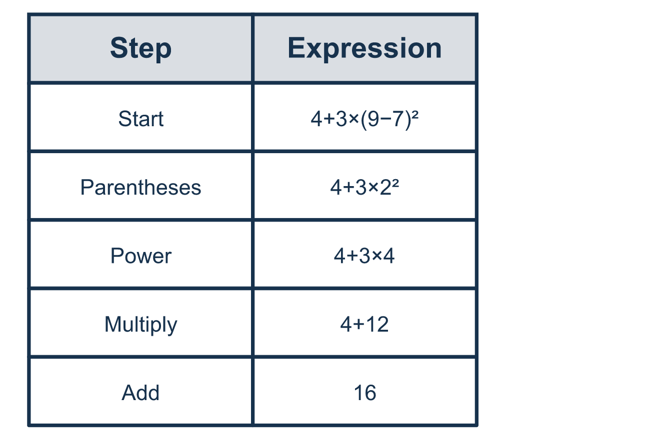
Our class model: rewrite after every step

Try it
Work it out on paper. Write one answer on each line.
- In 5 × (2 + 4), which do you do first?
A. Multiply 5 × 2 B. Multiply 5 × 4 C. Add 5 + 2 D. Add 2 + 4
My answer
- What is (8 − 3) × 2?
A. 2 B. 10 C. 13
My answer
- What is (6 + 2)²?
A. 64 B. 40 C. 10 D. 16
My answer
- What is 20 − (3 + 1)²?
A. 18 B. 16 C. 4 D. 256
My answer
- What is 2 + 3 × (5 − 1)?
A. 20 B. 14 C. 16
My answer
- What is 6 + 2 × (7 − 4)²?
A. 72 B. 42 C. 12 D. 24
My answer

Talk about it
What did you do first, second and third, and why does that order give only one answer?

Home mission
Make a game score at the table. Start with 6 points, then add 2 rounds worth (6 − 3)² points each. Ask your student to say the expression and rewrite it after every step.

If we get stuck, ask
- What step comes first, and why?
- Can you rewrite the whole expression after that step?
- These two operations have the same rank — which way do we go?

Do it on a screen

Scan or type the link. Same lesson, with hints. eduwonderlab.com/lessons/6-4-part2/homework.html
How did it feel? (optional) ☐ Tricky ☐ Getting there ☐ Got it

Family Math Studio · For grown-ups Lesson 6.4 · Session 2 · 6.AT.6c

Answers and talk notes
Write and Evaluate Numerical Expressions with Exponents

What your student is learning
Tonight we evaluate expressions that mix grouping symbols, powers and arithmetic — in the one order that gives one answer.

Answers
Ask your student to explain before you look.
- D. Add 2 + 4. Add 2 + 4 first. Grouping symbols are done before multiplying.
- B. 10. (8 − 3) × 2 = 5 × 2 = 10.
- A. 64. (6 + 2)² = 8² = 64. Add inside first, then square.
- C. 4. 20 − (3 + 1)² = 20 − 4² = 20 − 16 = 4.
- B. 14. 2 + 3 × (5 − 1) = 2 + 3 × 4 = 2 + 12 = 14.
- D. 24. 6 + 2 × (7 − 4)² = 6 + 2 × 3² = 6 + 2 × 9 = 6 + 18 = 24.

Talk about it
What did you do first, second and third, and why does that order give only one answer?

When they are stuck, ask
- What step comes first, and why?
- Can you rewrite the whole expression after that step?
- These two operations have the same rank — which way do we go?

Try not to say
- Just work left to right, it usually comes out.
- Multiplication always comes before division.
- Do the exponent last since it is a small number.

Home mission
Make a game score at the table. Start with 6 points, then add 2 rounds worth (6 − 3)² points each. Ask your student to say the expression and rewrite it after every step.

