Family Math Studio Lesson 6.4 · 6.AT.6c

Write and Evaluate Numerical Expressions with Exponents
Write one numerical expression for a situation and evaluate it, powers included.
Name Date

Tonight's spark
A theater order has three lines: 2 tickets at $15, 4 tickets at $20, and 8 tickets at 2³ dollars each. What does the whole order cost? Make a guess first: is the order more or less than $100?
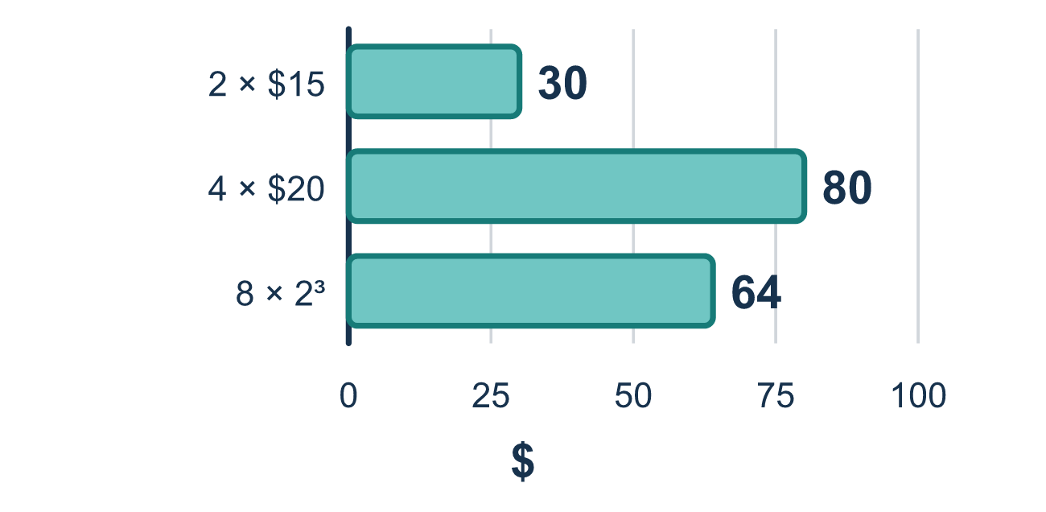
Our class model: one expression for the whole order

Try it
Work it out on paper. Write one answer on each line.
- In 6 + 3², which should you do first?
A. Find 3² B. Add 6 + 3 C. Multiply 3 × 2
My answer
- What is 2 + 3 × 4?
A. 20 B. 24 C. 14 D. 9
My answer
- What is 10 − 2²?
A. 64 B. 6 C. 8
My answer
- What is 3 × 2³?
A. 18 B. 216 C. 12 D. 24
My answer
- Which expression shows "four more than 5 squared"?
A. 4 + 5 × 2 B. 4 × 5² C. 4 + 5² D. (4 + 5)²
My answer
- What is 5 + 2 × 3²?
A. 63 B. 23 C. 41 D. 17
My answer

Talk about it
Which part of the expression do you evaluate first, and why?

Home mission
Imagine a ticket order: 3 tickets at $10 and 2 tickets at 2² dollars each. Ask your student to say the expression out loud, then the total. Which step comes first?

If we get stuck, ask
- Which stage comes first here?
- What does that exponent tell you to multiply?
- Did you multiply before you added?

Do it on a screen

Scan or type the link. Same lesson, with hints. eduwonderlab.com/lessons/6-4/homework.html
How did it feel? (optional) ☐ Tricky ☐ Getting there ☐ Got it

Family Math Studio · For grown-ups Lesson 6.4 · 6.AT.6c

Answers and talk notes
Write and Evaluate Numerical Expressions with Exponents

What your student is learning
Tonight we write one numerical expression for a whole situation and evaluate it using the order of operations, including powers like 2³.

Answers
Ask your student to explain before you look.
- A. Find 3². Find 3² first. Powers come before adding, so 6 + 3² = 6 + 9 = 15.
- C. 14. 2 + 3 × 4 = 2 + 12 = 14. Multiply before you add.
- B. 6. 10 − 2² = 10 − 4 = 6. Find the power first.
- D. 24. 3 × 2³ = 3 × 8 = 24. Find the power first, then multiply.
- C. 4 + 5². 4 + 5² means four more than 5 squared. The 5 is squared, then 4 is added.
- B. 23. 5 + 2 × 3² = 5 + 2 × 9 = 5 + 18 = 23.

Talk about it
Which part of the expression do you evaluate first, and why?

When they are stuck, ask
- Which stage comes first here?
- What does that exponent tell you to multiply?
- Did you multiply before you added?

Try not to say
- Just go left to right.
- 2³ means 2 times 3.
- The order doesn't really matter.

Home mission
Imagine a ticket order: 3 tickets at $10 and 2 tickets at 2² dollars each. Ask your student to say the expression out loud, then the total. Which step comes first?

