Family Math Studio Lesson 6.5 · Session 2 · 6.AT.6a

Write and Evaluate Algebraic Expressions
Put a number in for the letter, then find the value of an algebraic expression.
Name Date

Tonight's spark
A school store sells packs of 6 pencils. A student buys b packs, then gives away 9 pencils. The pencils left are 6b − 9. If b = 7, how many pencils are left? Make a guess first: are there more or fewer than 40 pencils left?
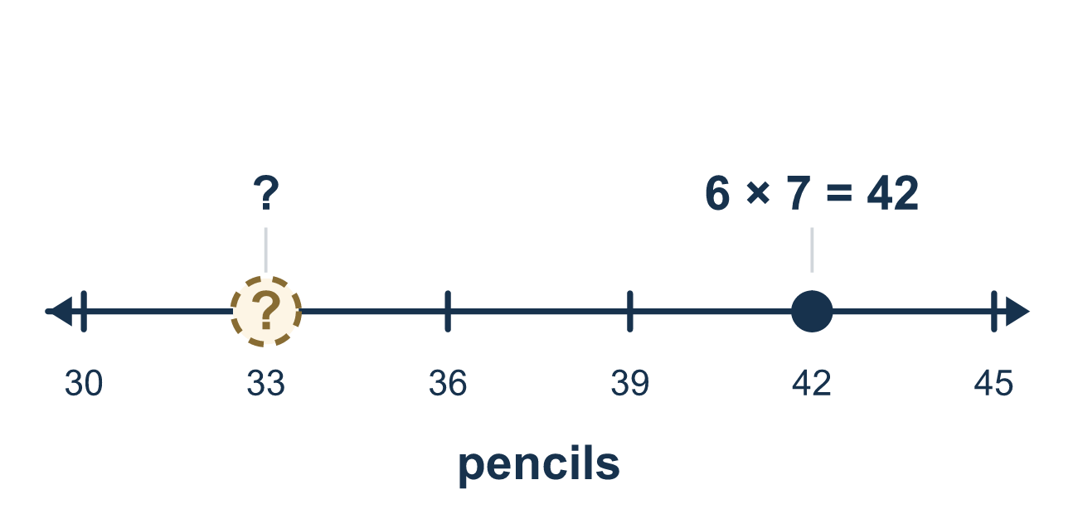
Our class model: substitute first, then calculate

Try it
Work it out on paper. Write one answer on each line.
- What does 5y mean?
A. 5 × y B. 5 + y C. y⁵ D. 5 and y side by side as digits
My answer
- To find the value of 4k when k = 3, which should you write?
A. 4 + 3 B. 43 C. 4 × 3 D. 4 ÷ 3
My answer
- What is the value of x + 8 when x = 5?
A. 3 B. 13 C. 40 D. 85
My answer
- What is the value of 3m when m = 6?
A. 9 B. 36 C. 63 D. 18
My answer
- What is the value of 2n + 5 when n = 4?
A. 13 B. 11 C. 29
My answer
- What is the value of 20 − 3w when w = 4?
A. 68 B. 21 C. 8 D. 12
My answer

Talk about it
What did you put in place of the letter, and what did you do first after that?

Home mission
Put 6 coins in each of 4 cups. Take away 9 coins. Ask your student to say 6b − 9 with b = 4, then count the coins left to check.

If we get stuck, ask
- What number goes in for the letter?
- Can you rewrite the whole expression with the number in it?
- Now which operation comes first?

Do it on a screen

Scan or type the link. Same lesson, with hints. eduwonderlab.com/lessons/6-5-part2/homework.html
How did it feel? (optional) ☐ Tricky ☐ Getting there ☐ Got it

Family Math Studio · For grown-ups Lesson 6.5 · Session 2 · 6.AT.6a

Answers and talk notes
Write and Evaluate Algebraic Expressions

What your student is learning
Tonight we take an algebraic expression, put a number in for the letter, and find its value.

Answers
Ask your student to explain before you look.
- A. 5 × y. 5y means 5 × y. A number written next to a letter is multiplication.
- C. 4 × 3. Write 4 × 3. Put 3 in place of k and multiply, so 4k = 12.
- B. 13. x + 8 = 5 + 8 = 13 when x = 5.
- D. 18. 3m = 3 × 6 = 18 when m = 6.
- A. 13. 2n + 5 = 2 × 4 + 5 = 8 + 5 = 13 when n = 4.
- C. 8. 20 − 3w = 20 − 3 × 4 = 20 − 12 = 8 when w = 4.

Talk about it
What did you put in place of the letter, and what did you do first after that?

When they are stuck, ask
- What number goes in for the letter?
- Can you rewrite the whole expression with the number in it?
- Now which operation comes first?

Try not to say
- 6b means 6 plus b.
- Calculate as you go, no need to rewrite.
- "9 less than x" means 9 − x.

Home mission
Put 6 coins in each of 4 cups. Take away 9 coins. Ask your student to say 6b − 9 with b = 4, then count the coins left to check.

