Family Math Studio Lesson 6.5 · 6.AT.6a

Write and Evaluate Algebraic Expressions
Write an algebraic expression for a situation and find its value.
Name Date

Tonight's spark
A concert charges $12 for each ticket plus one $50 fee, paid once. Nobody knows how many tickets the family will buy. Can one short line show the cost? Make a guess first: for 3 tickets, is the cost more or less than $80?
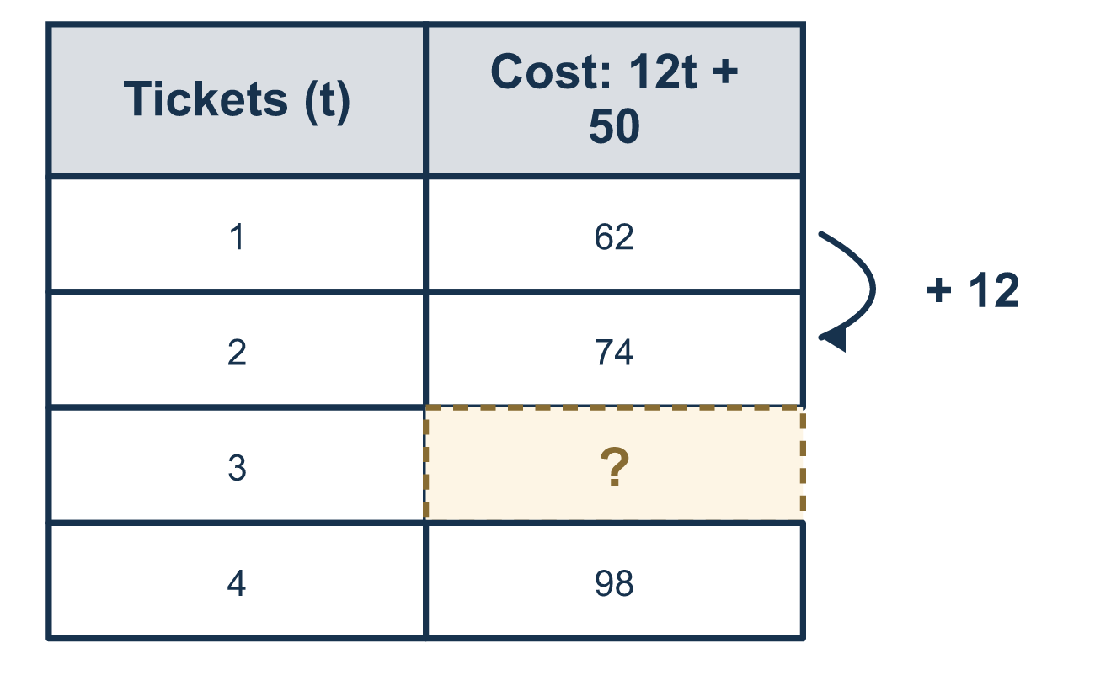
Our class model: a letter for the count

Try it
Work it out on paper. Write one answer on each line.
- In the expression 7n + 4, what is the coefficient?
A. n B. 4 C. 7 D. 11
My answer
- In the expression 3k + 8, which part is the constant?
A. 8 B. 3 C. k D. 11
My answer
- Which expression means "a number x increased by 6"?
A. 6x B. x − 6 C. 6 − x D. x + 6
My answer
- Each notebook costs $3. Let n be the number of notebooks. Which expression gives the total cost?
A. n + 3 B. 3n C. n ÷ 3 D. 3 − n
My answer
- What is the value of 4n + 1 when n = 5?
A. 9 B. 20 C. 21 D. 46
My answer
- A movie ticket costs $9 and a drink costs $3. Which expression gives the cost of t tickets and one drink?
A. 9 + 3t B. 9t + 3 C. 12t D. 9t + 3t
My answer

Talk about it
What does the letter stand for, and which number is multiplied by it?

Home mission
Pick a price from a ticket stub or a menu, like $8, and a one-time fee, like $10. Ask your student for the cost of 2 tickets, then 5. What stays the same? What changes?

If we get stuck, ask
- What key word do you see? Does it tell us to add, subtract, or multiply?
- Which number stays the same no matter what, and which one changes?
- Let's read the phrase out loud and write it one piece at a time.

Do it on a screen

Scan or type the link. Same lesson, with hints. eduwonderlab.com/lessons/6-5/homework.html
How did it feel? (optional) ☐ Tricky ☐ Getting there ☐ Got it

Family Math Studio · For grown-ups Lesson 6.5 · 6.AT.6a

Answers and talk notes
Write and Evaluate Algebraic Expressions

What your student is learning
Tonight we turn words into an algebraic expression, then evaluate it for a given number of students.

Answers
Ask your student to explain before you look.
- C. 7. In 7n + 4 the coefficient is 7, the number multiplied by the variable.
- A. 8. In 3k + 8 the constant is 8. It is the number with no variable, so it never changes.
- D. x + 6. x + 6 means x increased by 6. Increased by means add 6 to x.
- B. 3n. 3n is the total cost, because $3 is paid for each of the n notebooks.
- C. 21. 4n + 1 = 4 × 5 + 1 = 21 when n = 5.
- B. 9t + 3. 9t + 3 is the cost: $9 for each of the t tickets plus $3 once for the drink.

Talk about it
What does the letter stand for, and which number is multiplied by it?

When they are stuck, ask
- What key word do you see? Does it tell us to add, subtract, or multiply?
- Which number stays the same no matter what, and which one changes?
- Let's read the phrase out loud and write it one piece at a time.

Try not to say
- "5 less than a number" means 5 minus the number.
- Just put the numbers in the order you read them.
- A letter next to a number means add them.

Home mission
Pick a price from a ticket stub or a menu, like $8, and a one-time fee, like $10. Ask your student for the cost of 2 tickets, then 5. What stays the same? What changes?

