Family Math Studio Lesson 6.6 · Session 2 · 6.AT.7

Identify Equivalent Algebraic Expressions
Test whether two expressions are equivalent by putting the same number into both.
Name Date

Tonight's spark
A lunch combo is a sandwich that costs y dollars plus a $7 drink. Dani buys 2 combos and writes 2(y + 7). Kai writes 2y + 14. Do their costs match when y = 9? Make a guess first: will the two costs match?
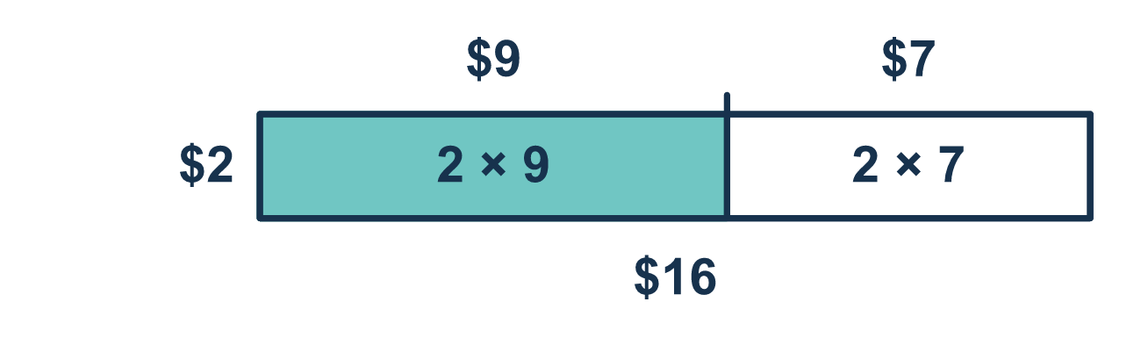
Our class model: test the same number in both

Try it
Work it out on paper. Write one answer on each line.
- What is the value of 3x + 1 when x = 4?
A. 13 B. 16 C. 35
My answer
- What is the value of 2(x + 5) when x = 3?
A. 11 B. 10 C. 16
My answer
- When x = 2, both 5x and x + 8 equal 10. What can you say?
A. They are equivalent for every x B. They match at x = 2, so test another number C. They are not equivalent because they look different D. They both equal 5
My answer
- Test x = 5. Do 2x + 4 and 6x give the same value?
A. Yes, both are 30 B. Yes, both are 14 C. No, 2x + 4 is 30 D. No, they are 14 and 30
My answer
- Test n = 4 in 3(n + 2) and 3n + 2. What are the two values?
A. 18 and 14 B. 14 and 14 C. 18 and 18 D. 12 and 14
My answer
- Which expression is equivalent to 2(m + 6)?
A. 2m + 6 B. m + 12 C. 2m + 12 D. 8m
My answer

Talk about it
When the two values are different, what does that tell you? If they match once, are you finished?

Home mission
Pretend a sandwich costs y dollars and a drink costs $7. Pick y = 5. Ask your student to find 2(5 + 7) and 2 × 5 + 14. Do they match? Why can one number not be enough proof?

If we get stuck, ask
- What number will you put into both expressions?
- Did the parentheses change what happens first?
- One test disagreed — is that enough to decide?

Do it on a screen

Scan or type the link. Same lesson, with hints. eduwonderlab.com/lessons/6-6-part2/homework.html
How did it feel? (optional) ☐ Tricky ☐ Getting there ☐ Got it

Family Math Studio · For grown-ups Lesson 6.6 · Session 2 · 6.AT.7

Answers and talk notes
Identify Equivalent Algebraic Expressions

What your student is learning
Tonight we TEST whether two expressions are equivalent — by putting the same number into both and comparing.

Answers
Ask your student to explain before you look.
- A. 13. 3x + 1 = 3 × 4 + 1 = 12 + 1 = 13 when x = 4.
- C. 16. 2(x + 5) = 2(3 + 5) = 2 × 8 = 16 when x = 3.
- B. They match at x = 2, so test another number. They match at x = 2, so test another number. One match is not enough to call them equivalent.
- D. No, they are 14 and 30. No, they are 14 and 30. When x = 5, 2x + 4 = 14 and 6x = 30.
- A. 18 and 14. 3(n + 2) = 3 × 6 = 18 and 3n + 2 = 12 + 2 = 14 when n = 4. The values are 18 and 14.
- C. 2m + 12. 2(m + 6) = 2m + 12. The 2 multiplies both m and 6, so 2m + 12 is equivalent.

Talk about it
When the two values are different, what does that tell you? If they match once, are you finished?

When they are stuck, ask
- What number will you put into both expressions?
- Did the parentheses change what happens first?
- One test disagreed — is that enough to decide?

Try not to say
- If it works for one number, they are equivalent.
- 3x + 2x is 5x squared.
- Test with x = 1, it is the easiest.

Home mission
Pretend a sandwich costs y dollars and a drink costs $7. Pick y = 5. Ask your student to find 2(5 + 7) and 2 × 5 + 14. Do they match? Why can one number not be enough proof?

