Family Math Studio Lesson 6.6 · 6.AT.7

Identify Equivalent Algebraic Expressions
Show two expressions are equivalent by combining like terms or testing a number.
Name Date

Tonight's spark
A party costs $3 per guest for food, $2 per guest for drinks, and $10 for decorations. Dee writes 3x + 2x + 10. Eli writes 5x + 10. Do they always get the same cost? Make a guess first: with 4 guests, will Dee and Eli match?
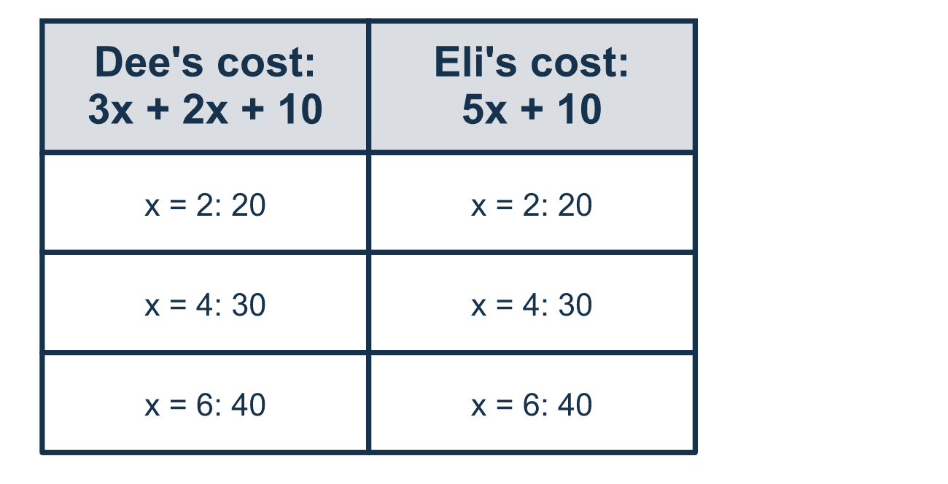
Our class model: test a number, then combine like terms

Try it
Work it out on paper. Write one answer on each line.
- In 4x + 3 + 2x, which terms are like terms?
A. 4x and 3 B. 4x and 2x C. 3 and 2x D. 4x + 3 and 2x
My answer
- Combine the like terms: 6y + 2y.
A. 12y B. 8 C. 62y D. 8y
My answer
- Simplify 5a + 3 + 2a.
A. 7a + 3 B. 10a + 3 C. 7a D. 15a
My answer
- Which expression is equivalent to 4n + n?
A. 4n² B. 4n C. 5n D. 5
My answer
- What is the value of 2x + 4 when x = 3?
A. 9 B. 10 C. 27
My answer

Talk about it
Do the two columns give the same value in every row? What do the like terms 4x and 2x combine to?

Home mission
Say a number of party guests, like 3. Ask your student to work out Dee's cost and Eli's cost out loud. Do they match? Try one more number.

If we get stuck, ask
- Which terms have the same letter? Those are the ones we can combine.
- Let's put the same number in for the letter in both and see if they match.
- When we combine like terms, we add the numbers in front and keep the letter.

Do it on a screen

Scan or type the link. Same lesson, with hints. eduwonderlab.com/lessons/6-6/homework.html
How did it feel? (optional) ☐ Tricky ☐ Getting there ☐ Got it

Family Math Studio · For grown-ups Lesson 6.6 · 6.AT.7

Answers and talk notes
Identify Equivalent Algebraic Expressions

What your student is learning
Tonight we learn when two expressions are equivalent. Equivalent means they always give the same answer, even when they look different.

Answers
Ask your student to explain before you look.
- B. 4x and 2x. 4x and 2x are like terms, because both have the variable x.
- D. 8y. 6y + 2y = 8y. Add the numbers in front of the y and keep the y.
- A. 7a + 3. 5a + 3 + 2a = 7a + 3. Combine 5a and 2a, and keep the 3.
- C. 5n. 4n + n = 5n, because n means 1n and 4 + 1 = 5.
- B. 10. 2x + 4 = 2 × 3 + 4 = 6 + 4 = 10 when x = 3.

Talk about it
Do the two columns give the same value in every row? What do the like terms 4x and 2x combine to?

When they are stuck, ask
- Which terms have the same letter? Those are the ones we can combine.
- Let's put the same number in for the letter in both and see if they match.
- When we combine like terms, we add the numbers in front and keep the letter.

Try not to say
- 2x + 3 can combine into 5x.
- If they match for one number, they are always equivalent.
- When you add 3x + 2x you get 5x² (change the little number).

Home mission
Say a number of party guests, like 3. Ask your student to work out Dee's cost and Eli's cost out loud. Do they match? Try one more number.

