Family Math Studio Lesson 6.7 · Session 2 · 6.NOS.4

Find Factors and Multiples
Find the least common multiple to tell when two repeating things happen together.
Name Date

Tonight's spark
Two city buses leave the same stop at 8:00. One leaves every 6 minutes. The other leaves every 9 minutes. When do they leave together again? Make a guess first: is it sooner than 10 minutes, or later?
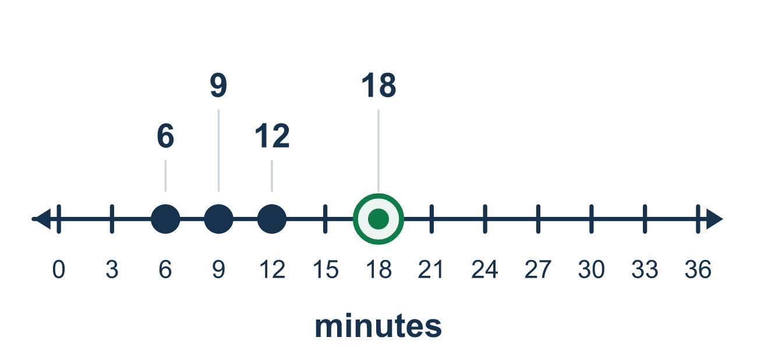
Our class model: skip-count both lists, find the first match

Try it
Work it out on paper. Write one answer on each line.
- Which list shows the first four multiples of 5?
A. 5, 6, 7, 8 B. 1, 5, 25, 125 C. 5, 10, 15, 20
My answer
- Which number is a multiple of both 3 and 4?
A. 12 B. 8 C. 9 D. 7
My answer
- Multiples of 3: 3, 6, 9, 12, 15. Multiples of 5: 5, 10, 15, 20. What is the LCM of 3 and 5?
A. 30 B. 8 C. 3 D. 15
My answer
- What is the LCM of 2 and 9?
A. 11 B. 18 C. 9 D. 36
My answer
- What is the LCM of 6 and 10?
A. 60 B. 16 C. 30 D. 2
My answer
- One bus leaves every 9 minutes and another every 12 minutes. They leave together at 8:00. After how many minutes do they leave together again?
A. 36 B. 108 C. 21 D. 3
My answer

Talk about it
Which number is the first one in both lists? What does it tell you about when the two patterns meet?

Home mission
Skip-count out loud. Your student says every 3rd number and you say every 4th number. Which number do you both say first? That number is the LCM of 3 and 4.

If we get stuck, ask
- What numbers do you land on skip-counting by this one?
- What is the first number that shows up in both lists?
- Is this question about sharing into groups, or about repeating cycles?

Do it on a screen

Scan or type the link. Same lesson, with hints. eduwonderlab.com/lessons/6-7-part2/homework.html
How did it feel? (optional) ☐ Tricky ☐ Getting there ☐ Got it

Family Math Studio · For grown-ups Lesson 6.7 · Session 2 · 6.NOS.4

Answers and talk notes
Find Factors and Multiples

What your student is learning
Tonight we find the LEAST COMMON MULTIPLE — the first number two counting patterns land on together.

Answers
Ask your student to explain before you look.
- C. 5, 10, 15, 20. 5, 10, 15, 20 are the first four multiples of 5. Skip count by 5.
- A. 12. 12 is a multiple of both: 3 × 4 = 12 and 4 × 3 = 12.
- D. 15. The LCM of 3 and 5 is 15. It is the first number to show up in both lists.
- B. 18. The LCM of 2 and 9 is 18. It is the first multiple of 9 that is also even.
- C. 30. The LCM of 6 and 10 is 30. Multiples of 6: 6, 12, 18, 24, 30. Multiples of 10: 10, 20, 30.
- A. 36. The LCM of 9 and 12 is 36, so the buses leave together again after 36 minutes.

Talk about it
Which number is the first one in both lists? What does it tell you about when the two patterns meet?

When they are stuck, ask
- What numbers do you land on skip-counting by this one?
- What is the first number that shows up in both lists?
- Is this question about sharing into groups, or about repeating cycles?

Try not to say
- Multiply the two numbers, that is the LCM.
- Factors and multiples are basically the same.
- The LCM is always the bigger number.

Home mission
Skip-count out loud. Your student says every 3rd number and you say every 4th number. Which number do you both say first? That number is the LCM of 3 and 4.

