Family Math Studio Lesson 6.7 · 6.NOS.4

Find Factors and Multiples
Find the greatest common factor to split things into equal groups with none left over.
Name Date

Tonight's spark
A school store has 48 pencils and 36 notebooks. The manager wants identical combo packs with nothing left over. What is the most packs she can make? Make a guess first: can she make more or fewer than 10 packs?
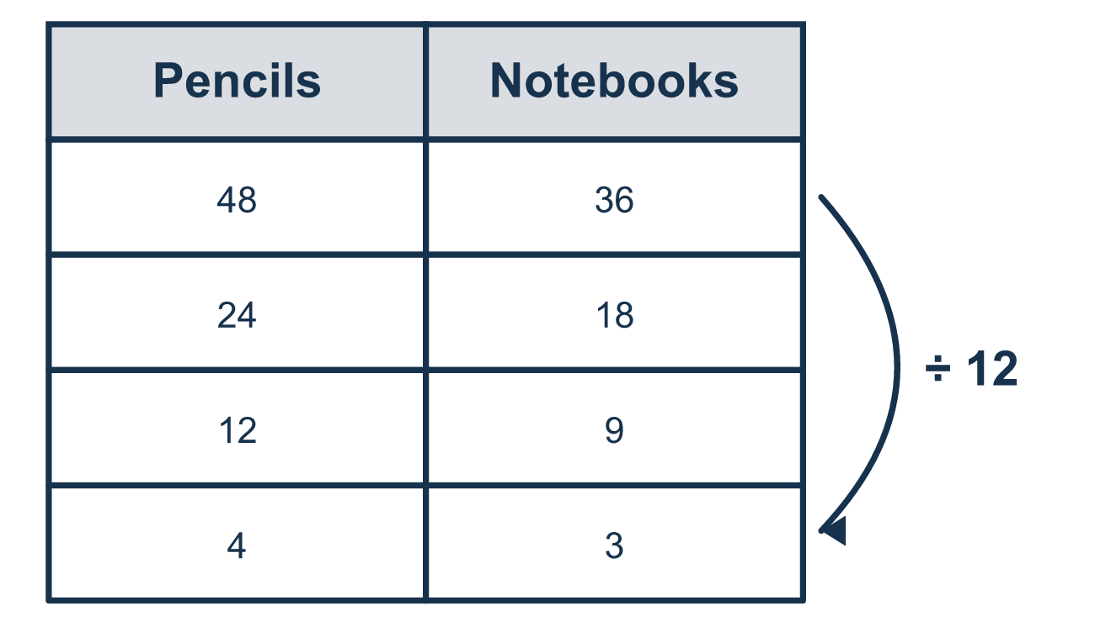
Our class model: list factors, find the greatest shared one

Try it
Work it out on paper. Write one answer on each line.
- Which number is a factor of 18?
A. 4 B. 6 C. 36 D. 0
My answer
- Which number is a multiple of 7?
A. 17 B. 27 C. 71 D. 42
My answer
- What is the GCF of 12 and 18?
A. 6 B. 3 C. 36 D. 2
My answer
- What is the LCM of 4 and 10?
A. 2 B. 40 C. 20 D. 14
My answer
- A teacher has 24 pencils and 36 erasers. She makes identical kits with nothing left over. What is the greatest number of kits?
A. 6 B. 12 C. 72
My answer

Talk about it
Which shared factor gives the most packs?

Home mission
Grab two small piles, like 12 coins and 18 buttons. Ask your student: what is the most identical piles you can make with nothing left over? How many of each go in a pile?

If we get stuck, ask
- Is something being split up, or repeating?
- What divides both numbers evenly?
- What is the first number both lists share?

Do it on a screen

Scan or type the link. Same lesson, with hints. eduwonderlab.com/lessons/6-7/homework.html
How did it feel? (optional) ☐ Tricky ☐ Getting there ☐ Got it

Family Math Studio · For grown-ups Lesson 6.7 · 6.NOS.4

Answers and talk notes
Find Factors and Multiples

What your student is learning
Tonight we work with factors and multiples: the greatest common factor (GCF) for splitting things into equal groups, and the least common multiple (LCM) for finding when two repeating things line up.

Answers
Ask your student to explain before you look.
- B. 6. 6 is a factor of 18, because 18 ÷ 6 = 3 with nothing left over.
- D. 42. 42 is a multiple of 7, because 7 × 6 = 42.
- A. 6. The GCF of 12 and 18 is 6. It is the largest number that divides both.
- C. 20. The LCM of 4 and 10 is 20. It is the first number in both lists of multiples.
- B. 12. The GCF of 24 and 36 is 12, so she can make 12 kits.

Talk about it
Which shared factor gives the most packs?

When they are stuck, ask
- Is something being split up, or repeating?
- What divides both numbers evenly?
- What is the first number both lists share?

Try not to say
- Just multiply the two numbers together.
- Factors and multiples are the same thing.
- Skip the 1 — it doesn't count.

Home mission
Grab two small piles, like 12 coins and 18 buttons. Ask your student: what is the most identical piles you can make with nothing left over? How many of each go in a pile?

