Family Math Studio Lesson 6.8 · Session 2 · 6.AT.7

Generate Equivalent Expressions
Expand to remove parentheses, or factor by pulling out the greatest common factor.
Name Date

Tonight's spark
A rug is 3 feet tall and made of two strips. One strip covers 15 square feet. The other covers 12 square feet. How wide is the whole rug? Guess first: is the rug wider than 5 feet, or narrower?
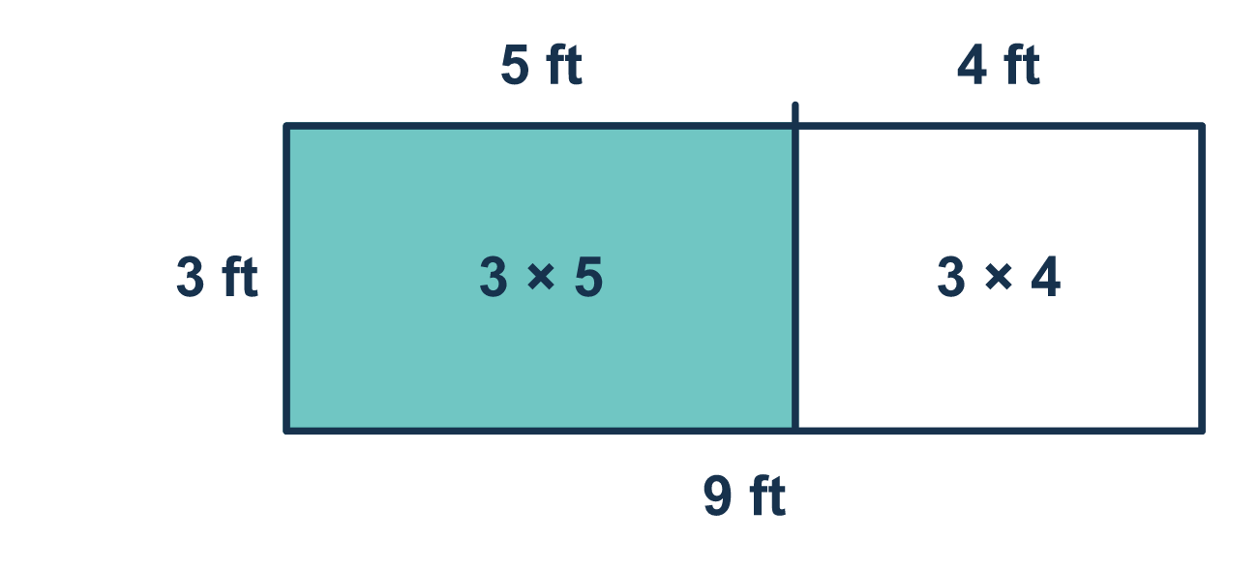
Our class model: pull out the GCF

Try it
Work it out on paper. Write one answer on each line.
- Expand 3(x + 2).
A. 3x + 2 B. 3x + 5 C. 3x + 6 D. x + 6
My answer
- Which expression equals 5(2 + 7)?
A. 5 × 2 + 5 × 7 B. 5 × 2 + 7 C. 2 + 5 × 7 D. 5 + 2 + 7
My answer
- What is the greatest common factor (GCF) of 12 and 18?
A. 3 B. 6 C. 2 D. 36
My answer
- Expand 2(4x + 3).
A. 8x + 3 B. 4x + 6 C. 8x + 5 D. 8x + 6
My answer
- Factor 8x + 12 using the greatest common factor.
A. 4(2x + 3) B. 2(4x + 6) C. 4(2x + 12) D. 12(x + 1)
My answer
- A rug is 3 feet tall. Its width is split into a part x feet wide and a part 4 feet wide. Which expression shows the total area as the sum of the two parts?
A. 3x + 4 B. x + 12 C. 3x + 12 D. 3 + x + 4
My answer

Talk about it
Did the outside number reach every term inside the parentheses? What is the greatest common factor (GCF) of the two terms?

Home mission
Set out 4 plates. Put 3 crackers and 2 grapes on each. Can your student say the total two ways, 4(3 + 2) and 4 × 3 + 4 × 2? Then push the food together: 12 crackers and 8 grapes. What number is shared by both?

If we get stuck, ask
- Did the outside number reach every term inside?
- What is the biggest number that divides both terms?
- Can you check by doing the opposite move?

Do it on a screen

Scan or type the link. Same lesson, with hints. eduwonderlab.com/lessons/6-8-part2/homework.html
How did it feel? (optional) ☐ Tricky ☐ Getting there ☐ Got it

Family Math Studio · For grown-ups Lesson 6.8 · Session 2 · 6.AT.7

Answers and talk notes
Generate Equivalent Expressions

What your student is learning
Tonight we do two opposite moves: EXPANDING removes parentheses, and FACTORING puts them back.

Answers
Ask your student to explain before you look.
- C. 3x + 6. The 3 reaches both terms: 3 × x + 3 × 2 = 3x + 6.
- A. 5 × 2 + 5 × 7. The outside 5 multiplies each term inside: 5(2 + 7) = 5 × 2 + 5 × 7.
- B. 6. The largest number that divides both 12 and 18 is 6.
- D. 8x + 6. Multiply each term by 2: 2 × 4x = 8x and 2 × 3 = 6, so 8x + 6.
- A. 4(2x + 3). The GCF of 8 and 12 is 4, and 8x ÷ 4 = 2x and 12 ÷ 4 = 3, so 4(2x + 3).
- C. 3x + 12. The two parts have areas 3 × x = 3x and 3 × 4 = 12, so the total is 3x + 12.

Talk about it
Did the outside number reach every term inside the parentheses? What is the greatest common factor (GCF) of the two terms?

When they are stuck, ask
- Did the outside number reach every term inside?
- What is the biggest number that divides both terms?
- Can you check by doing the opposite move?

Try not to say
- Multiply the outside number by the first term only.
- Any shared factor works, it does not have to be the greatest.
- Expanding and factoring are unrelated skills.

Home mission
Set out 4 plates. Put 3 crackers and 2 grapes on each. Can your student say the total two ways, 4(3 + 2) and 4 × 3 + 4 × 2? Then push the food together: 12 crackers and 8 grapes. What number is shared by both?

