Family Math Studio Lesson 6.8 · 6.AT.7

Generate Equivalent Expressions
Use the order, grouping and identity properties to write equal expressions.
Name Date

Tonight's spark
A rec-center band has 3 guitarists, 5 drummers and 2 keyboard players. Ana counts 3 + 5 + 2. Ben counts 5 + 3 + 2. Will they get the same total? Guess first: will Ana and Ben match? Is the band more or less than 8 people?
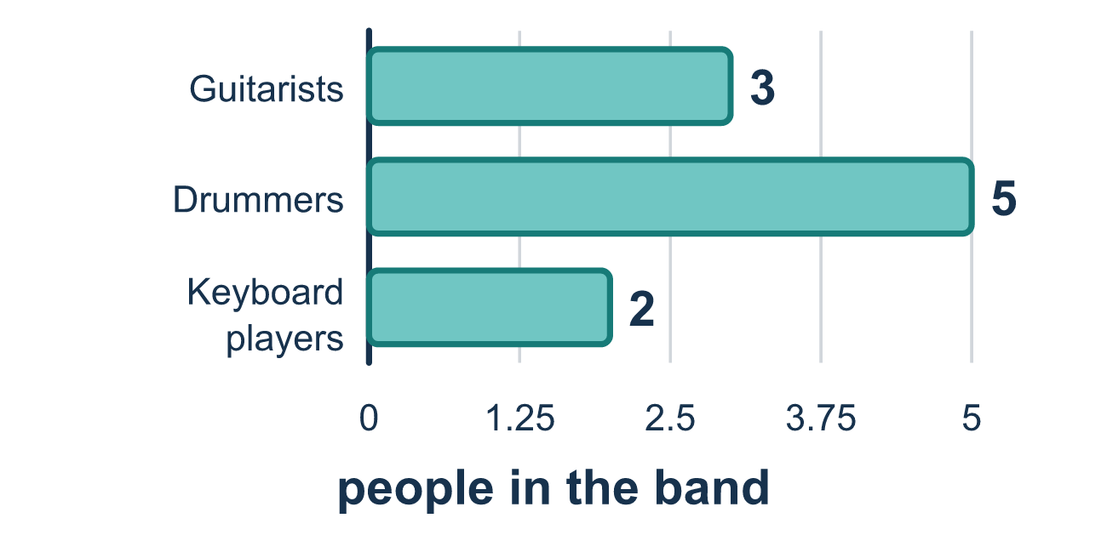
Our class model: the order and grouping rules

Try it
Work it out on paper. Write one answer on each line.
- Which equation shows the Commutative Property?
A. (7 + 4) + 2 = 7 + (4 + 2) B. 7 + 4 = 4 + 7 C. 7 + 0 = 7 D. 7 − 4 = 4 − 7
My answer
- What number makes this true? 12 + 9 = 9 + ___
A. 12 B. 21 C. 3 D. 9
My answer
- Which number makes this true? 48 + ___ = 48
A. 1 B. 48 C. 96 D. 0
My answer
- Which property is shown? (3 + 8) + 2 = 3 + (8 + 2)
A. Commutative Property B. Identity Property C. Associative Property D. Distributive Property
My answer
- Use the properties to find 5 + 18 + 15. What is the total?
A. 23 B. 38 C. 33
My answer
- Use the properties to find 4 × 9 × 5. What is the product?
A. 180 B. 36 C. 45 D. 18
My answer

Talk about it
Which property did you use: did you change the order (Commutative) or the grouping (Associative)? Did the total change?

Home mission
Line up 3 forks, 5 spoons and 2 cups. Count them 3 + 5 + 2. Now start with the spoons. Does the total change? Then try 5 − 2 and 2 − 5 with spoons and cups. Which order works?

If we get stuck, ask
- Did the order of the numbers change, or did the parentheses move?
- Let's add both ways and see if we get the same total.
- Is this adding or multiplying? The properties only work for those two.

Do it on a screen

Scan or type the link. Same lesson, with hints. eduwonderlab.com/lessons/6-8/homework.html
How did it feel? (optional) ☐ Tricky ☐ Getting there ☐ Got it

Family Math Studio · For grown-ups Lesson 6.8 · 6.AT.7

Answers and talk notes
Generate Equivalent Expressions

What your student is learning
Tonight we learn math rules called properties. They let us change the order or the grouping of numbers without changing the answer.

Answers
Ask your student to explain before you look.
- B. 7 + 4 = 4 + 7. 7 + 4 = 4 + 7 swaps the order of the two numbers, and the sum stays 11.
- A. 12. The Commutative Property lets 12 + 9 trade places to 9 + 12, so the blank is 12.
- D. 0. The Identity Property says adding 0 leaves a number the same, so 48 + 0 = 48.
- C. Associative Property. The grouping changed from (3 + 8) + 2 to 3 + (8 + 2), so this is the Associative Property.
- B. 38. Regroup to make a friendly ten: (5 + 15) + 18 = 20 + 18 = 38.
- A. 180. Swap and regroup: (4 × 5) × 9 = 20 × 9 = 180.

Talk about it
Which property did you use: did you change the order (Commutative) or the grouping (Associative)? Did the total change?

When they are stuck, ask
- Did the order of the numbers change, or did the parentheses move?
- Let's add both ways and see if we get the same total.
- Is this adding or multiplying? The properties only work for those two.

Try not to say
- Order never matters in math.
- If there are parentheses, it must be the commutative property.
- You can switch the order in subtraction too.

Home mission
Line up 3 forks, 5 spoons and 2 cups. Count them 3 + 5 + 2. Now start with the spoons. Does the total change? Then try 5 − 2 and 2 − 5 with spoons and cups. Which order works?

