Family Math Studio Lesson 6.9 · Session 2 · 6.NOS.1

Divide Whole Numbers by Fractions
Solve a real problem by dividing a whole number by a fraction and checking the answer is bigger.
Name Date

Tonight's spark
An animal shelter gets 6 pounds of dog treats. It packs them in bags of 2/3 pound each. How many bags will the shelter have? Guess first: will the shelter have more than 6 bags, or fewer?
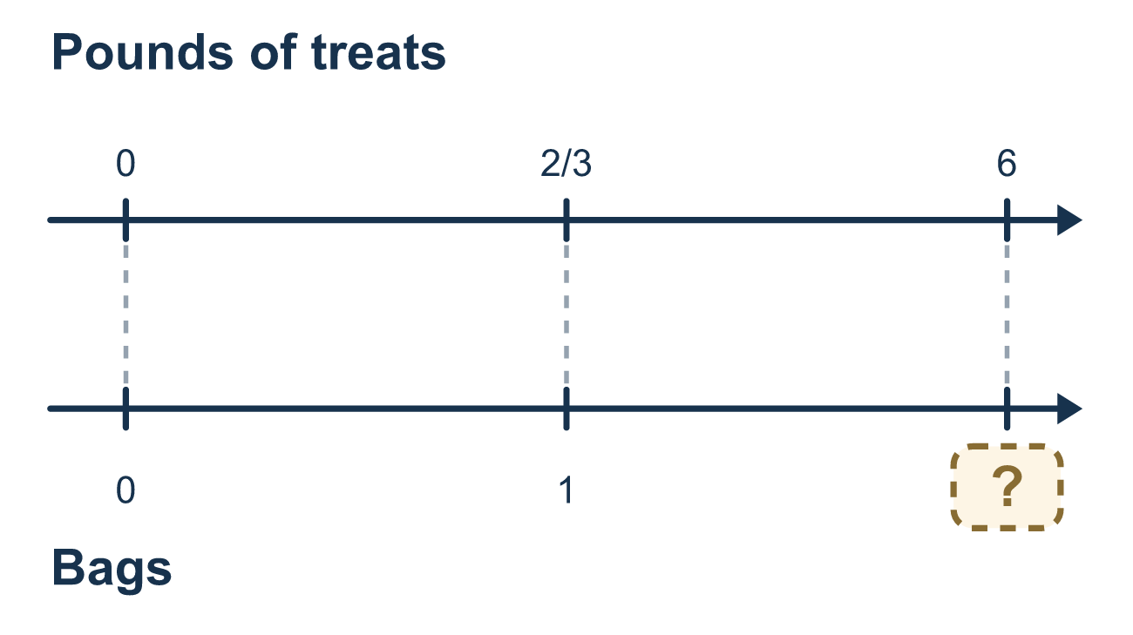
Our class model: put the whole number over 1

Try it
Work it out on paper. Write one answer on each line.
- When you divide a whole number by a fraction less than 1, the answer is...
A. smaller than the whole number B. exactly the same as the whole number C. bigger than the whole number
My answer
- 6 pounds of rice go into bags that each hold 2/3 pound. Which division sentence fits?
A. 6 ÷ 2/3 B. 2/3 ÷ 6 C. 6 × 2/3 D. 6 − 2/3
My answer
- Find 9 ÷ 3/4.
A. 27/4 B. 12 C. 6 D. 36
My answer
- Find 10 ÷ 5/6.
A. 8 1/3 B. 16 C. 60 D. 12
My answer
- A hose fills buckets that each hold 3/4 gallon. How many buckets can it fill with 6 gallons?
A. 8 B. 4 1/2 C. 9
My answer

Talk about it
Should the answer be more than 4 or less than 4? How do you know?

Home mission
Pour 3 cups of dry beans into a bowl. Find a 1/3-cup scoop. Guess first: more or fewer than 3 scoops? Then scoop and count. Does the count match 3 ÷ 1/3?

If we get stuck, ask
- How many of those fit into this? Say it in words first.
- Did you flip the second fraction?
- Is the divisor less than 1? Then which way should the answer go?

Do it on a screen

Scan or type the link. Same lesson, with hints. eduwonderlab.com/lessons/6-9-part2/homework.html
How did it feel? (optional) ☐ Tricky ☐ Getting there ☐ Got it

Family Math Studio · For grown-ups Lesson 6.9 · Session 2 · 6.NOS.1

Answers and talk notes
Divide Whole Numbers by Fractions

What your student is learning
Tonight we divide a whole number by a fraction in a real counting problem — how many small bags a big amount fills.

Answers
Ask your student to explain before you look.
- C. bigger than the whole number. Small pieces fit more times, so the answer is bigger than the whole number.
- A. 6 ÷ 2/3. The whole amount (6 pounds) is split into bags of 2/3 pound, so 6 ÷ 2/3.
- B. 12. Flip 3/4 to 4/3: 9 × 4/3 = 36/3 = 12.
- D. 12. Flip 5/6 to 6/5: 10 × 6/5 = 60/5 = 12.
- A. 8. 6 ÷ 3/4 = 6 × 4/3 = 24/3 = 8 buckets.

Talk about it
Should the answer be more than 4 or less than 4? How do you know?

When they are stuck, ask
- How many of those fit into this? Say it in words first.
- Did you flip the second fraction?
- Is the divisor less than 1? Then which way should the answer go?

Try not to say
- Keep, Change — that is enough.
- Dividing always gives a smaller answer.
- Flip whichever fraction looks easier.

Home mission
Pour 3 cups of dry beans into a bowl. Find a 1/3-cup scoop. Guess first: more or fewer than 3 scoops? Then scoop and count. Does the count match 3 ÷ 1/3?

