Family Math Studio Lesson 6.9 · 6.NOS.1

Divide Whole Numbers by Fractions
Divide a whole number by a fraction by asking how many pieces fit.
Name Date

Tonight's spark
A corner store has 4 pounds of rice. Each bag holds 1/2 pound. How many bags can the store fill? Guess first: will it be fewer than 4 bags, or more?
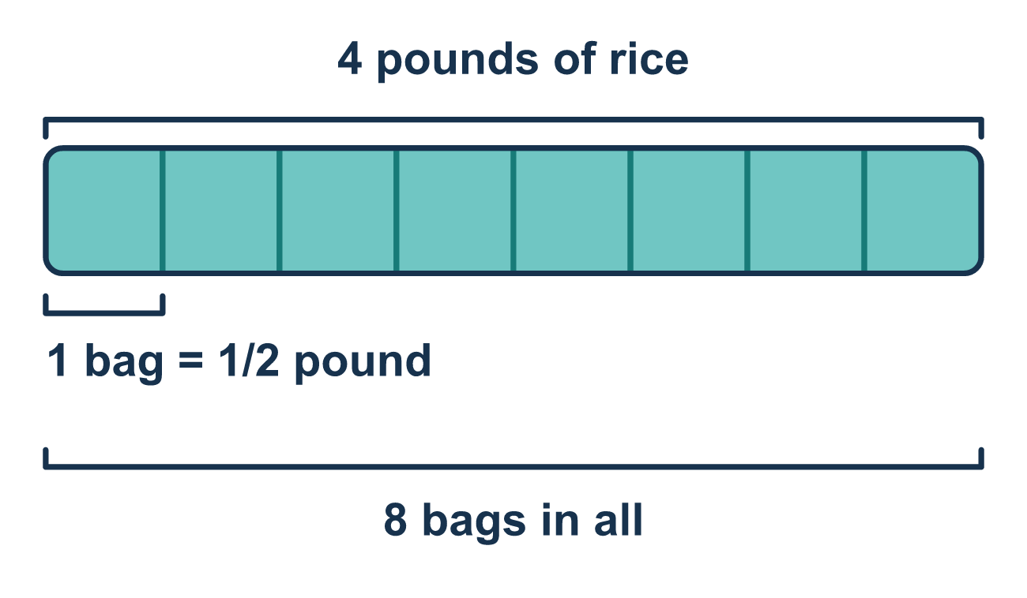
Our class model: Keep, Change, Flip

Try it
Work it out on paper. Write one answer on each line.
- What is the reciprocal of 2/3?
A. 2/3 B. 3/2 C. 5/3
My answer
- How many 1/3s fit in 2 wholes?
A. 6 B. 2/3 C. 5 D. 3
My answer
- Which is the Keep, Change, Flip rewrite of 5 ÷ 1/4?
A. 5 × 1/4 B. 5 ÷ 4 C. 1/5 × 4 D. 5 × 4/1
My answer
- Find 7 ÷ 1/2.
A. 14 B. 3 1/2 C. 9 D. 5
My answer
- Find 8 ÷ 2/3.
A. 16/3 B. 12 C. 10 D. 24
My answer
- A scoop holds 1/4 pound. How many scoops can you fill from a 5-pound bag?
A. 1 1/4 B. 9 C. 20
My answer

Talk about it
Are half-pound bags big or small? Should the store fill more than 4 bags, or fewer?

Home mission
Find a 1/2-cup scoop and a big bowl. Ask first: will it take more or fewer than 3 scoops to measure 3 cups? Then scoop rice or water and count.

If we get stuck, ask
- Which fraction do we flip — and which number stays the same?
- Once we flip, what multiplication problem do we have now?
- Should the answer be bigger or smaller than the whole number? Why?

Do it on a screen

Scan or type the link. Same lesson, with hints. eduwonderlab.com/lessons/6-9/homework.html
How did it feel? (optional) ☐ Tricky ☐ Getting there ☐ Got it

Family Math Studio · For grown-ups Lesson 6.9 · 6.NOS.1

Answers and talk notes
Divide Whole Numbers by Fractions

What your student is learning
Tonight we learn a quick trick to divide a whole number by a fraction. It is called Keep, Change, Flip.

Answers
Ask your student to explain before you look.
- B. 3/2. Flip the fraction: the top and bottom trade places, so the reciprocal of 2/3 is 3/2.
- A. 6. Each whole holds 3 thirds, so 2 wholes hold 2 × 3 = 6 thirds.
- D. 5 × 4/1. Keep the 5, change ÷ to ×, and flip 1/4 to 4/1: 5 × 4/1.
- A. 14. Flip 1/2 to 2 and multiply: 7 × 2 = 14, since each whole holds 2 halves.
- B. 12. Flip 2/3 to 3/2: 8 × 3/2 = 24/2 = 12.
- C. 20. 5 ÷ 1/4 = 5 × 4 = 20 scoops, since each pound holds 4 quarter-pound scoops.

Talk about it
Are half-pound bags big or small? Should the store fill more than 4 bags, or fewer?

When they are stuck, ask
- Which fraction do we flip — and which number stays the same?
- Once we flip, what multiplication problem do we have now?
- Should the answer be bigger or smaller than the whole number? Why?

Try not to say
- Flip the whole number too.
- Just multiply by the fraction without flipping it.
- Dividing always makes the answer smaller.

Home mission
Find a 1/2-cup scoop and a big bowl. Ask first: will it take more or fewer than 3 scoops to measure 3 cups? Then scoop rice or water and count.

