Family Math Studio Lesson 7.1 · Session 2 · 6.NOS.5

Explore Integers and Their Opposites
Write integers for gains, losses, above and below, and say what zero means.
Name Date

Tonight's spark
In a board game, your score is −58. One card says: change your score to its opposite. A second card says the same thing. What is your score now? Guess first: will your score end positive or negative?
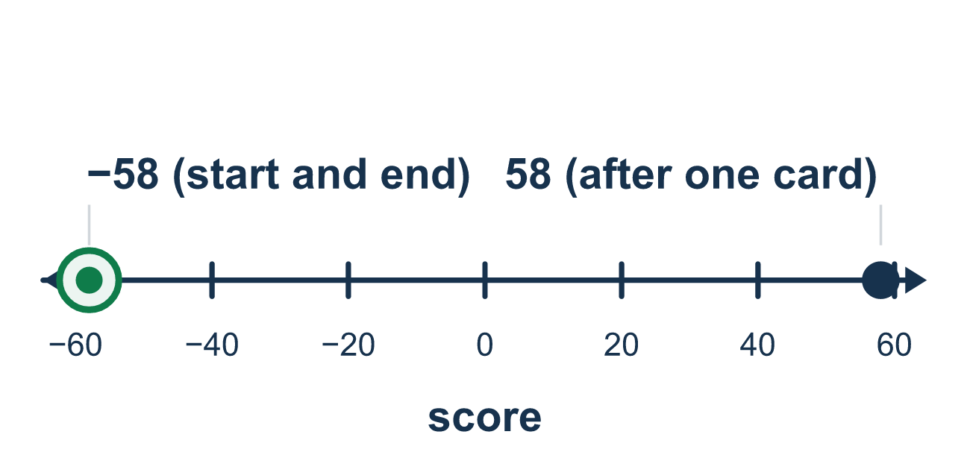
Our class model: flipping to the opposite

Try it
Work it out on paper. Write one answer on each line.
- A savings account drops by $15. Which integer shows that change?
A. 15 B. −15 C. 0 D. 1.5
My answer
- What is the opposite of 27?
A. −27 B. 27 C. 0 D. 1/27
My answer
- Maya gains 9 points and then loses 9 points. What is the total change?
A. 18 B. −18 C. 9 D. 0
My answer
- Which situation matches −5?
A. 5 degrees above zero B. 5 dollars earned C. 5 feet below the ground D. 5 points gained
My answer
- What is the opposite of the opposite of −33?
A. 33 B. −33 C. 0 D. −66
My answer
- A cave is 30 meters under the ground. The ground is 0. Which integer shows the cave?
A. −30 B. 30 C. 0 D. −3
My answer

Talk about it
After two flips across 0, where do you end up? What does that tell you?

Home mission
Write −58 on one side of a paper and 58 on the other. Flip it three times. Can your student say what shows, and why?

If we get stuck, ask
- How far from zero is it, and which side is it on?
- What does zero mean in this story?
- Is this a gain or a loss? Up or down?

Do it on a screen

Scan or type the link. Same lesson, with hints. eduwonderlab.com/lessons/7-1-part2/homework.html
How did it feel? (optional) ☐ Tricky ☐ Getting there ☐ Got it

Family Math Studio · For grown-ups Lesson 7.1 · Session 2 · 6.NOS.5

Answers and talk notes
Explore Integers and Their Opposites

What your student is learning
Tonight we write integers for real situations — gains and losses, above and below — and say what ZERO means in each one.

Answers
Ask your student to explain before you look.
- B. −15. A loss is negative, so the change is −15.
- A. −27. The opposite of 27 is −27. Both are 27 units from 0.
- D. 0. A gain of 9 and a loss of 9 cancel, so the total change is 0.
- C. 5 feet below the ground. Below the ground is negative, so 5 feet below the ground is −5.
- B. −33. The first opposite is 33, and the opposite of 33 is −33. Two flips return to the start.
- A. −30. Under the ground is below 0, so the cave is −30.

Talk about it
After two flips across 0, where do you end up? What does that tell you?

When they are stuck, ask
- How far from zero is it, and which side is it on?
- What does zero mean in this story?
- Is this a gain or a loss? Up or down?

Try not to say
- The opposite of a negative is still negative.
- Negative numbers are just numbers with a minus in front, ignore it.
- −12 is bigger than −3 because 12 is bigger.

Home mission
Write −58 on one side of a paper and 58 on the other. Flip it three times. Can your student say what shows, and why?

