Family Math Studio Lesson 7.1 · 6.NOS.5

Explore Integers and Their Opposites
Use integers for real situations and name the opposite of a number.
Name Date

Tonight's spark
A park sign says Badwater Basin is 86 meters below sea level. Sea level is the starting point, 0. What number should the sign use? Guess first: is the number above 0 or below 0?
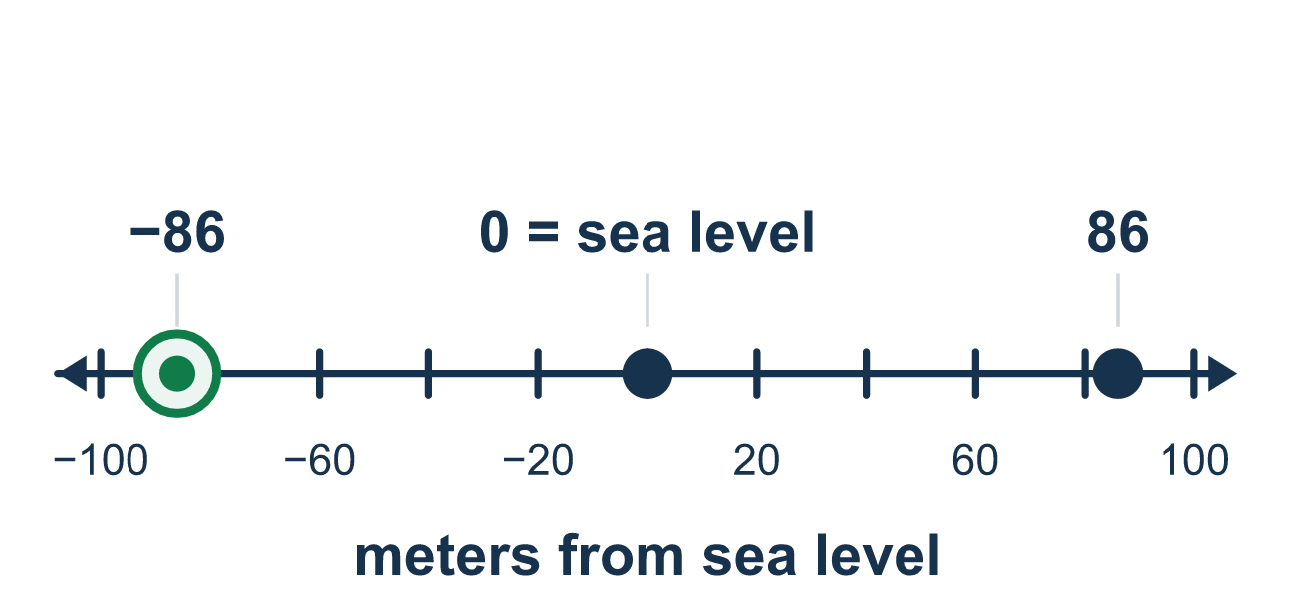
Our class model: zero and the number line

Try it
Work it out on paper. Write one answer on each line.
- Which integer shows 8 degrees below zero?
A. 8 B. −8 C. 0
My answer
- What is the opposite of 6?
A. −6 B. 6 C. 1/6 D. 0
My answer
- A bank account goes up by $20. Which integer shows the change?
A. −20 B. 0 C. −2 D. 20
My answer
- A submarine is at −30 meters. What does 0 stand for?
A. The bottom of the ocean B. Sea level C. 30 meters up D. The speed of the submarine
My answer
- What is the opposite of −15?
A. −15 B. −5 C. 15 D. 0
My answer
- A point is 7 units to the left of 0 on the number line. Which integer is it?
A. 7 B. 1/7 C. −7 D. 0
My answer

Talk about it
What does 0 mean in this story? Which side of 0 is the number on, and what is its opposite?

Home mission
Say the kitchen floor is sea level, 0. The pantry is 3 steps below it. Can your student say the integer, then its opposite?

If we get stuck, ask
- What does 0 stand for in this story? Start there.
- Is this amount above 0 or below 0? That decides the sign.
- How many units from 0 is it? Jump that same distance the other way to find the opposite.

Do it on a screen
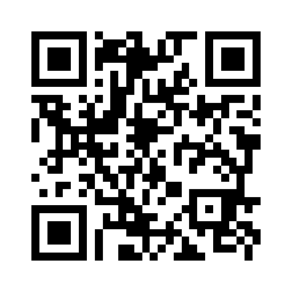
Scan or type the link. Same lesson, with hints. eduwonderlab.com/lessons/7-1/homework.html
How did it feel? (optional) ☐ Tricky ☐ Getting there ☐ Got it

Family Math Studio · For grown-ups Lesson 7.1 · 6.NOS.5

Answers and talk notes
Explore Integers and Their Opposites

What your student is learning
Tonight we use integers — positive and negative whole numbers — to describe real situations, say what 0 means in each one, and name a number's opposite.

Answers
Ask your student to explain before you look.
- B. −8. Below zero is negative, so 8 degrees below zero is −8.
- A. −6. The opposite of 6 is −6. Both are 6 units from 0.
- D. 20. Money coming in is a gain, so the change is 20.
- B. Sea level. Sea level is 0. The submarine is 30 meters below it.
- C. 15. The opposite of −15 is 15. Both are 15 units from 0.
- C. −7. Left of 0 is negative, so the point is −7.

Talk about it
What does 0 mean in this story? Which side of 0 is the number on, and what is its opposite?

When they are stuck, ask
- What does 0 stand for in this story? Start there.
- Is this amount above 0 or below 0? That decides the sign.
- How many units from 0 is it? Jump that same distance the other way to find the opposite.

Try not to say
- The negative sign just means the number is small.
- Below sea level and above sea level can both be written as positive numbers.
- The opposite of −9 is still −9.

Home mission
Say the kitchen floor is sea level, 0. The pantry is 3 steps below it. Can your student say the integer, then its opposite?

