Family Math Studio Lesson 7.2 · Session 2 · 6.NOS.6

Represent Rational Numbers and Their Opposites on the Number Line
Find the opposite of a fraction or decimal and place both on a number line.
Name Date

Tonight's spark
A weather chart lists Monday's low as −5.6 degrees. A reporter asks for the opposite reading: the same distance from 0, on the other side. What is it? Guess first: will the opposite reading be above 0 or below 0?
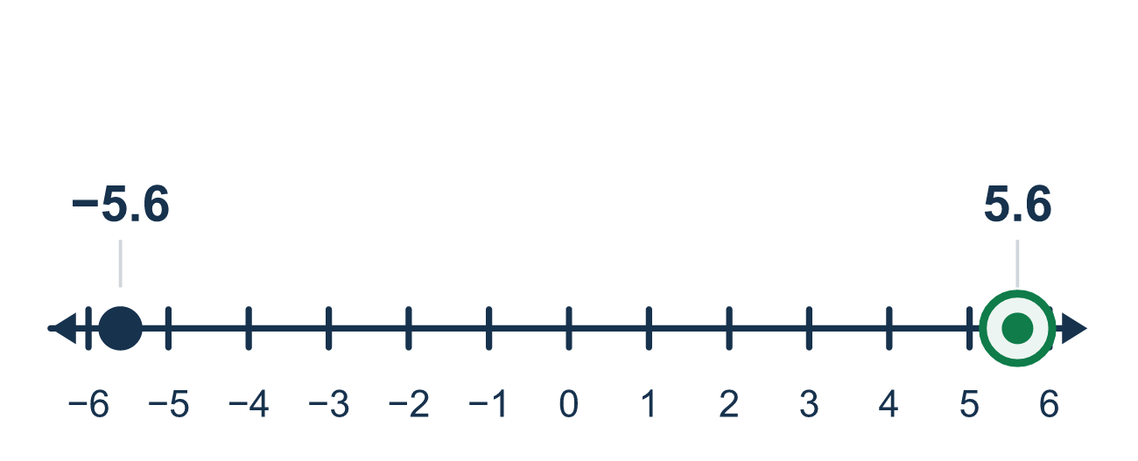
Our class model: the same distance, the other side

Try it
Work it out on paper. Write one answer on each line.
- What is the opposite of 3/4?
A. 4/3 B. 3/4 C. −3/4 D. −4/3
My answer
- What is the opposite of −5.6?
A. 5.6 B. −5.6 C. −6.5 D. 0.56
My answer
- Which pair are opposites?
A. 1.2 and 2.1 B. 1.2 and 12 C. −1.2 and −2.1 D. 1.2 and −1.2
My answer
- The point −2.5 is 2.5 units left of 0. How far from 0 is its opposite?
A. 5 units B. 0 units C. 2.5 units D. −2.5 units
My answer
- What is the opposite of the opposite of −6.35?
A. 6.35 B. −6.35 C. 0 D. −63.5
My answer
- A point is halfway between 1 and 2. What is its opposite?
A. −1.5 B. 1.5 C. −2.5 D. −0.5
My answer

Talk about it
Is the opposite of a fraction or decimal the same distance from 0? Which side is it on?

Home mission
Put a fork on the table as zero. Put a coin one hand-width to the right of the fork. Ask your student: where does the opposite coin go? Then ask: where does the opposite of the opposite go?

If we get stuck, ask
- Which two whole numbers does this value fall between?
- Same distance from zero — which side now?
- What happens if you take the opposite twice?

Do it on a screen

Scan or type the link. Same lesson, with hints. eduwonderlab.com/lessons/7-2-part2/homework.html
How did it feel? (optional) ☐ Tricky ☐ Getting there ☐ Got it

Family Math Studio · For grown-ups Lesson 7.2 · Session 2 · 6.NOS.6

Answers and talk notes
Represent Rational Numbers and Their Opposites on the Number Line

What your student is learning
Tonight we find opposites of fractions and decimals — not just whole numbers — and locate both on a number line.

Answers
Ask your student to explain before you look.
- C. −3/4. The opposite of 3/4 is −3/4. The fraction keeps its size and only changes side.
- A. 5.6. The opposite of −5.6 is 5.6.
- D. 1.2 and −1.2. 1.2 and −1.2 are the same distance from 0 on opposite sides.
- C. 2.5 units. An opposite is the same distance from 0, so it is 2.5 units away.
- B. −6.35. The first opposite is 6.35, and the opposite of that is −6.35.
- A. −1.5. The point is 1.5, so its opposite is −1.5.

Talk about it
Is the opposite of a fraction or decimal the same distance from 0? Which side is it on?

When they are stuck, ask
- Which two whole numbers does this value fall between?
- Same distance from zero — which side now?
- What happens if you take the opposite twice?

Try not to say
- For −3/4, go to −3 and then count 4 more.
- Only whole numbers have opposites.
- The opposite is just the number with a minus added.

Home mission
Put a fork on the table as zero. Put a coin one hand-width to the right of the fork. Ask your student: where does the opposite coin go? Then ask: where does the opposite of the opposite go?

