Family Math Studio Lesson 7.2 · 6.NOS.6

Represent Rational Numbers and Their Opposites on the Number Line
Place fractions and decimals, including negatives, on a number line.
Name Date

Tonight's spark
A rec-center treasure map has a hallway number line. The floor tags show integers only. A clue says the prize is at −2.5. Where is it? Guess first: is the prize left or right of the −2 tag?
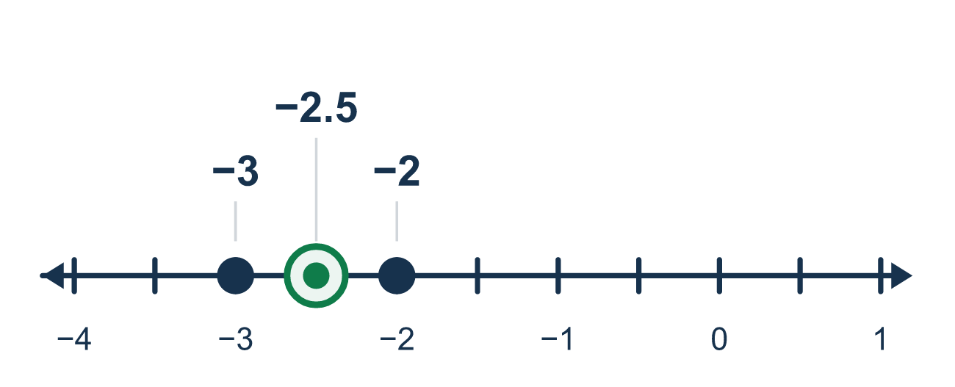
Our class model: neighbor integers, then equal parts

Try it
Work it out on paper. Write one answer on each line.
- Which two integers is 2.5 between?
A. 1 and 2 B. 2 and 3 C. 3 and 4
My answer
- Between which two integers is −4.5?
A. −4 and −3 B. 4 and 5 C. −6 and −5 D. −5 and −4
My answer
- The space from 0 to 1 is split into 4 equal parts. What decimal is the 3rd mark?
A. 0.3 B. 0.75 C. 0.25 D. 0.34
My answer
- What decimal is halfway between −3 and −2?
A. −2.5 B. −3.5 C. −2.25 D. −1.5
My answer
- Write −5/2 as a decimal.
A. −5.2 B. 2.5 C. −2.5 D. −0.52
My answer
- A point is 3/4 of the way from 0 to −1. Which number is it?
A. −3/4 B. 3/4 C. −1/4 D. −4/3
My answer

Talk about it
Which two integers is it between? How many equal parts do you split the space into?

Home mission
Lay three coins in a row, going left from your hand. Call them 0, −1 and −2. Ask your student where −1.5 goes. Slide a fork there. How did your student decide?

If we get stuck, ask
- Which two integers does this number sit between?
- Into how many equal parts should we split that space?
- Can you say this number another way, as a fraction or a decimal?

Do it on a screen

Scan or type the link. Same lesson, with hints. eduwonderlab.com/lessons/7-2/homework.html
How did it feel? (optional) ☐ Tricky ☐ Getting there ☐ Got it

Family Math Studio · For grown-ups Lesson 7.2 · 6.NOS.6

Answers and talk notes
Represent Rational Numbers and Their Opposites on the Number Line

What your student is learning
Tonight we place rational numbers — fractions and decimals — on a number line, not just integers.

Answers
Ask your student to explain before you look.
- B. 2 and 3. 2.5 is halfway between 2 and 3.
- D. −5 and −4. −4.5 is halfway between −5 and −4.
- B. 0.75. Each part is 0.25, so the 3rd mark is 0.75, which is 3/4.
- A. −2.5. Halfway between −3 and −2 is −2.5.
- C. −2.5. 5/2 means 5 ÷ 2 = 2.5, and the sign stays negative, so −2.5.
- A. −3/4. Going toward −1 means negative, so 3/4 of the way is −3/4.

Talk about it
Which two integers is it between? How many equal parts do you split the space into?

When they are stuck, ask
- Which two integers does this number sit between?
- Into how many equal parts should we split that space?
- Can you say this number another way, as a fraction or a decimal?

Try not to say
- Fractions and decimals do not belong on a number line.
- Just put -2.5 right on top of the -2.
- The dots between integers do not have to be evenly spaced.

Home mission
Lay three coins in a row, going left from your hand. Call them 0, −1 and −2. Ask your student where −1.5 goes. Slide a fork there. How did your student decide?

