Family Math Studio Lesson 7.3 · Session 2 · 6.NOS.8

Understand Absolute Value of Rational Numbers
Use absolute value to find the distance between two numbers.
Name Date

Tonight's spark
A town's weather board shows a low of −27 degrees and a high of 55 degrees in one day. By how many degrees did the temperature rise? Guess first: did it rise by more than 55 degrees, or less?
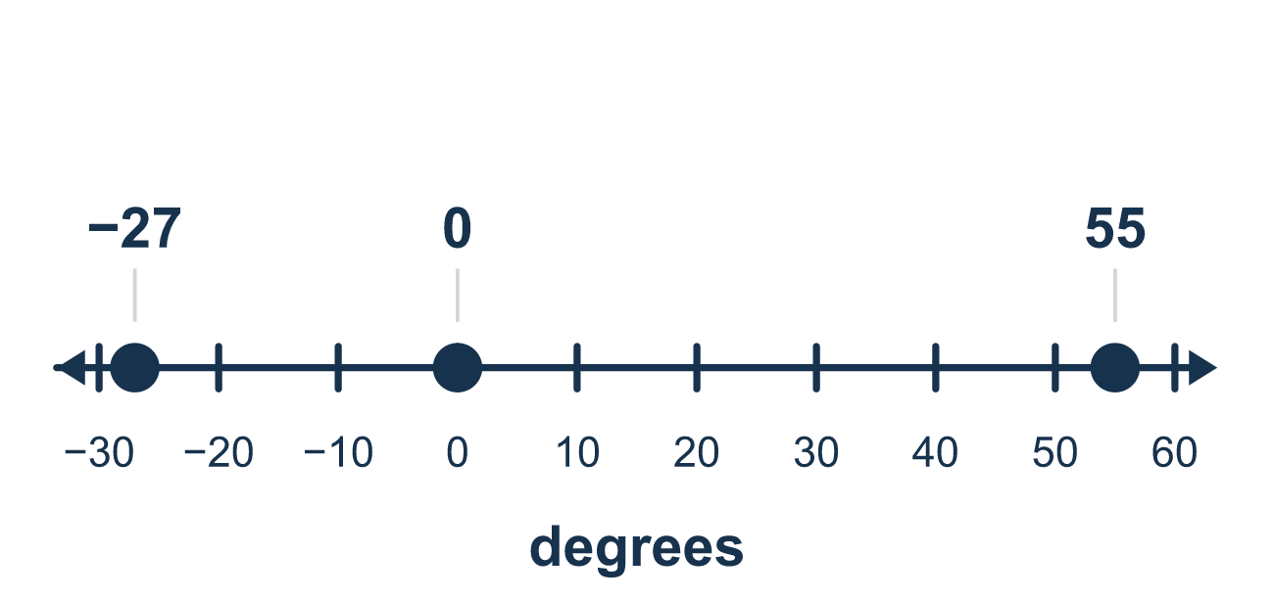
Our class model: up to zero, then out again

Try it
Work it out on paper. Write one answer on each line.
- What is |−16|?
A. −16 B. 16 C. 0 D. 160
My answer
- What is |−5| + |8|?
A. 3 B. −13 C. 13 D. 40
My answer
- −4 and 9 are on opposite sides of 0. How far apart are they?
A. 13 B. 5 C. 36 D. −5
My answer
- −12 and −5 are on the same side of 0. How far apart are they?
A. 17 B. −7 C. 60 D. 7
My answer
- A diver rises from −10 feet to 6 feet. How many feet did the diver rise?
A. 4 B. 16 C. −16 D. 60
My answer
- The temperature went from −25 to 40. Which expression gives the total change?
A. |−25| + |40| B. |40| − |−25| C. |−25| − |40| D. 40 − 25
My answer

Talk about it
Does 0 fall between the two numbers? Do you add or subtract the distances from 0?

Home mission
Pick a spot in the room as zero. Put a sock 5 steps to its left and a spoon 3 steps to its right. Ask your student how many steps lie between them. Do they add or subtract? Why?

If we get stuck, ask
- Does zero fall between these two numbers?
- How far is each one from zero?
- Can a distance ever be negative?

Do it on a screen

Scan or type the link. Same lesson, with hints. eduwonderlab.com/lessons/7-3-part2/homework.html
How did it feel? (optional) ☐ Tricky ☐ Getting there ☐ Got it

Family Math Studio · For grown-ups Lesson 7.3 · Session 2 · 6.NOS.8

Answers and talk notes
Understand Absolute Value of Rational Numbers

What your student is learning
Tonight we use absolute value to find the TOTAL distance between two points — including when they sit on opposite sides of zero.

Answers
Ask your student to explain before you look.
- B. 16. −16 is 16 units from 0, so |−16| = 16.
- C. 13. |−5| = 5 and |8| = 8, so 5 + 8 = 13.
- A. 13. Add the distances from 0: 4 + 9 = 13.
- D. 7. Same side, so subtract the distances: 12 − 5 = 7.
- B. 16. The diver crosses 0: 10 + 6 = 16 feet.
- A. |−25| + |40|. 0 is between −25 and 40, so add: |−25| + |40| = 65.

Talk about it
Does 0 fall between the two numbers? Do you add or subtract the distances from 0?

When they are stuck, ask
- Does zero fall between these two numbers?
- How far is each one from zero?
- Can a distance ever be negative?

Try not to say
- Just subtract the two numbers, distance is always subtraction.
- −8 is greater than −3 because 8 is greater than 3.
- Absolute value means to make it negative.

Home mission
Pick a spot in the room as zero. Put a sock 5 steps to its left and a spoon 3 steps to its right. Ask your student how many steps lie between them. Do they add or subtract? Why?

