Family Math Studio Lesson 7.3 · 6.NOS.8

Understand Absolute Value of Rational Numbers
Find the absolute value of a number as its distance from zero.
Name Date

Tonight's spark
A school hallway map puts 0 at the front office. The art room is at −6, six tiles left. The gym is at 6, six tiles right. Which is farther from the office? Guess first: is one of them farther, or is it a tie?
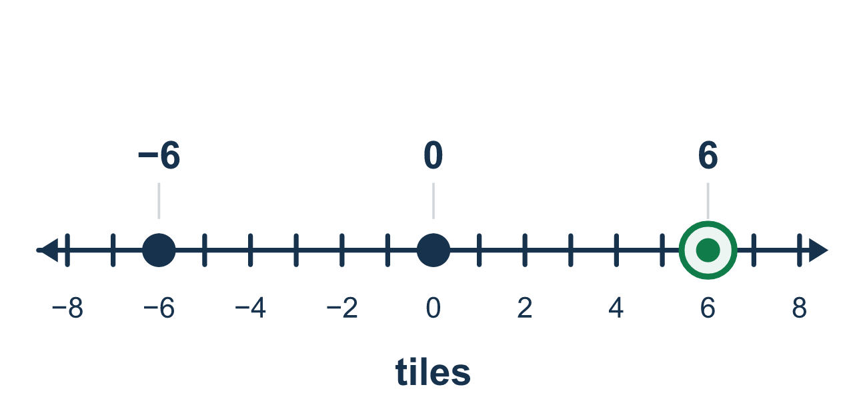
Our class model: distance from zero

Try it
Work it out on paper. Write one answer on each line.
- What is |−9|?
A. −9 B. 9 C. 0 D. 1/9
My answer
- What is |12|?
A. −12 B. 0 C. 12 D. 21
My answer
- What is |−3.5|?
A. 3.5 B. −3.5 C. 0.35 D. 35
My answer
- What is |−3/4|?
A. −3/4 B. 4/3 C. 3/4 D. 1/4
My answer
- A diver is at −20 feet. What does |−20| tell us?
A. The diver is 20 feet above sea level B. Sea level is −20 feet C. The diver is at 0 D. The diver is 20 feet from sea level
My answer
- Which number has the greatest absolute value?
A. −8 B. 5 C. −2 D. 7
My answer

Talk about it
How far is this number from 0? Can a distance ever be negative?

Home mission
Pick a doorway as zero. Take 4 steps left of it and say, "I am at −4." Ask your student: how far from zero am I? Then take 4 steps right and ask again.

If we get stuck, ask
- How far is that number from zero?
- Can a distance ever be negative?
- What is the opposite of this number?

Do it on a screen

Scan or type the link. Same lesson, with hints. eduwonderlab.com/lessons/7-3/homework.html
How did it feel? (optional) ☐ Tricky ☐ Getting there ☐ Got it

Family Math Studio · For grown-ups Lesson 7.3 · 6.NOS.8

Answers and talk notes
Understand Absolute Value of Rational Numbers

What your student is learning
Tonight we find the absolute value of a rational number — a whole number, a fraction, or a decimal — as its distance from zero.

Answers
Ask your student to explain before you look.
- B. 9. −9 is 9 units from 0, so |−9| = 9.
- C. 12. 12 is 12 units from 0, so |12| = 12.
- A. 3.5. −3.5 is 3.5 units from 0, so |−3.5| = 3.5.
- C. 3/4. −3/4 is 3/4 of a unit from 0, so |−3/4| = 3/4.
- D. The diver is 20 feet from sea level. The diver is 20 feet from sea level, because |−20| = 20.
- A. −8. |−8| = 8 is more than 5, 2 and 7, so −8 is farthest from 0.

Talk about it
How far is this number from 0? Can a distance ever be negative?

When they are stuck, ask
- How far is that number from zero?
- Can a distance ever be negative?
- What is the opposite of this number?

Try not to say
- Absolute value just erases the minus sign.
- |−6| can be negative sometimes.
- The number line is not needed here.

Home mission
Pick a doorway as zero. Take 4 steps left of it and say, "I am at −4." Ask your student: how far from zero am I? Then take 4 steps right and ask again.

