Family Math Studio Lesson 7.4 · Session 2 · 6.NOS.8

Compare and Order Integers and Rational Numbers
Order negatives, fractions and decimals from least to greatest.
Name Date

Tonight's spark
A rec-center game gives four players these score changes: 0.5, −1.5, 2 and −3. The coach lines them up from least to greatest. Who is first? Guess first: is the first player the one with 2, or the one with −3?
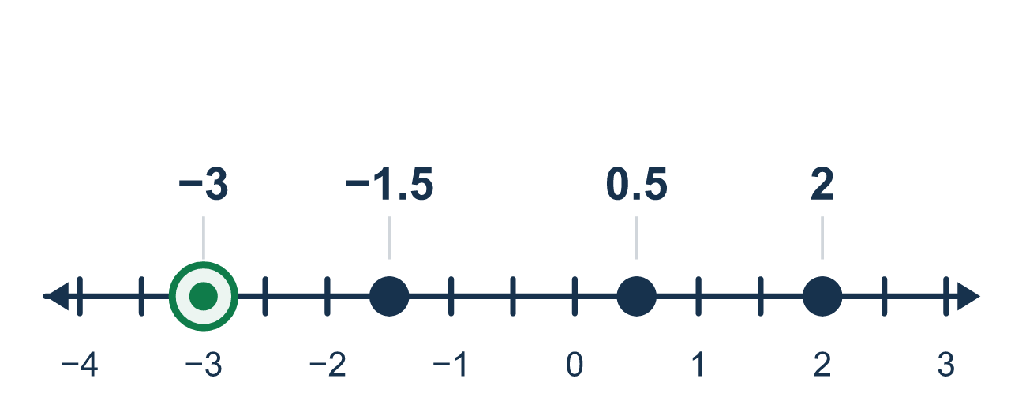
Our class model: the number line is the judge

Try it
Work it out on paper. Write one answer on each line.
- Write 3/4 as a decimal.
A. 0.34 B. 0.75 C. 0.43 D. 7.5
My answer
- Which is less: −0.5 or −1.5?
A. −1.5 B. −0.5 C. They are equal
My answer
- Which decimal equals −1/4?
A. −0.14 B. −4.1 C. −0.25 D. 0.25
My answer
- Which number is the least: 0.6, −0.6, −1.2 or 1/2?
A. −0.6 B. 0.6 C. 1/2 D. −1.2
My answer
- Order from least to greatest: 0.5, −2, −0.5.
A. −2, 0.5, −0.5 B. −2, −0.5, 0.5 C. 0.5, −0.5, −2 D. −0.5, −2, 0.5
My answer
- Which comparison is true?
A. −3/4 < −0.5 B. −3/4 > −0.5 C. −3/4 = −0.5
My answer

Talk about it
Which numbers are negative? After changing to decimals, which is farthest left?

Home mission
Write 0.5, −2 and −0.5 on three scraps of paper. Ask your student to line them up on the table from least to greatest. Which one went farthest left? How do you know?

If we get stuck, ask
- Which of these are to the left of zero?
- Can you sketch a number line and place them?
- Left to right — which comes first?

Do it on a screen

Scan or type the link. Same lesson, with hints. eduwonderlab.com/lessons/7-4-part2/homework.html
How did it feel? (optional) ☐ Tricky ☐ Getting there ☐ Got it

Family Math Studio · For grown-ups Lesson 7.4 · Session 2 · 6.NOS.8

Answers and talk notes
Compare and Order Integers and Rational Numbers

What your student is learning
Tonight we put mixed numbers in order — negatives, fractions and decimals together — using the number line as the judge.

Answers
Ask your student to explain before you look.
- B. 0.75. 3 ÷ 4 = 0.75, so 3/4 = 0.75.
- A. −1.5. −1.5 is farther left than −0.5, so −1.5 is less.
- C. −0.25. 1 ÷ 4 = 0.25, and the sign is negative, so −0.25.
- D. −1.2. −1.2 is farthest left, so it is the least.
- B. −2, −0.5, 0.5. From left to right: −2, −0.5, 0.5.
- A. −3/4 < −0.5. −3/4 = −0.75, which is left of −0.5, so −3/4 < −0.5.

Talk about it
Which numbers are negative? After changing to decimals, which is farthest left?

When they are stuck, ask
- Which of these are to the left of zero?
- Can you sketch a number line and place them?
- Left to right — which comes first?

Try not to say
- −15 is greater than −8 because 15 is greater.
- Ignore the minus signs and order the digits.
- Fractions always come before decimals.

Home mission
Write 0.5, −2 and −0.5 on three scraps of paper. Ask your student to line them up on the table from least to greatest. Which one went farthest left? How do you know?

