Family Math Studio Lesson 7.4 · 6.NOS.8

Compare and Order Integers and Rational Numbers
Compare and order integers using a number line.
Name Date

Tonight's spark
Two bus-stop thermometers read −7 and −5 degrees. Which stop is colder? Guess first: does the 7 make −7 warmer or colder than −5?
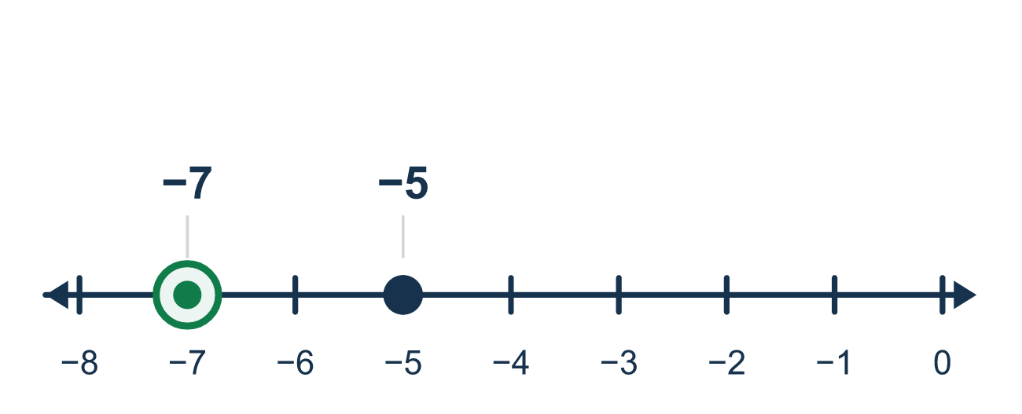
Our class model: left is less, right is greater

Try it
Work it out on paper. Write one answer on each line.
- Which number is the greatest?
A. −7 B. −4 C. 0 D. 2
My answer
- Which symbol makes −3 ___ 5 true?
A. < B. > C. =
My answer
- Which is less: −9 or −2?
A. −2 B. −9 C. They are equal
My answer
- Which number is farthest to the left on a number line?
A. −6 B. −1 C. 0 D. 4
My answer
- Order from least to greatest: −2, 5, −8, 0.
A. −2, −8, 0, 5 B. −8, −2, 0, 5 C. 0, −2, −8, 5 D. 5, 0, −2, −8
My answer
- A fish is at −6 meters and a diver is at −10 meters. Which statement is true?
A. −10 > −6 B. −6 < −10 C. −10 < −6 D. −10 = −6
My answer

Talk about it
Which number is farther left? Which is less?

Home mission
Lay a string on the table as a number line, with a coin at 0. Put one coin 5 finger-widths left of 0 and another 7 finger-widths left. Ask: which coin is less? Which would be colder?

If we get stuck, ask
- Which number is farther to the left on the number line? That one is less.
- Let's draw a number line and mark both numbers to see them.
- Does the wide side of the symbol point to the bigger number?

Do it on a screen

Scan or type the link. Same lesson, with hints. eduwonderlab.com/lessons/7-4/homework.html
How did it feel? (optional) ☐ Tricky ☐ Getting there ☐ Got it

Family Math Studio · For grown-ups Lesson 7.4 · 6.NOS.8

Answers and talk notes
Compare and Order Integers and Rational Numbers

What your student is learning
Tonight we compare and order integers (positive and negative whole numbers) using a number line.

Answers
Ask your student to explain before you look.
- D. 2. 2 is farthest to the right, so 2 is the greatest.
- A. <. −3 is to the left of 5, so −3 < 5.
- B. −9. −9 is farther left than −2, so −9 is less.
- A. −6. −6 is farthest left, so it is the least.
- B. −8, −2, 0, 5. From left to right on the number line: −8, −2, 0, 5.
- C. −10 < −6. −10 is farther left than −6, so −10 < −6.

Talk about it
Which number is farther left? Which is less?

When they are stuck, ask
- Which number is farther to the left on the number line? That one is less.
- Let's draw a number line and mark both numbers to see them.
- Does the wide side of the symbol point to the bigger number?

Try not to say
- -7 is bigger than -5 because 7 is bigger than 5.
- Just ignore the negative signs when you compare.
- The number with more digits is always greater.

Home mission
Lay a string on the table as a number line, with a coin at 0. Put one coin 5 finger-widths left of 0 and another 7 finger-widths left. Ask: which coin is less? Which would be colder?

