Family Math Studio Lesson 7.5 · Session 2 · 6.NOS.6

Represent Rational Numbers on the Coordinate Plane
Flip a point across an axis and name where it lands.
Name Date

Tonight's spark
A class mural plan puts a star at R, (3.25, −5.5), on a grid. The painter flips a copy of the star across the x-axis, like a mirror. Where does the copy land? Guess first: does the copy land above or below the star?
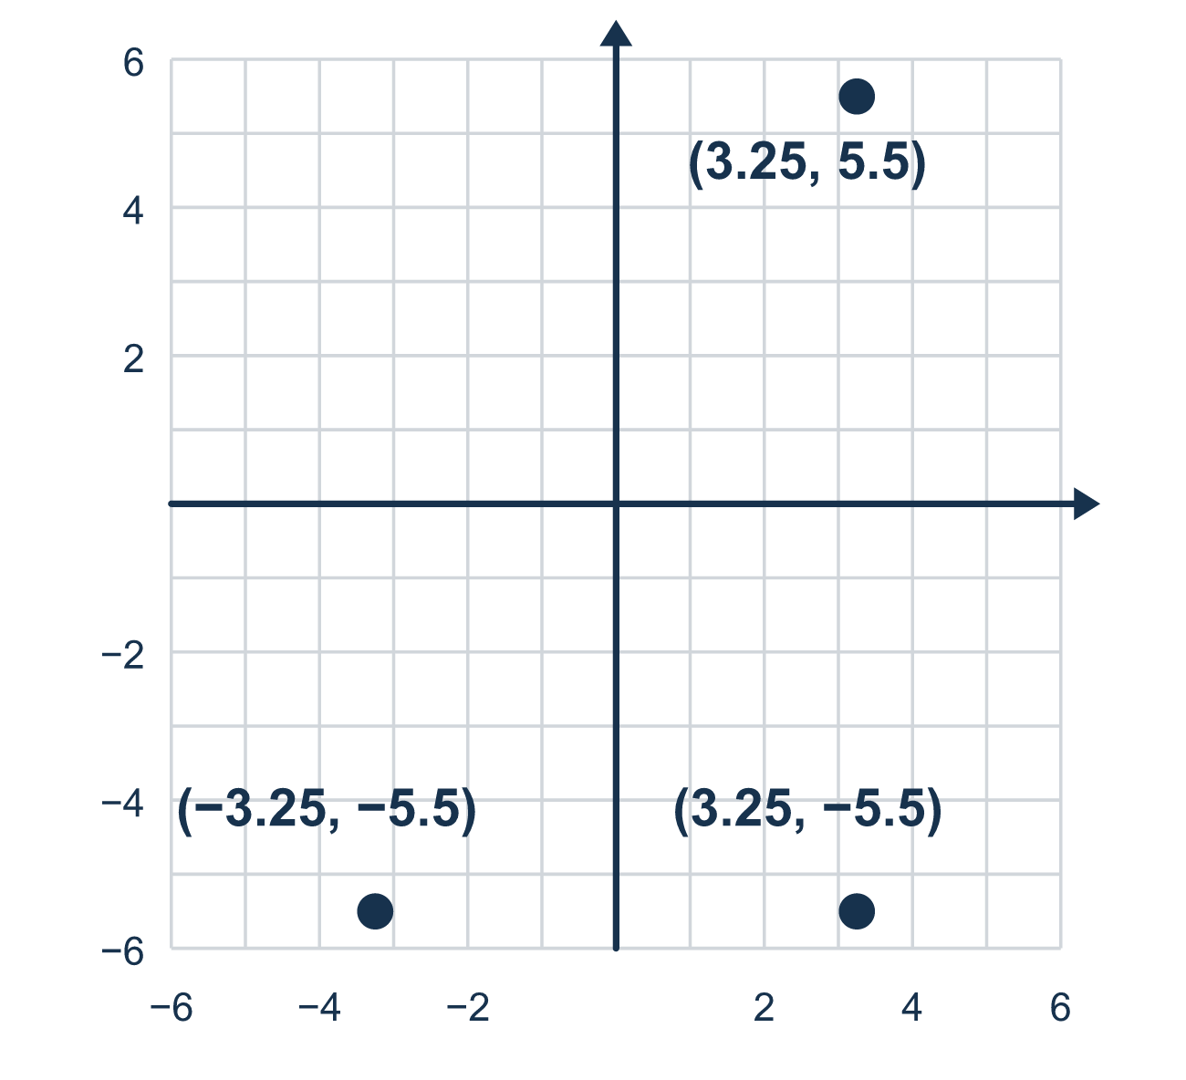
Our class model: the mirror line

Try it
Work it out on paper. Write one answer on each line.
- Which coordinate changes sign when you reflect across the x-axis?
A. The x-coordinate B. The y-coordinate C. Both coordinates
My answer
- Reflect (4, 3) across the x-axis.
A. (−4, 3) B. (4, −3) C. (−4, −3) D. (4, 3)
My answer
- Reflect (6, 1) across the y-axis.
A. (6, −1) B. (−6, −1) C. (1, 6) D. (−6, 1)
My answer
- Reflect (−5, 2) across the x-axis.
A. (−5, −2) B. (5, −2) C. (5, 2) D. (−5, 2)
My answer
- Reflect (1.5, −4) across the y-axis.
A. (1.5, 4) B. (−1.5, 4) C. (−1.5, −4) D. (1.5, −4)
My answer

Talk about it
Which coordinate changes sign when you reflect across the x-axis? Which stays the same?

Home mission
Lay a ruler on the table as the x-axis. Put a coin below it for the mural star. Ask: where does its mirror copy go? Put a second coin there. Then compare how far each coin is from the ruler. Which number changed, the left-right one or the up-down one?

If we get stuck, ask
- Which axis are we reflecting across?
- Does that axis run left-right or up-down? Which value has to change?
- Is the image the same distance from the mirror line?

Do it on a screen

Scan or type the link. Same lesson, with hints. eduwonderlab.com/lessons/7-5-part2/homework.html
How did it feel? (optional) ☐ Tricky ☐ Getting there ☐ Got it

Family Math Studio · For grown-ups Lesson 7.5 · Session 2 · 6.NOS.6

Answers and talk notes
Represent Rational Numbers on the Coordinate Plane

What your student is learning
Tonight we reflect points across the x-axis and the y-axis — and see exactly which coordinate changes sign.

Answers
Ask your student to explain before you look.
- B. The y-coordinate. The y-coordinate changes sign across the x-axis, and x stays the same.
- B. (4, −3). Across the x-axis, y changes sign: (4, −3).
- D. (−6, 1). Across the y-axis, x changes sign: (−6, 1).
- A. (−5, −2). Across the x-axis, y changes sign: (−5, −2).
- C. (−1.5, −4). Across the y-axis, x changes sign: (−1.5, −4).

Talk about it
Which coordinate changes sign when you reflect across the x-axis? Which stays the same?

When they are stuck, ask
- Which axis are we reflecting across?
- Does that axis run left-right or up-down? Which value has to change?
- Is the image the same distance from the mirror line?

Try not to say
- Reflecting over the x-axis changes the x-coordinate.
- Flip both coordinates, it is safer.
- The reflected point can be any distance from the axis.

Home mission
Lay a ruler on the table as the x-axis. Put a coin below it for the mural star. Ask: where does its mirror copy go? Put a second coin there. Then compare how far each coin is from the ruler. Which number changed, the left-right one or the up-down one?

