Family Math Studio Lesson 7.5 · 6.NOS.6

Represent Rational Numbers on the Coordinate Plane
Plot and name points on a grid with two numbers: sideways first, then up.
Name Date

Tonight's spark
A rec-center treasure hunt uses floor tiles. The card says: prize at (5, 4). Mia starts on the center tile, goes 5 right, then 4 up. Dev goes 4 right, then 5 up. Who finds the prize? Guess first: will Mia and Dev land on the same tile?
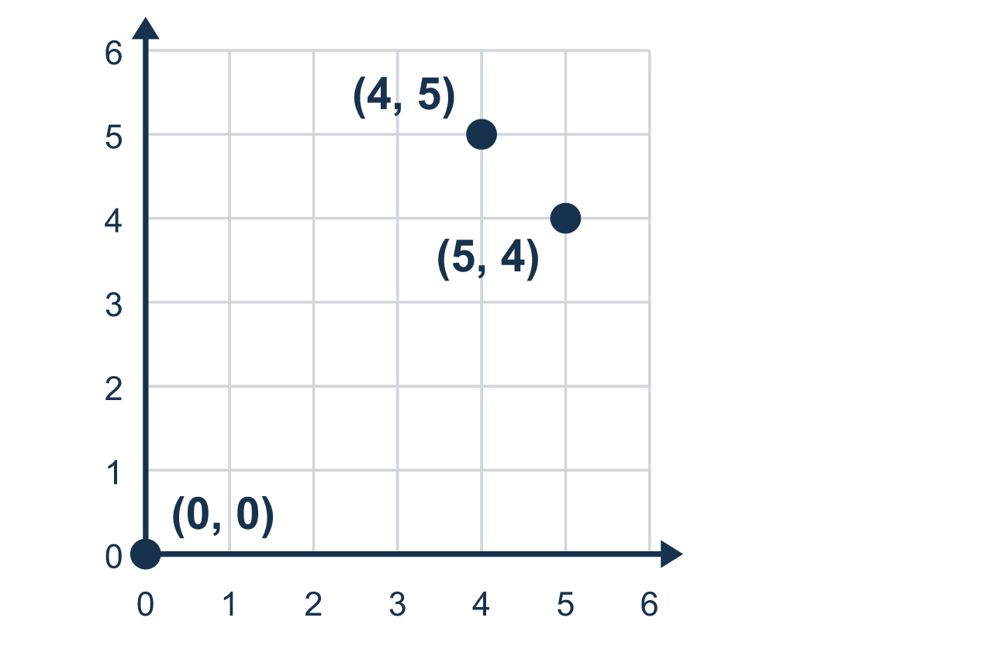
Our class model: right first, then up

Try it
Work it out on paper. Write one answer on each line.
- Which ordered pair names the origin?
A. (0, 0) B. (1, 1) C. (0, 1) D. (1, 0)
My answer
- To plot (4, 2), how far do you move right from the origin?
A. 2 B. 4 C. 6 D. 0
My answer
- Which ordered pair means 3 right and 5 up?
A. (5, 3) B. (8, 0) C. (3, 5) D. (3, 3)
My answer
- What is the x-coordinate of (7, 1)?
A. 1 B. 8 C. 0 D. 7
My answer
- Which point is farther to the right: (2, 8) or (6, 1)?
A. (2, 8) B. (6, 1) C. They are the same distance D. You cannot tell
My answer

Talk about it
Which number tells how far to go sideways? Which tells how far to go up?

Home mission
Use the corner of the table nearest you as the origin. Slide a coin 5 finger-widths right, then 4 finger-widths away from you. Say the point: (5, 4). Now try (4, 5). Does the coin land in the same place?

If we get stuck, ask
- Where do we always start? Let's put our finger on the origin first.
- Which number is first? That one tells us how far to move sideways.
- Say the point out loud. What is each number telling us to do?

Do it on a screen

Scan or type the link. Same lesson, with hints. eduwonderlab.com/lessons/7-5/homework.html
How did it feel? (optional) ☐ Tricky ☐ Getting there ☐ Got it

Family Math Studio · For grown-ups Lesson 7.5 · 6.NOS.6

Answers and talk notes
Represent Rational Numbers on the Coordinate Plane

What your student is learning
Tonight we plot points on a grid called the coordinate plane. We use two numbers, called an ordered pair, to say exactly where a point goes.

Answers
Ask your student to explain before you look.
- A. (0, 0). The origin is where the two lines cross, at (0, 0).
- B. 4. The first number, 4, tells how far to move right.
- C. (3, 5). Right comes first and up comes second, so (3, 5).
- D. 7. The x-coordinate is the first number, 7.
- B. (6, 1). Right depends on the first number, and 6 is greater than 2, so (6, 1) is farther right.

Talk about it
Which number tells how far to go sideways? Which tells how far to go up?

When they are stuck, ask
- Where do we always start? Let's put our finger on the origin first.
- Which number is first? That one tells us how far to move sideways.
- Say the point out loud. What is each number telling us to do?

Try not to say
- Move up first, then sideways.
- The order of the two numbers does not matter.
- Just guess where the point goes.

Home mission
Use the corner of the table nearest you as the origin. Slide a coin 5 finger-widths right, then 4 finger-widths away from you. Say the point: (5, 4). Now try (4, 5). Does the coin land in the same place?

