Family Math Studio Lesson 7.6 · Session 2 · 6.NOS.9

Determine Distance on the Coordinate Plane
Find two distances on the coordinate plane and compare them.
Name Date

Tonight's spark
A park map has a hub at G, (1.75, 8.25). Cruz walks straight to C, (1.75, 2.25). Dara walks straight to D, (−5.25, 8.25). One unit is one block. Who walks farther? Guess first: Cruz goes down and Dara goes left. Who walks farther?
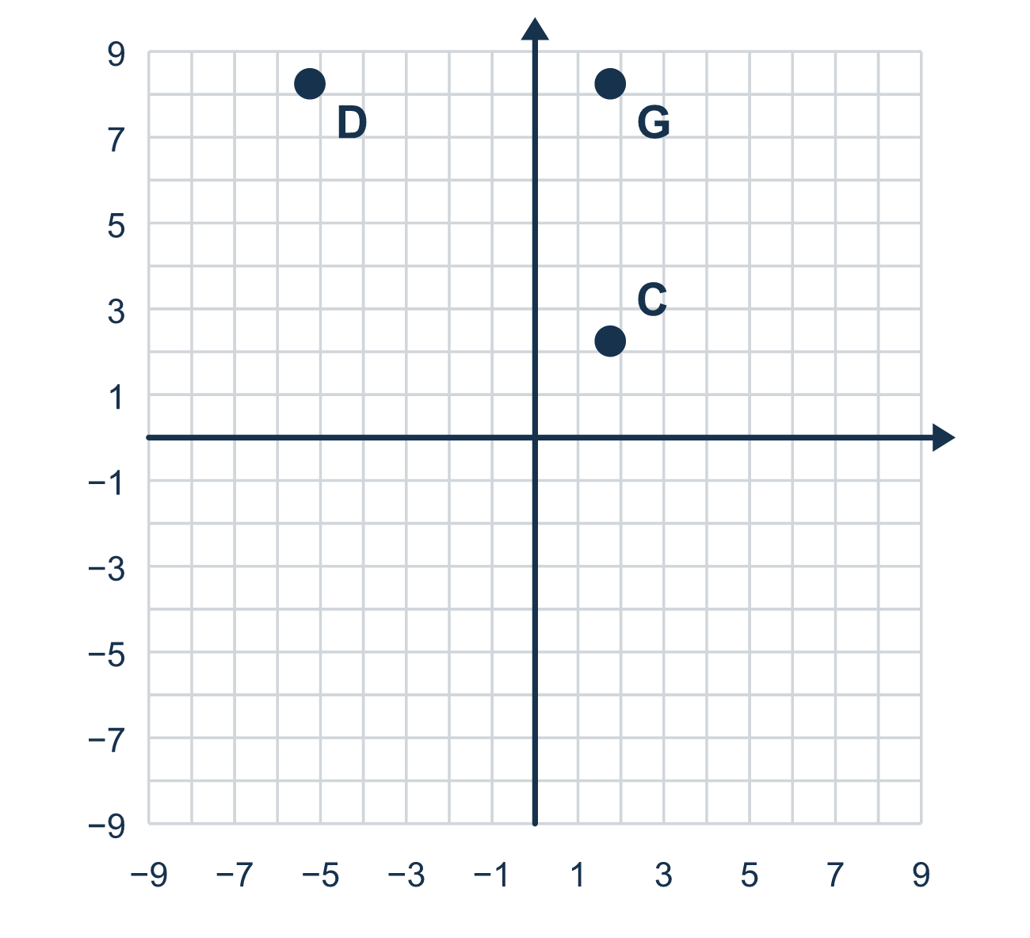
Our class model: find the shared coordinate, then use the other

Try it
Work it out on paper. Write one answer on each line.
- Which coordinate do (3, 1) and (3, −5) share?
A. The x-coordinate B. The y-coordinate C. Neither one
My answer
- Find the distance between (2, 6) and (2, 1).
A. 7 B. 5 C. 6 D. 1
My answer
- Find the distance between (−4, 3) and (5, 3).
A. 1 B. 4 C. 5 D. 9
My answer
- Find the distance between (1.5, 4) and (1.5, −2.5).
A. 6.5 B. 1.5 C. 4 D. 2.5
My answer
- Ana walks from (0, 5) to (0, −3). Beto walks from (0, 5) to (6, 5). Who walks farther?
A. Beto, by 4 units B. Ana, by 2 units C. Ana, by 14 units D. They walk the same
My answer

Talk about it
Which coordinate does each trip share? Do you add or subtract for each trip, and who goes farther?

Home mission
Cross two forks on the table to make the axes. Put one coin 3 finger-widths above the crossing and another 5 below it. Ask your student: how far apart are the coins? Add or subtract? Why?

If we get stuck, ask
- Which coordinate do these two points share?
- Do the other two values have the same sign or opposite signs?
- Does the trip cross an axis? Then what do we do?

Do it on a screen

Scan or type the link. Same lesson, with hints. eduwonderlab.com/lessons/7-6-part2/homework.html
How did it feel? (optional) ☐ Tricky ☐ Getting there ☐ Got it

Family Math Studio · For grown-ups Lesson 7.6 · Session 2 · 6.NOS.9

Answers and talk notes
Determine Distance on the Coordinate Plane

What your student is learning
Tonight we find two distances on a grid and compare them — deciding each time whether to add or subtract the absolute values.

Answers
Ask your student to explain before you look.
- A. The x-coordinate. The x-coordinate is shared: both points have x = 3.
- B. 5. Both y-values are positive, so subtract: 6 − 1 = 5.
- D. 9. The x-values are on opposite sides of 0, so add: 4 + 5 = 9.
- A. 6.5. The y-values are on opposite sides of 0, so add: 4 + 2.5 = 6.5.
- B. Ana, by 2 units. Ana, by 2 units: Ana walks 5 + 3 = 8 units and Beto walks 6 units.

Talk about it
Which coordinate does each trip share? Do you add or subtract for each trip, and who goes farther?

When they are stuck, ask
- Which coordinate do these two points share?
- Do the other two values have the same sign or opposite signs?
- Does the trip cross an axis? Then what do we do?

Try not to say
- Always subtract to find a distance.
- A distance can come out negative, just keep the sign.
- Compare the coordinates instead of the distances.

Home mission
Cross two forks on the table to make the axes. Put one coin 3 finger-widths above the crossing and another 5 below it. Ask your student: how far apart are the coins? Add or subtract? Why?

