Family Math Studio Lesson 7.6 · 6.NOS.9

Determine Distance on the Coordinate Plane
Find the distance between two points on the coordinate plane.
Name Date

Tonight's spark
A city bus map uses a grid. Two stops sit on the same street: one at (−3, 2) and one at (4, 2). Each square is one block. How many blocks apart are the stops? Guess first: are the stops more than 4 blocks apart, or fewer?
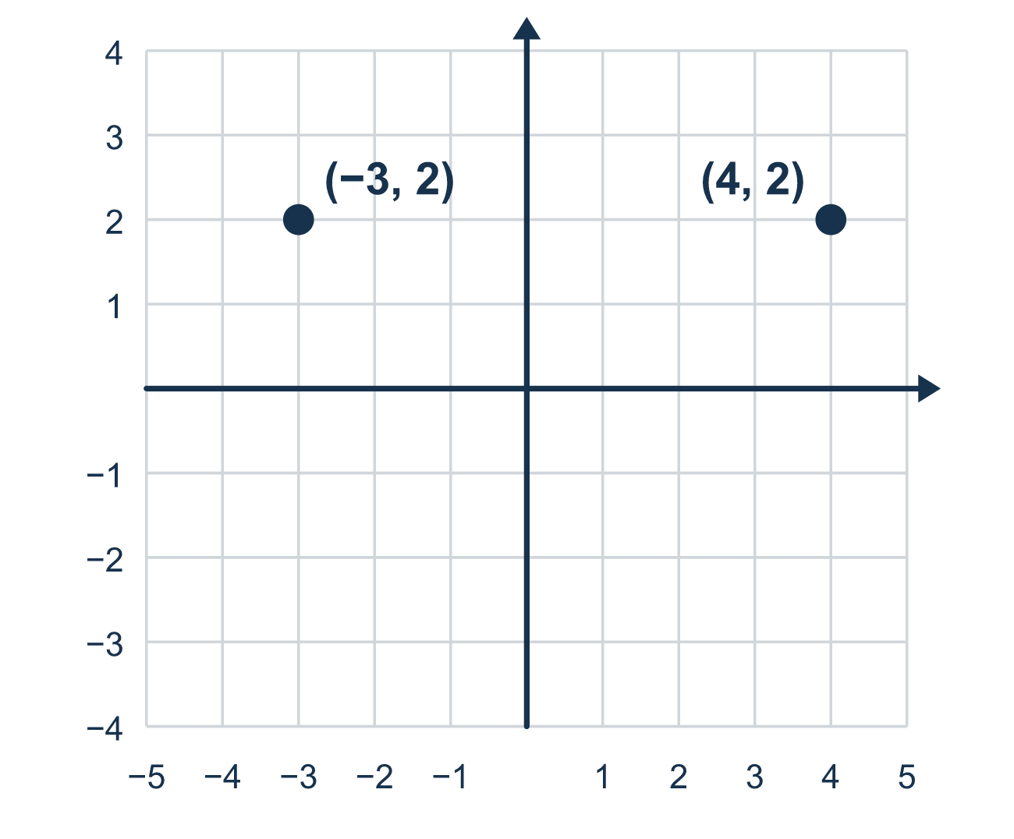
Our class model: same row or column, then add or subtract

Try it
Work it out on paper. Write one answer on each line.
- Which coordinates are the same in (2, 5) and (9, 5)?
A. The x-coordinates B. The y-coordinates C. Both D. Neither
My answer
- Find the distance between (1, 3) and (6, 3).
A. 5 B. 7 C. 18 D. 3
My answer
- What is |−4| + |3|?
A. −1 B. 1 C. 7 D. 12
My answer
- Find the distance between (−2, 4) and (5, 4).
A. 3 B. 5 C. 2 D. 7
My answer
- Find the distance between (6, −3) and (6, −9).
A. 12 B. 6 C. −6 D. 3
My answer
- Find the distance between (4, −5) and (4, 3).
A. 8 B. 2 C. 5 D. 3
My answer

Talk about it
Which coordinate is the same? Are the other coordinates on the same side of 0 or opposite sides?

Home mission
Pick one floor tile as (0, 0). Stand 3 tiles left of it. Have your student stand 4 tiles right of it, on the same row. Ask: how many tiles apart are you? Add or subtract? Why?

If we get stuck, ask
- Are the two points on the same side of zero, or opposite sides?
- How far is each number from zero? Let's find both absolute values.
- Do the points share a row or a column? That tells us which numbers to use.

Do it on a screen

Scan or type the link. Same lesson, with hints. eduwonderlab.com/lessons/7-6/homework.html
How did it feel? (optional) ☐ Tricky ☐ Getting there ☐ Got it

Family Math Studio · For grown-ups Lesson 7.6 · 6.NOS.9

Answers and talk notes
Determine Distance on the Coordinate Plane

What your student is learning
Tonight we find the distance between two points on the grid when they share a row or a column. We use absolute value (distance from zero).

Answers
Ask your student to explain before you look.
- B. The y-coordinates. The y-coordinates are the same: both points have y = 5.
- A. 5. Both x-values are positive, so subtract: 6 − 1 = 5.
- C. 7. |−4| = 4 and |3| = 3, so 4 + 3 = 7.
- D. 7. −2 and 5 are on opposite sides of 0, so add: 2 + 5 = 7.
- B. 6. Both y-values are negative, so subtract: 9 − 3 = 6.
- A. 8. The y-values are on opposite sides of 0, so add: 5 + 3 = 8.

Talk about it
Which coordinate is the same? Are the other coordinates on the same side of 0 or opposite sides?

When they are stuck, ask
- Are the two points on the same side of zero, or opposite sides?
- How far is each number from zero? Let's find both absolute values.
- Do the points share a row or a column? That tells us which numbers to use.

Try not to say
- Just subtract the two numbers no matter what their signs are.
- Distance can be negative if one point is below zero.
- You always have to count every single square to find distance.

Home mission
Pick one floor tile as (0, 0). Stand 3 tiles left of it. Have your student stand 4 tiles right of it, on the same row. Ask: how many tiles apart are you? Add or subtract? Why?

