Family Math Studio Lesson 7.7 · Session 2 · 6.GR.3

Represent Polygons on the Coordinate Plane
Use coordinates and a scale to find real side lengths and areas.
Name Date

Tonight's spark
A community garden needs 30,000 square feet. On the plan, one side runs from (−2.5, 10.5) to (−2.5, 4.5). One grid unit is 25 feet. How long is the other side, in feet? Make a guess first: is the other side more than 100 feet, or less?
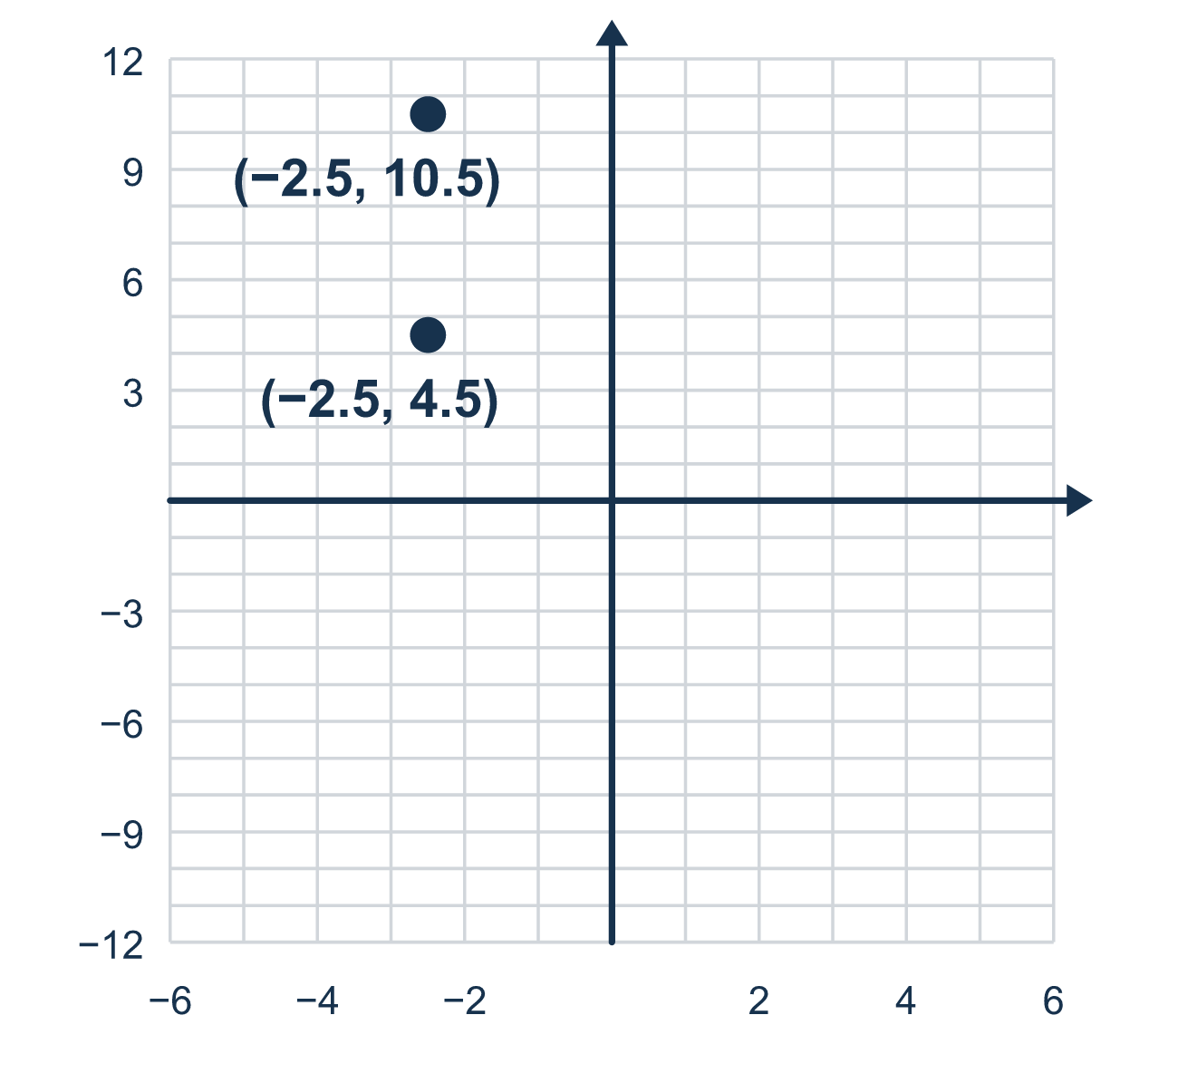
Our class model: count units, then convert

Try it
Work it out on paper. Write one answer on each line.
- On a plan, 1 unit = 5 feet. A side is 4 units long. How many feet is that?
A. 9 feet B. 20 feet C. 4 feet D. 45 feet
My answer
- On a plan, 1 unit = 10 feet. A side is 30 feet long. How many units is that?
A. 300 units B. 40 units C. 3 units D. 20 units
My answer
- The points (2, 1) and (2, 7) have the same x. How many units apart are they?
A. 6 units B. 8 units C. 7 units D. 1 unit
My answer
- The points (−3, 2) and (−3, −4) have the same x. If 1 unit = 20 feet, how long is the real side?
A. 40 feet B. 6 feet C. 26 feet D. 120 feet
My answer
- A plot is 8 units by 5 units. If 1 unit = 10 feet, what is its area in square feet?
A. 40 square feet B. 400 square feet C. 260 square feet D. 4,000 square feet
My answer

Talk about it
How many grid units is the side? What does each unit stand for in real feet?

Home mission
Choose a hallway or a counter. Let one step stand for 2 feet. Ask your student: if the hallway is 7 steps, how many feet is that? Then flip it: a 10-foot wall is how many steps?

If we get stuck, ask
- What does one grid unit stand for here?
- Is this number in grid units or in feet?
- Does this distance cross zero? Then what do we do?

Do it on a screen

Scan or type the link. Same lesson, with hints. eduwonderlab.com/lessons/7-7-part2/homework.html
How did it feel? (optional) ☐ Tricky ☐ Getting there ☐ Got it

Family Math Studio · For grown-ups Lesson 7.7 · Session 2 · 6.GR.3

Answers and talk notes
Represent Polygons on the Coordinate Plane

What your student is learning
Tonight a grid unit stands for real feet — so we count units, convert to feet, and solve a real design problem.

Answers
Ask your student to explain before you look.
- B. 20 feet. 4 × 5 = 20 feet.
- C. 3 units. 30 ÷ 10 = 3 units.
- A. 6 units. Both y-values are positive, so subtract: 7 − 1 = 6 units.
- D. 120 feet. The side is 2 + 4 = 6 units, and 6 × 20 = 120 feet.
- D. 4,000 square feet. The sides are 80 feet and 50 feet, so the area is 80 × 50 = 4,000 square feet.

Talk about it
How many grid units is the side? What does each unit stand for in real feet?

When they are stuck, ask
- What does one grid unit stand for here?
- Is this number in grid units or in feet?
- Does this distance cross zero? Then what do we do?

Try not to say
- Grid units and feet are the same thing.
- Just subtract the coordinates, the signs will work out.
- Convert at the very end, it does not matter when.

Home mission
Choose a hallway or a counter. Let one step stand for 2 feet. Ask your student: if the hallway is 7 steps, how many feet is that? Then flip it: a 10-foot wall is how many steps?

