Family Math Studio Lesson 7.7 · 6.GR.3

Represent Polygons on the Coordinate Plane
Draw a polygon from its corner coordinates, then find side lengths, perimeter and area.
Name Date

Tonight's spark
A town plan on a grid shows a garden. Two fence posts sit at (−4, 3) and (5, 3). The fence runs straight between them. How many units long is it? Make a guess first: is the fence longer than 5 units, or shorter?
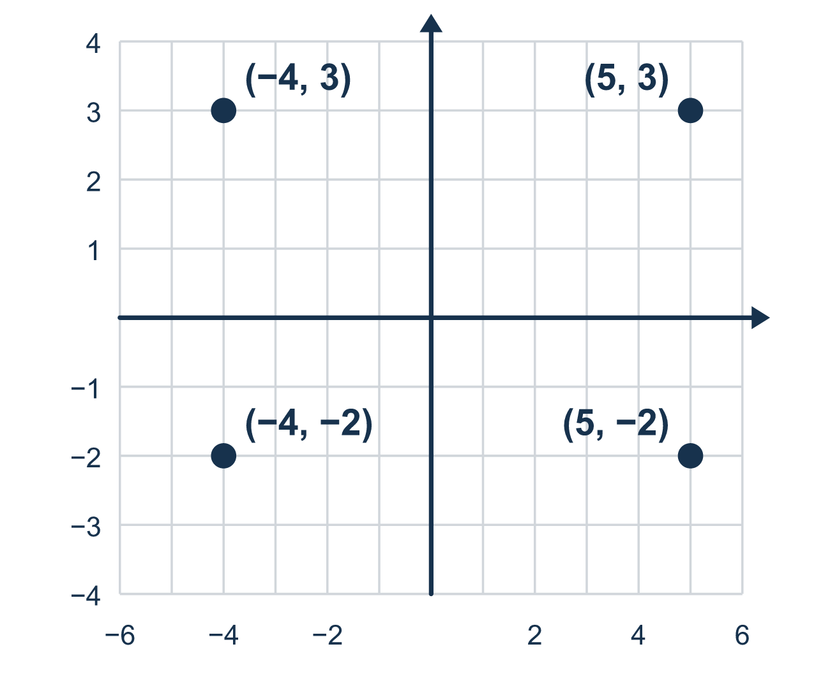
Our class model: the shared-coordinate rule

Try it
Work it out on paper. Write one answer on each line.
- The vertices (1, 4) and (7, 4) share y = 4. Is the side between them horizontal or vertical?
A. Horizontal B. Vertical C. Slanted
My answer
- Find the length of the side from (2, 3) to (8, 3).
A. 10 B. 6 C. 5 D. 16
My answer
- Find the length of the side from (−4, 2) to (3, 2).
A. 1 B. 12 C. 7 D. 6
My answer
- Find the length of the side from (5, 3) to (5, −2).
A. 1 B. 3 C. 2 D. 5
My answer
- A rectangle is 9 units long and 4 units wide. What is its perimeter?
A. 13 units B. 26 units C. 36 units D. 18 units
My answer

Talk about it
Which vertices share a coordinate? How long is the side between them?

Home mission
Pretend the middle of your table is (0, 0). Let one hand-width be 1 unit. Point to two spots in a straight row: one 3 units left, one 4 units right. How far apart are they? Then try two spots in a straight column.

If we get stuck, ask
- Which coordinate is the same for both points?
- How many units apart are the coordinates that change?
- Did you count carefully across zero?

Do it on a screen

Scan or type the link. Same lesson, with hints. eduwonderlab.com/lessons/7-7/homework.html
How did it feel? (optional) ☐ Tricky ☐ Getting there ☐ Got it

Family Math Studio · For grown-ups Lesson 7.7 · 6.GR.3

Answers and talk notes
Represent Polygons on the Coordinate Plane

What your student is learning
Tonight we draw a polygon from its vertex coordinates, then use the coordinates to find side lengths, perimeter, and area.

Answers
Ask your student to explain before you look.
- A. Horizontal. Horizontal: the y-values match, so the side runs straight across.
- B. 6. Both x-values are positive, so subtract: 8 − 2 = 6.
- C. 7. −4 and 3 are on opposite sides of 0, so add: 4 + 3 = 7.
- D. 5. 3 and −2 are on opposite sides of 0, so add: 3 + 2 = 5.
- B. 26 units. 9 + 4 + 9 + 4 = 26 units.

Talk about it
Which vertices share a coordinate? How long is the side between them?

When they are stuck, ask
- Which coordinate is the same for both points?
- How many units apart are the coordinates that change?
- Did you count carefully across zero?

Try not to say
- Just subtract the numbers and ignore the signs.
- It does not matter which number goes first.
- Perimeter and area are the same thing.

Home mission
Pretend the middle of your table is (0, 0). Let one hand-width be 1 unit. Point to two spots in a straight row: one 3 units left, one 4 units right. How far apart are they? Then try two spots in a straight column.

