Family Math Studio Lesson 7.8 · Session 2 · 6.NOS.7

Ordered Pairs in All Four Quadrants
Name the quadrant of a point from the signs of its coordinates.
Name Date

Tonight's spark
Base camp is the center of a map. Four clues are at A (4, 3), B (−5, 2), C (−3, −4) and D (2, −5). One clue is in the upper left. Which one? Make a guess first: how many of the four clues are on the left side of the map?
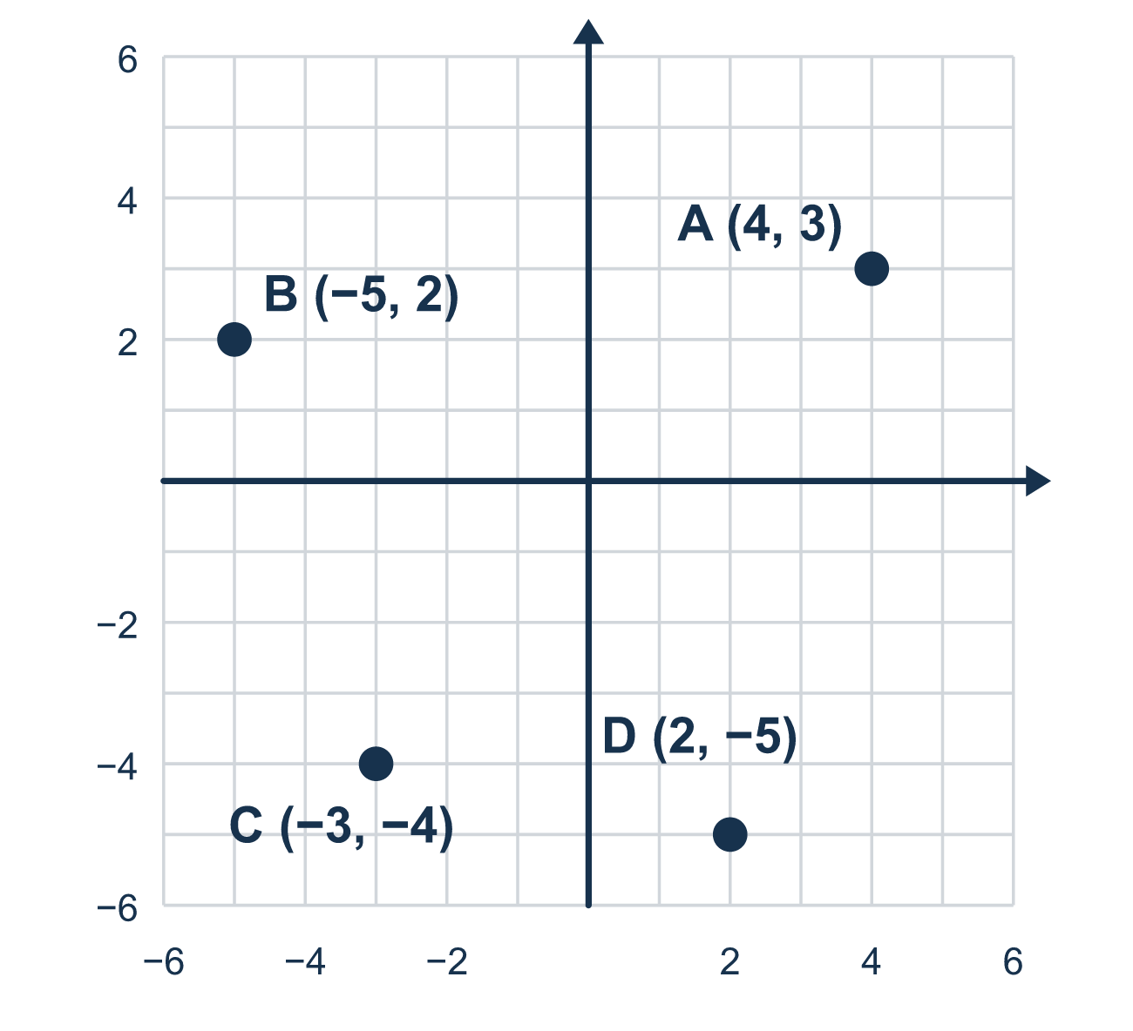
Our class model: read the signs

Try it
Work it out on paper. Write one answer on each line.
- Which signs does (3, −8) have?
A. (+, +) B. (−, +) C. (−, −) D. (+, −)
My answer
- A point has a positive x and a positive y. Which quadrant is it in?
A. Quadrant I B. Quadrant II C. Quadrant III D. Quadrant IV
My answer
- Which quadrant is (−7, 2) in?
A. Quadrant I B. Quadrant II C. Quadrant III D. Quadrant IV
My answer
- Which quadrant is (−5, −9) in?
A. Quadrant I B. Quadrant II C. Quadrant III D. Quadrant IV
My answer
- Which ordered pair is in Quadrant III?
A. (−3, 4) B. (3, −4) C. (−3, −4) D. (3, 4)
My answer

Talk about it
What are the two signs? Which quadrant do those signs name?

Home mission
Fold a sheet of paper in half, then in half the other way. The folds cross in the middle. Say only the signs, like (−, +). Can your student point to the right part of the paper? Try (+, −), then (−, −).

If we get stuck, ask
- Does the first number send you left or right?
- Does the second number send you up or down?
- Which corner of the grid is that?

Do it on a screen

Scan or type the link. Same lesson, with hints. eduwonderlab.com/lessons/7-8-part2/homework.html
How did it feel? (optional) ☐ Tricky ☐ Getting there ☐ Got it

Family Math Studio · For grown-ups Lesson 7.8 · Session 2 · 6.NOS.7

Answers and talk notes
Ordered Pairs in All Four Quadrants

What your student is learning
Tonight we name a point's quadrant from its SIGNS alone — without plotting it at all.

Answers
Ask your student to explain before you look.
- D. (+, −). 3 is positive and −8 is negative, so the signs are (+, −).
- A. Quadrant I. (+, +) is Quadrant I, the upper right.
- B. Quadrant II. The signs are (−, +), so it is in Quadrant II.
- C. Quadrant III. The signs are (−, −), so it is in Quadrant III.
- C. (−3, −4). Quadrant III has signs (−, −), and (−3, −4) matches.

Talk about it
What are the two signs? Which quadrant do those signs name?

When they are stuck, ask
- Does the first number send you left or right?
- Does the second number send you up or down?
- Which corner of the grid is that?

Try not to say
- A negative first number means move down.
- You always have to plot it to know the quadrant.
- Quadrant numbers go clockwise.

Home mission
Fold a sheet of paper in half, then in half the other way. The folds cross in the middle. Say only the signs, like (−, +). Can your student point to the right part of the paper? Try (+, −), then (−, −).

