Family Math Studio Lesson 7.8 · 6.NOS.7

Ordered Pairs in All Four Quadrants
Plot points in all four quadrants, using positive and negative numbers.
Name Date

Tonight's spark
A rec-center treasure map puts base camp at the center. The first clue says (−3, −4). Which way do you walk, and which of the four map sections do you land in? Make a guess first: upper half of the map, or lower half?
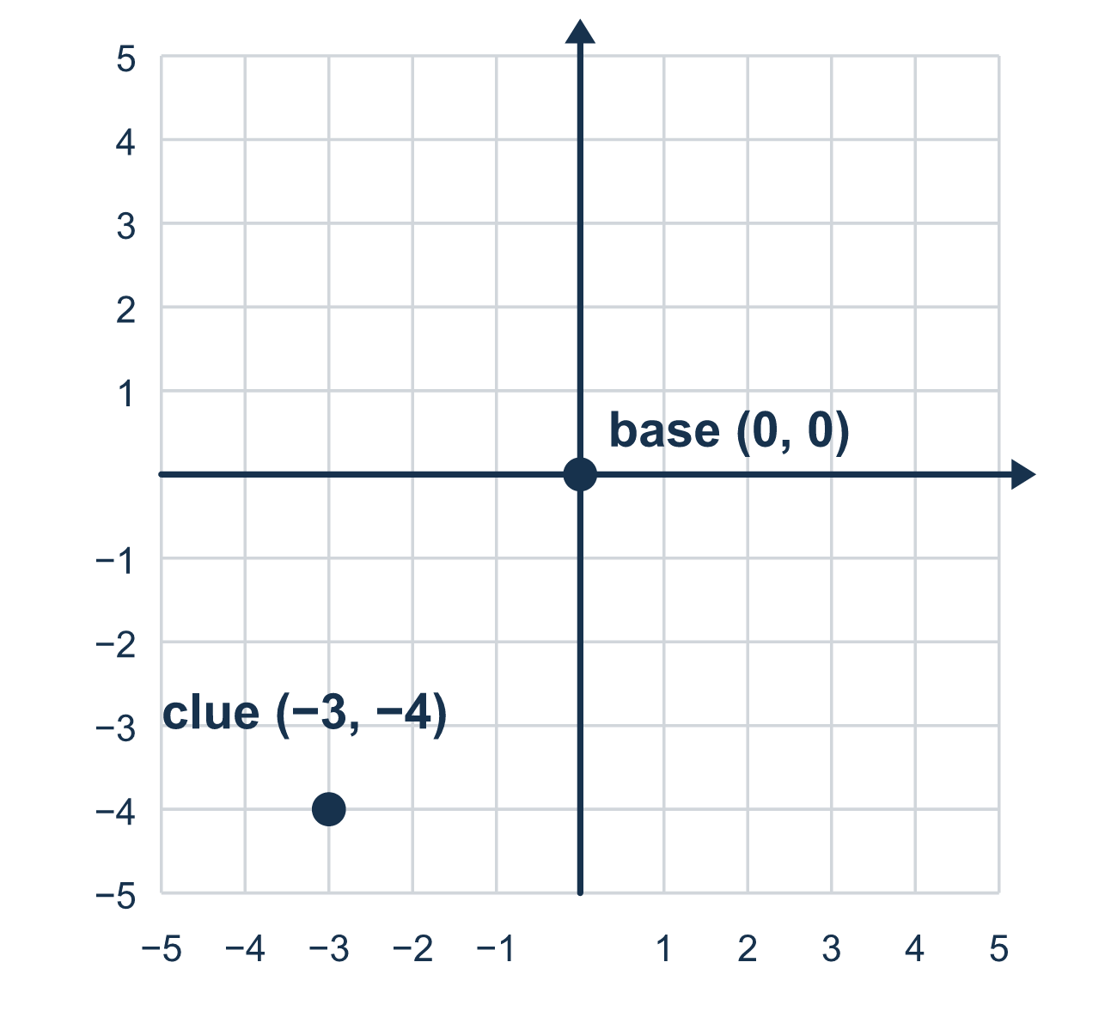
Our class model: the sign tells the way

Try it
Work it out on paper. Write one answer on each line.
- To plot (−2, 5), which way do you move for the −2?
A. Right 2 B. Left 2 C. Up 2 D. Down 2
My answer
- To plot (4, −3), which way do you move for the −3?
A. Left 3 B. Up 3 C. Down 3 D. Right 3
My answer
- Which ordered pair is 3 units left and 2 units down from the origin?
A. (3, 2) B. (−2, −3) C. (3, −2) D. (−3, −2)
My answer
- Which ordered pair names a point in the upper-left part of the grid?
A. (−2, 3) B. (2, 3) C. (2, −3) D. (−2, −3)
My answer
- A point has coordinates (−4, 6). Starting at the origin, how do you reach it?
A. Right 4, up 6 B. Left 6, up 4 C. Left 4, up 6 D. Left 4, down 6
My answer

Talk about it
Which way does a negative first number send you? Which way does a negative second number send you?

Home mission
Make the middle of a table «base camp.» Hide a coin by saying where it is. Use a pair like (−2, 1). Your student shows which way to move for each number. Then switch roles.

If we get stuck, ask
- Is the first number positive or negative? Does that mean left or right?
- Is the second number positive or negative? Does that mean up or down?
- We always start at the center, the origin. Put your finger there first.

Do it on a screen

Scan or type the link. Same lesson, with hints. eduwonderlab.com/lessons/7-8/homework.html
How did it feel? (optional) ☐ Tricky ☐ Getting there ☐ Got it

Family Math Studio · For grown-ups Lesson 7.8 · 6.NOS.7

Answers and talk notes
Ordered Pairs in All Four Quadrants

What your student is learning
Tonight we plot points in all four parts of the grid, called quadrants. Now the numbers can be negative, which means left or down.

Answers
Ask your student to explain before you look.
- B. Left 2. A negative first number means move left, so Left 2.
- C. Down 3. A negative second number means move down, so Down 3.
- D. (−3, −2). Left 3 is x = −3 and down 2 is y = −2, so (−3, −2).
- A. (−2, 3). Upper left means left (negative x) and up (positive y), so (−2, 3).
- C. Left 4, up 6. −4 means left 4 and 6 means up 6: Left 4, up 6.

Talk about it
Which way does a negative first number send you? Which way does a negative second number send you?

When they are stuck, ask
- Is the first number positive or negative? Does that mean left or right?
- Is the second number positive or negative? Does that mean up or down?
- We always start at the center, the origin. Put your finger there first.

Try not to say
- A negative sign just means the same direction, right and up.
- Ignore the negative signs and plot the point in Quadrant I.
- The order of the numbers does not matter anymore with negatives.

Home mission
Make the middle of a table «base camp.» Hide a coin by saying where it is. Use a pair like (−2, 1). Your student shows which way to move for each number. Then switch roles.

