Family Math Studio Lesson 7.9 · Session 2 · 6.NOS.7

Reflect Points Across Axes
Reflect points across an axis and check the distance from the mirror line.
Name Date

Tonight's spark
A scavenger hunt map shows a prize at (−6, 4). The host hides a decoy at its mirror twin across the y-axis. How far from the y-axis is the decoy? Make a guess first: is the decoy closer to the y-axis than the prize, or farther?
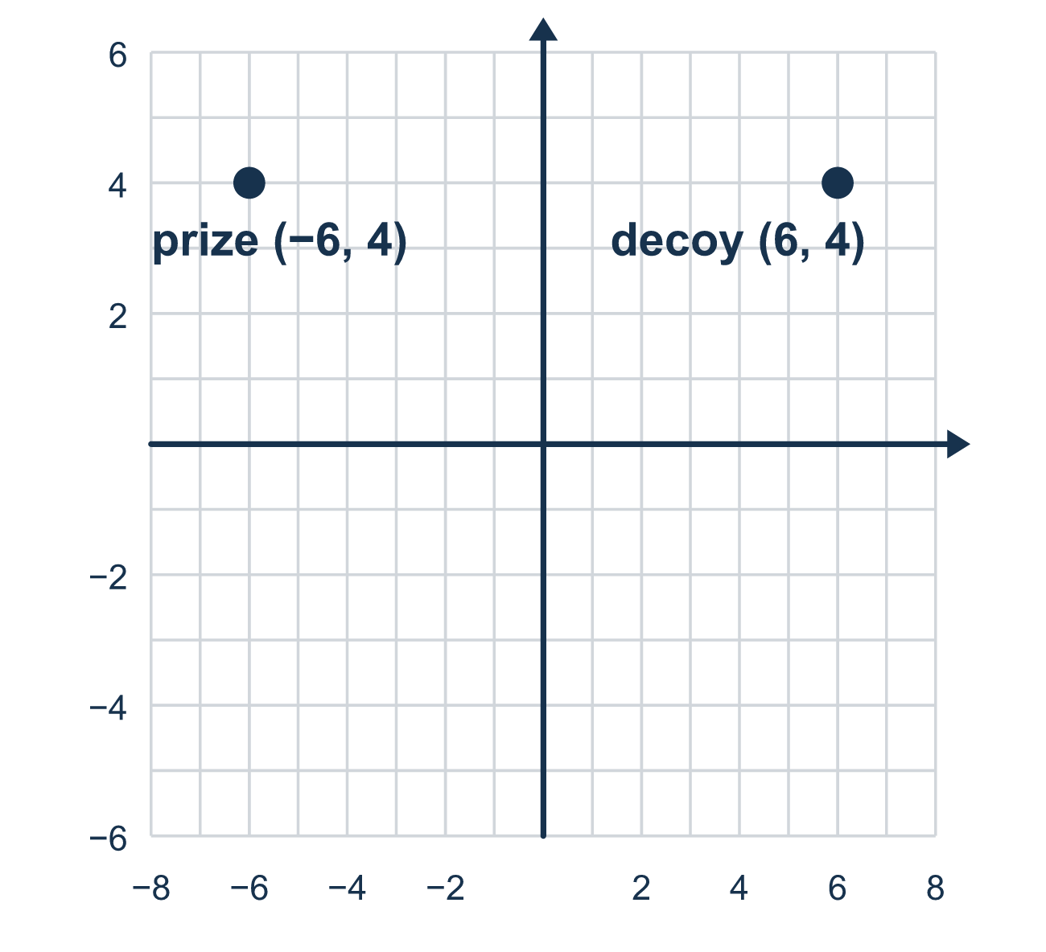
Our class model: same distance from the mirror

Try it
Work it out on paper. Write one answer on each line.
- Reflect (−4, 2) over the y-axis.
A. (4, 2) B. (−4, −2) C. (4, −2) D. (−4, 2)
My answer
- How far is the point (−7, 3) from the y-axis?
A. 3 units B. 7 units C. −7 units D. 10 units
My answer
- (5, −2) is reflected over the x-axis. How far is the new point from the x-axis?
A. 5 units B. 3 units C. 2 units D. 7 units
My answer
- The point (−9, 4) is reflected over the y-axis. Where is its reflection?
A. (9, −4) B. (−9, −4) C. (4, 9) D. (9, 4)
My answer
- A chest is at (6, −1). Its decoy is the reflection over the x-axis. Where is the decoy?
A. (−6, −1) B. (6, 1) C. (−6, 1) D. (1, 6)
My answer

Talk about it
How far is the chest from the mirror axis? How far is the decoy?

Home mission
Use a long table edge or a strip of tape as a mirror line. Place a coin 4 finger-widths from it. Can your student place the coin's mirror twin? Then move the coin closer. What happens to the twin?

If we get stuck, ask
- Which axis is the mirror line here?
- Which coordinate has the same name as that axis?
- Are both points the same distance from the mirror?

Do it on a screen

Scan or type the link. Same lesson, with hints. eduwonderlab.com/lessons/7-9-part2/homework.html
How did it feel? (optional) ☐ Tricky ☐ Getting there ☐ Got it

Family Math Studio · For grown-ups Lesson 7.9 · Session 2 · 6.NOS.7

Answers and talk notes
Reflect Points Across Axes

What your student is learning
Tonight we reflect a point across an axis in a real map problem — and check the distance from the mirror line.

Answers
Ask your student to explain before you look.
- A. (4, 2). Over the y-axis, x changes sign: (4, 2).
- B. 7 units. The x-coordinate measures distance from the y-axis, and |−7| = 7 units.
- C. 2 units. The new point is (5, 2), and |2| = 2 units from the x-axis.
- D. (9, 4). Over the y-axis, x changes sign, so the reflection is (9, 4), also 9 units from the axis.
- B. (6, 1). Over the x-axis, y changes sign, so the decoy is at (6, 1).

Talk about it
How far is the chest from the mirror axis? How far is the decoy?

When they are stuck, ask
- Which axis is the mirror line here?
- Which coordinate has the same name as that axis?
- Are both points the same distance from the mirror?

Try not to say
- Reflecting over the x-axis flips the x-coordinate.
- Change both signs for any reflection.
- The distance to the mirror can be different on each side.

Home mission
Use a long table edge or a strip of tape as a mirror line. Place a coin 4 finger-widths from it. Can your student place the coin's mirror twin? Then move the coin closer. What happens to the twin?

