Family Math Studio Lesson 7.9 · 6.NOS.7

Reflect Points Across Axes
Reflect points across the x-axis and the y-axis.
Name Date

Tonight's spark
A treasure marker sits at (3, 2) on a map. The map is folded along the up-and-down line through the center, like a mirror. Where does the marker's twin land? Make a guess first: does the twin land on the left side or the right side?
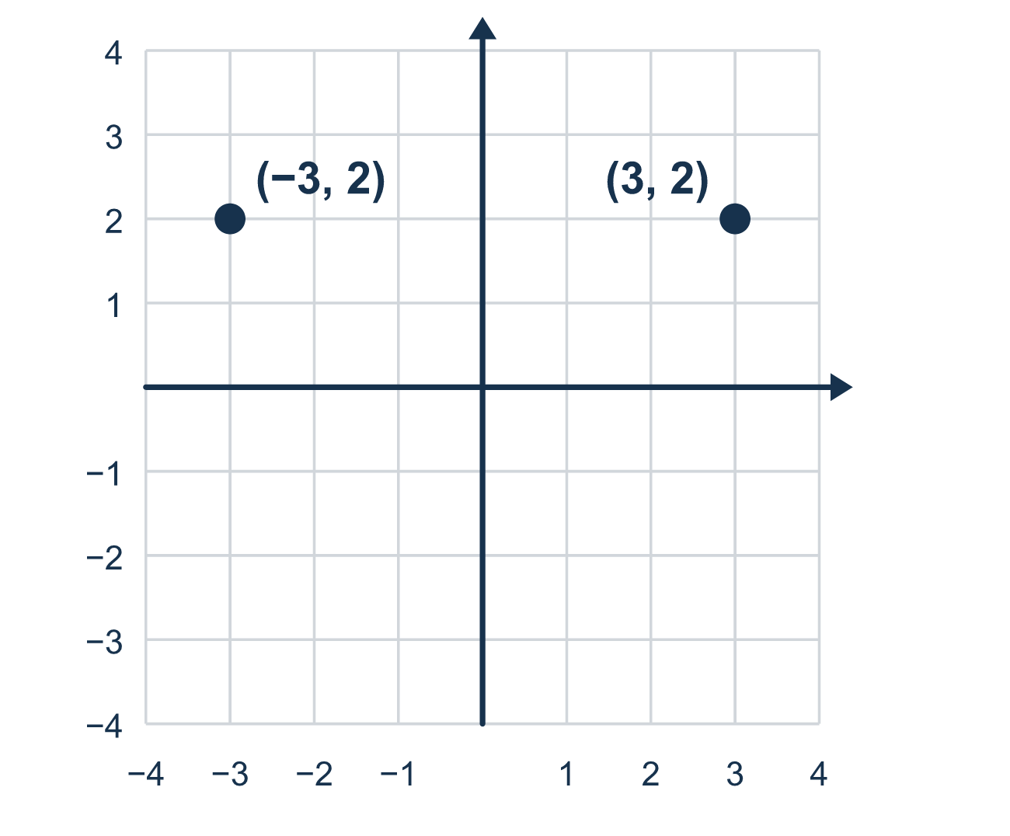
Our class model: the axis you flip over

Try it
Work it out on paper. Write one answer on each line.
- Reflecting over the y-axis changes the sign of which coordinate?
A. The x-coordinate B. The y-coordinate C. Both coordinates
My answer
- Reflect (5, 2) over the y-axis.
A. (5, −2) B. (−5, 2) C. (−5, −2) D. (2, 5)
My answer
- Reflect (−3, 4) over the x-axis.
A. (3, 4) B. (3, −4) C. (−3, 4) D. (−3, −4)
My answer
- Reflect (1, −6) over the y-axis.
A. (−1, −6) B. (1, 6) C. (−1, 6) D. (−6, 1)
My answer
- A point is reflected over the x-axis and lands at (7, −3). What was the original point?
A. (−7, −3) B. (7, 3) C. (−7, 3) D. (3, −7)
My answer
- Which pair of points are reflections of each other over the y-axis?
A. (2, 3) and (2, −3) B. (2, 3) and (−2, −3) C. (2, 3) and (−2, 3) D. (2, 3) and (3, 2)
My answer

Talk about it
Which axis is the mirror? Which coordinate changes sign and which stays the same?

Home mission
Stand a small toy 3 spoon-lengths in front of a mirror. How far behind the mirror does its twin seem to be? Move the toy to 5 spoon-lengths. What happens to the twin?

If we get stuck, ask
- Which line are we flipping over, the x-axis or the y-axis?
- Over the x-axis the y changes; over the y-axis the x changes. Which one is it here?
- Only one number changes its sign. Which number stays exactly the same?

Do it on a screen

Scan or type the link. Same lesson, with hints. eduwonderlab.com/lessons/7-9/homework.html
How did it feel? (optional) ☐ Tricky ☐ Getting there ☐ Got it

Family Math Studio · For grown-ups Lesson 7.9 · 6.NOS.7

Answers and talk notes
Reflect Points Across Axes

What your student is learning
Tonight we reflect points across the x-axis and the y-axis. A reflection is a flip, like a mirror image.

Answers
Ask your student to explain before you look.
- A. The x-coordinate. The x-coordinate changes sign: the y-axis is vertical, so the point flips left or right.
- B. (−5, 2). Over the y-axis, x changes sign: (−5, 2).
- D. (−3, −4). Over the x-axis, y changes sign: (−3, −4).
- A. (−1, −6). Over the y-axis, x changes sign: (−1, −6).
- B. (7, 3). Reflecting again undoes the flip, so the original point was (7, 3).
- C. (2, 3) and (−2, 3). (2, 3) and (−2, 3) have opposite x-coordinates and the same y-coordinate.

Talk about it
Which axis is the mirror? Which coordinate changes sign and which stays the same?

When they are stuck, ask
- Which line are we flipping over, the x-axis or the y-axis?
- Over the x-axis the y changes; over the y-axis the x changes. Which one is it here?
- Only one number changes its sign. Which number stays exactly the same?

Try not to say
- When you reflect, both numbers change their signs.
- Reflecting over the x-axis changes the x-coordinate.
- A reflection moves the point closer to the line.

Home mission
Stand a small toy 3 spoon-lengths in front of a mirror. How far behind the mirror does its twin seem to be? Move the toy to 5 spoon-lengths. What happens to the twin?

