Family Math Studio Lesson 8.1 · Session 2 · 6.AT.8

Understand Equations and Their Solutions
Write equations from words, then test and revise your guess.
Name Date

Tonight's spark
A corner bakery made 64 rolls. Some were sold, and 27 are left. How many rolls were sold? Make a guess first: were more than 30 rolls sold, or fewer?
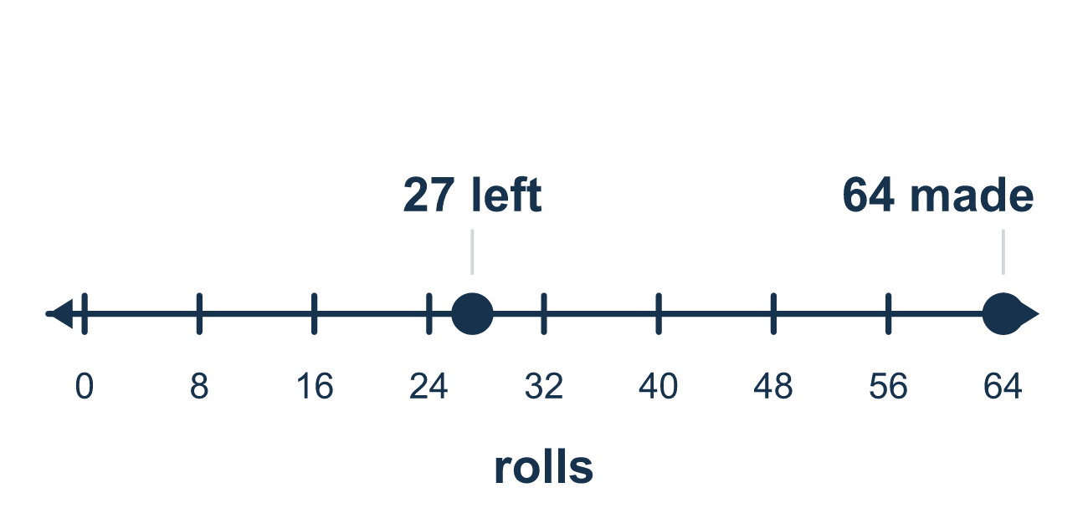
Our class model: say it in words first

Try it
Work it out on paper. Write one answer on each line.
- Which phrase matches n + 8?
A. a number divided by 8 B. a number increased by 8 C. 8 times a number D. a number decreased by 8
My answer
- Which expression matches 'a number decreased by 8'?
A. n − 8 B. 8 − n C. n + 8 D. 8 ÷ n
My answer
- Which equation says 'a number divided by 4 is 6'?
A. 4 ÷ n = 6 B. n × 4 = 6 C. n ÷ 4 = 6 D. n − 4 = 6
My answer
- 'Twice a number is 18.' Which equation matches?
A. n + 2 = 18 B. n ÷ 2 = 18 C. n − 2 = 18 D. 2n = 18
My answer
- Jordan has $20 and spends m dollars on lunch. He has $13 left. Which equation shows this?
A. 20 − m = 13 B. m − 20 = 13 C. 20 + m = 13 D. m ÷ 20 = 13
My answer
- Is n = 9 a solution of n − 4 = 5?
A. No, because 9 − 4 = 13 B. No, because 9 is bigger than 5 C. Yes, because 9 − 4 = 5 D. Yes, because 9 + 4 = 5
My answer

Talk about it
What does your letter stand for? Which number comes first in the symbols, and why?

Home mission
Count out 12 spoons or coins. Hide some under a cup and leave 7 in view. Can your student write 12 − c = 7? Then lift the cup to test a guess.

If we get stuck, ask
- What are we trying to find? Give it a letter.
- Can you say the relationship in words before using symbols?
- Try a number. Was it too big or too small?

Do it on a screen

Scan or type the link. Same lesson, with hints. eduwonderlab.com/lessons/8-1-part2/homework.html
How did it feel? (optional) ☐ Tricky ☐ Getting there ☐ Got it

Family Math Studio · For grown-ups Lesson 8.1 · Session 2 · 6.AT.8

Answers and talk notes
Understand Equations and Their Solutions

What your student is learning
Tonight we turn a word problem into an equation — naming the unknown, writing the sentence in symbols, and testing a guess.

Answers
Ask your student to explain before you look.
- B. a number increased by 8. The phrase a number increased by 8 means n + 8.
- A. n − 8. n − 8 is correct because the number comes first and 8 is taken away.
- C. n ÷ 4 = 6. n ÷ 4 = 6 puts the unknown number first and divides it by 4.
- D. 2n = 18. 2n = 18 means 2 times the number is 18.
- A. 20 − m = 13. 20 − m = 13 shows starting with 20 and taking away m.
- C. Yes, because 9 − 4 = 5. Yes, because 9 − 4 = 5, so both sides match.

Talk about it
What does your letter stand for? Which number comes first in the symbols, and why?

When they are stuck, ask
- What are we trying to find? Give it a letter.
- Can you say the relationship in words before using symbols?
- Try a number. Was it too big or too small?

Try not to say
- Write the numbers in the order they appear in the sentence.
- Guessing is not real math, just solve it.
- "Decreased by 8" means 8 minus the number.

Home mission
Count out 12 spoons or coins. Hide some under a cup and leave 7 in view. Can your student write 12 − c = 7? Then lift the cup to test a guess.

