Family Math Studio Lesson 8.1 · 6.AT.8

Understand Equations and Their Solutions
Write an equation for a situation and check whether a value is a solution.
Name Date

Tonight's spark
An escape-game clue card says: some stolen gems plus 8 more equals 20 gems. How many gems were stolen at first? Make a guess first: is the number more than 10, or less?
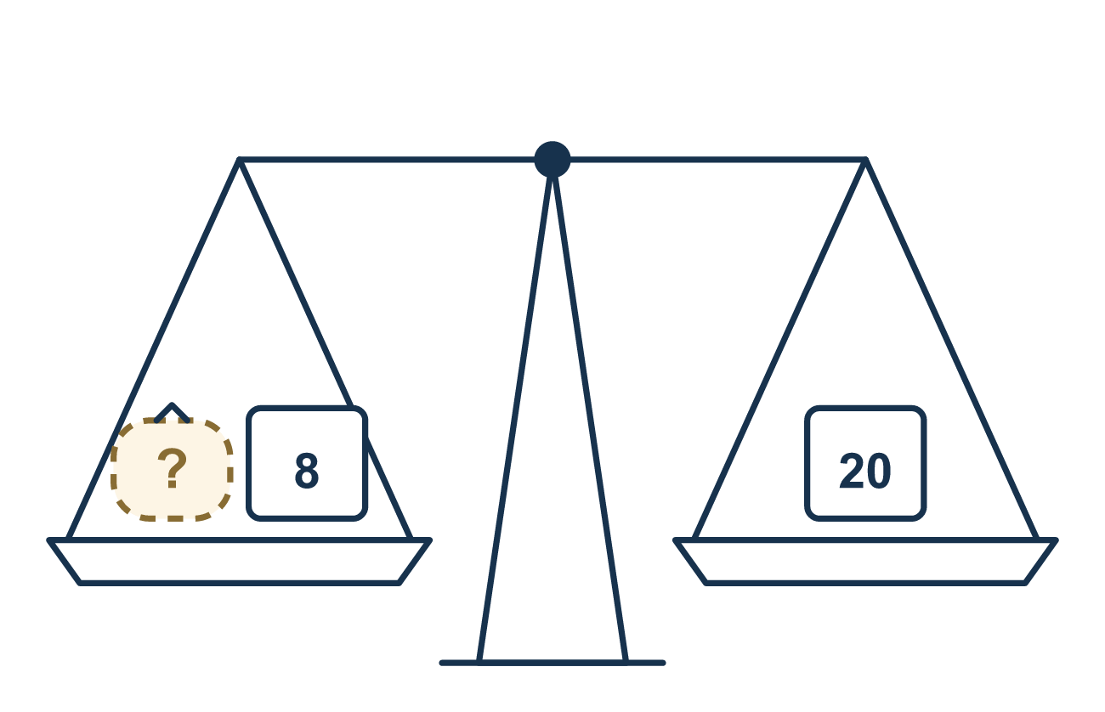
Our class model: match the words to symbols

Try it
Work it out on paper. Write one answer on each line.
- Which of these is an equation?
A. x + 5 B. x + 5 = 12 C. 12 + 5 D. n × 3
My answer
- In the equation n + 4 = 9, which part is the variable?
A. 4 B. 9 C. n D. +
My answer
- Which value is the solution of x + 3 = 9?
A. 6 B. 12 C. 3 D. 9
My answer
- Sam had 12 stickers and gave away s stickers. He has 7 left. Which equation matches?
A. s − 12 = 7 B. 12 + s = 7 C. 12 × s = 7 D. 12 − s = 7
My answer
- Is y = 4 a solution of 3y = 12?
A. No, because 3 × 4 = 7 B. No, because 4 is not 12 C. Yes, because 3 × 4 = 12 D. Yes, because 3 + 4 = 12
My answer

Talk about it
What does the letter stand for in your equation? Which number makes both sides equal?

Home mission
Hide some coins in a cup. Put 3 more coins next to it. Say, «The cup plus 3 coins is 10 coins.» Can your student write n + 3 = 10? Then test a guess by putting it in for n.

If we get stuck, ask
- What number are we trying to find? Let's pick a letter for it.
- What does the word 'plus' tell us to write? And the word 'equals'?
- Read the clue out loud. What is each part telling us to do?

Do it on a screen

Scan or type the link. Same lesson, with hints. eduwonderlab.com/lessons/8-1/homework.html
How did it feel? (optional) ☐ Tricky ☐ Getting there ☐ Got it

Family Math Studio · For grown-ups Lesson 8.1 · 6.AT.8

Answers and talk notes
Understand Equations and Their Solutions

What your student is learning
Tonight we turn a word clue into an equation, and we check whether a value is a solution by substituting it.

Answers
Ask your student to explain before you look.
- B. x + 5 = 12. x + 5 = 12 is an equation because it has an equal sign between two sides.
- C. n. n is the variable because it is a letter standing for an unknown number.
- A. 6. The solution is 6 because 6 + 3 = 9.
- D. 12 − s = 7. 12 − s = 7 matches because he starts with 12 and takes away s.
- C. Yes, because 3 × 4 = 12. Yes, because 3 × 4 = 12, so both sides are equal.

Talk about it
What does the letter stand for in your equation? Which number makes both sides equal?

When they are stuck, ask
- What number are we trying to find? Let's pick a letter for it.
- What does the word 'plus' tell us to write? And the word 'equals'?
- Read the clue out loud. What is each part telling us to do?

Try not to say
- An equation is any sentence that has numbers in it.
- You don't need the equal sign.
- Just guess the answer instead of writing the equation.

Home mission
Hide some coins in a cup. Put 3 more coins next to it. Say, «The cup plus 3 coins is 10 coins.» Can your student write n + 3 = 10? Then test a guess by putting it in for n.

