Family Math Studio Lesson 8.2 · Session 2 · 6.AT.8

Write and Solve Equations Using Addition or Subtraction
Solve equations that subtract by adding the same amount to both sides.
Name Date

Tonight's spark
A corner store had some bags of chips on the shelf. Today it sold 18 bags. Now 27 bags are left. How many bags were on the shelf this morning? Guess first: were there more than 27 bags, or fewer?
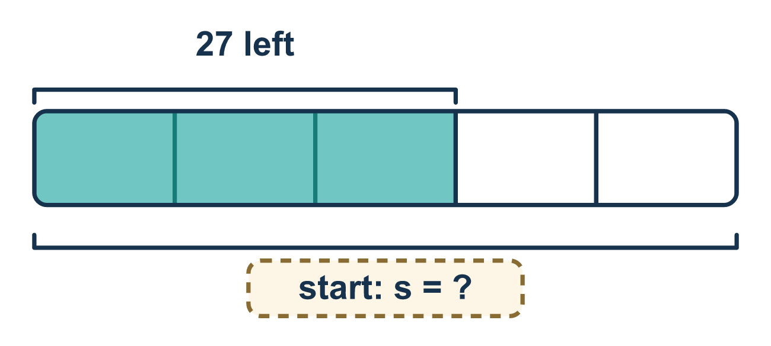
Our class model: adding back to undo subtracting

Try it
Work it out on paper. Write one answer on each line.
- What undoes subtracting 4?
A. Adding 4 B. Subtracting 4 C. Multiplying by 4 D. Dividing by 4
My answer
- Solve: x − 5 = 3
A. 2 B. 8 C. 15 D. 3
My answer
- Solve: n − 10 = 6
A. 4 B. 60 C. 16
My answer
- Solve: k − 7 = 12
A. 5 B. 84 C. 12 D. 19
My answer
- Is x = 20 a solution of x − 9 = 11?
A. Yes, because 20 − 9 = 11 B. No, because 20 − 9 = 29 C. No, because 20 is bigger than 11 D. Yes, because 20 + 9 = 11
My answer
- Lena had some money. She spent $6 and has $9 left, so m − 6 = 9. How much did she start with?
A. $3 B. $54 C. $15 D. $9
My answer

Talk about it
Why does adding undo the subtraction? What must you do to the other side?

Home mission
Fill a bowl with beans without counting. Take out 18 and count what is left. Say s − 18 = your count. Can your student find s? Pour them back to check.

If we get stuck, ask
- What operation do you see in the equation?
- What is the opposite of that operation?
- Did you do it to both sides?

Do it on a screen

Scan or type the link. Same lesson, with hints. eduwonderlab.com/lessons/8-2-part2/homework.html
How did it feel? (optional) ☐ Tricky ☐ Getting there ☐ Got it

Family Math Studio · For grown-ups Lesson 8.2 · Session 2 · 6.AT.8

Answers and talk notes
Write and Solve Equations Using Addition or Subtraction

What your student is learning
Tonight we solve equations where something was SUBTRACTED from the variable — by adding it back to both sides.

Answers
Ask your student to explain before you look.
- A. Adding 4. Adding 4 undoes subtracting 4.
- B. 8. x = 8, because 3 + 5 = 8.
- C. 16. n = 16, because 6 + 10 = 16.
- D. 19. k = 19, because 12 + 7 = 19.
- A. Yes, because 20 − 9 = 11. Yes, because 20 − 9 = 11, so both sides match.
- C. $15. She started with $15, because 9 + 6 = 15.

Talk about it
Why does adding undo the subtraction? What must you do to the other side?

When they are stuck, ask
- What operation do you see in the equation?
- What is the opposite of that operation?
- Did you do it to both sides?

Try not to say
- Subtract 7 from both sides to solve x − 7 = 15.
- You only need to change the side with the variable.
- Skip the check, you did the steps right.

Home mission
Fill a bowl with beans without counting. Take out 18 and count what is left. Say s − 18 = your count. Can your student find s? Pour them back to check.

