Family Math Studio Lesson 8.2 · 6.AT.8

Write and Solve Equations Using Addition or Subtraction
Solve equations that add or subtract by undoing the operation on both sides.
Name Date

Tonight's spark
A rec-center team has 23 points at halftime. The final scoreboard says 58. How many points did the team score in the second half? Guess first: did they score more than 30 points, or fewer?
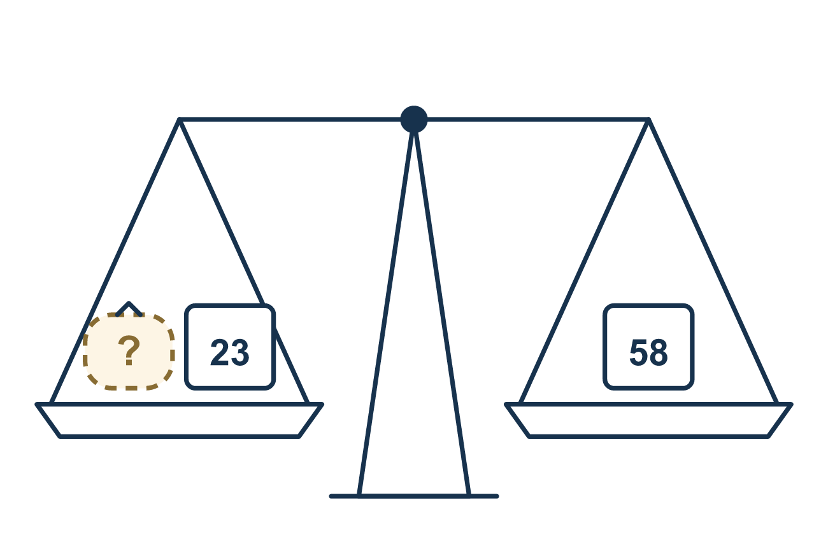
Our class model: the balance and the inverse move

Try it
Work it out on paper. Write one answer on each line.
- What is the inverse (opposite) operation of adding 5?
A. Adding 5 B. Subtracting 5 C. Multiplying by 5 D. Dividing by 5
My answer
- Solve: x + 6 = 10
A. 16 B. 6 C. 4 D. 10
My answer
- Solve: n − 3 = 7
A. 4 B. 10 C. 21
My answer
- To solve m + 12 = 20, what do you do to both sides?
A. Subtract 12 B. Add 12 C. Divide by 12 D. Subtract 20
My answer
- A game costs $24. You have $15 and need m more dollars, so 15 + m = 24. What is m?
A. $39 B. $15 C. $24 D. $9
My answer
- Solve: p − 8 = 14
A. 6 B. 112 C. 22
My answer

Talk about it
What operation undoes + 4? What did you do to both sides to keep the balance?

Home mission
Count out 58 beans. Cover 23 of them with a cup. Ask: how many beans are showing? What equation says showing + 23 = 58? Then count to check.

If we get stuck, ask
- Is the number being added or subtracted? What is the opposite action?
- Did we do the same thing to both sides to keep it balanced?
- Let's put the answer back in and check if the sentence is true.

Do it on a screen

Scan or type the link. Same lesson, with hints. eduwonderlab.com/lessons/8-2/homework.html
How did it feel? (optional) ☐ Tricky ☐ Getting there ☐ Got it

Family Math Studio · For grown-ups Lesson 8.2 · 6.AT.8

Answers and talk notes
Write and Solve Equations Using Addition or Subtraction

What your student is learning
Tonight we solve an equation that adds or subtracts. To solve means to find the number that makes the equation true.

Answers
Ask your student to explain before you look.
- B. Subtracting 5. Subtracting 5 undoes adding 5.
- C. 4. x = 4, because 10 − 6 = 4.
- B. 10. n = 10, because 7 + 3 = 10.
- A. Subtract 12. Subtract 12 from both sides to leave m alone.
- D. $9. m = $9, because 24 − 15 = 9.
- C. 22. p = 22, because 14 + 8 = 22.

Talk about it
What operation undoes + 4? What did you do to both sides to keep the balance?

When they are stuck, ask
- Is the number being added or subtracted? What is the opposite action?
- Did we do the same thing to both sides to keep it balanced?
- Let's put the answer back in and check if the sentence is true.

Try not to say
- To undo adding 23, just add 23 again.
- You only have to change one side.
- Don't bother checking the answer.

Home mission
Count out 58 beans. Cover 23 of them with a cup. Ask: how many beans are showing? What equation says showing + 23 = 58? Then count to check.

