Family Math Studio Lesson 8.3 · Session 2 · 6.AT.8

Write and Solve Equations Using Multiplication or Division
Solve equations where the letter is divided by multiplying both sides.
Name Date

Tonight's spark
A torn supply receipt shows a box of pens shared evenly. Six club members each got 13 pens. The box total is torn off. How many pens were in the box? Guess first: were there more than 50 pens in the box, or fewer?
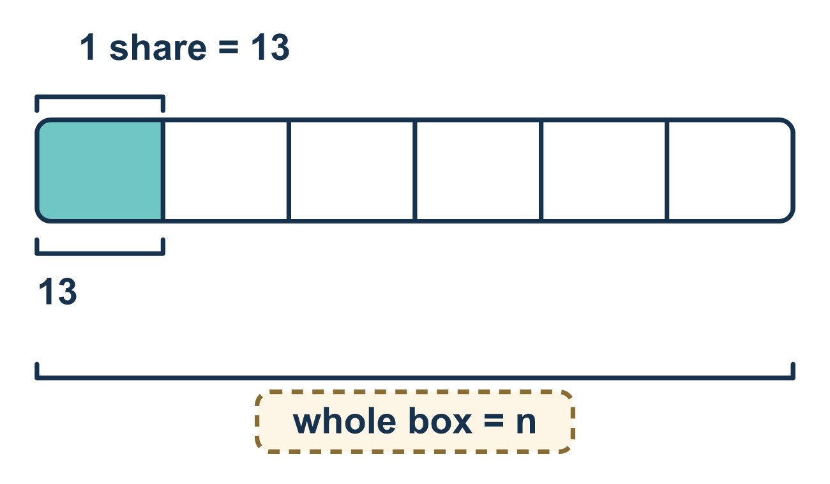
Our class model: multiply to undo dividing

Try it
Work it out on paper. Write one answer on each line.
- What undoes dividing by 6?
A. Dividing by 6 B. Subtracting 6 C. Multiplying by 6 D. Adding 6
My answer
- Solve: n ÷ 2 = 8
A. 4 B. 6 C. 10 D. 16
My answer
- Solve: x ÷ 5 = 4
A. 1 B. 20 C. 9
My answer
- Solve: m ÷ 3 = 7
A. 21 B. 10 C. 4
My answer
- Which equation can be solved by multiplying both sides by 4?
A. x + 4 = 9 B. x ÷ 4 = 9 C. 4x = 36 D. x − 4 = 9
My answer

Talk about it
Why do we multiply to undo dividing? What would go wrong if you divided by 4 again?

Home mission
Put the same number of beans in each of 6 cups, without counting out loud. Tell your student only how many are in one cup, such as 4. Can they say how many beans there are in all? Pour the cups together to check.

If we get stuck, ask
- Is the variable being multiplied or divided here?
- What is the opposite of that?
- What does your answer mean in the story?

Do it on a screen

Scan or type the link. Same lesson, with hints. eduwonderlab.com/lessons/8-3-part2/homework.html
How did it feel? (optional) ☐ Tricky ☐ Getting there ☐ Got it

Family Math Studio · For grown-ups Lesson 8.3 · Session 2 · 6.AT.8

Answers and talk notes
Write and Solve Equations Using Multiplication or Division

What your student is learning
Tonight we solve equations where the variable was DIVIDED — by multiplying both sides by the same number.

Answers
Ask your student to explain before you look.
- C. Multiplying by 6. Multiplying by 6 undoes dividing by 6.
- D. 16. n = 16, because 8 × 2 = 16.
- B. 20. x = 20, because 4 × 5 = 20.
- A. 21. m = 21, because 7 × 3 = 21.
- B. x ÷ 4 = 9. x ÷ 4 = 9 is solved by multiplying both sides by 4.

Talk about it
Why do we multiply to undo dividing? What would go wrong if you divided by 4 again?

When they are stuck, ask
- Is the variable being multiplied or divided here?
- What is the opposite of that?
- What does your answer mean in the story?

Try not to say
- Multiply both sides by 6 to solve 6x = 42.
- Do the same operation you see in the equation.
- The answer is just a number, the units do not matter.

Home mission
Put the same number of beans in each of 6 cups, without counting out loud. Tell your student only how many are in one cup, such as 4. Can they say how many beans there are in all? Pour the cups together to check.

