Family Math Studio Lesson 8.3 · 6.AT.8

Write and Solve Equations Using Multiplication or Division
Solve equations that multiply or divide by doing the opposite to both sides.
Name Date

Tonight's spark
At a family escape game, Detective Park locks 21 clues in 3 identical boxes. Every box holds the same number of clues. How many clues are in one box? Guess first: are there more than 10 clues in one box, or fewer?
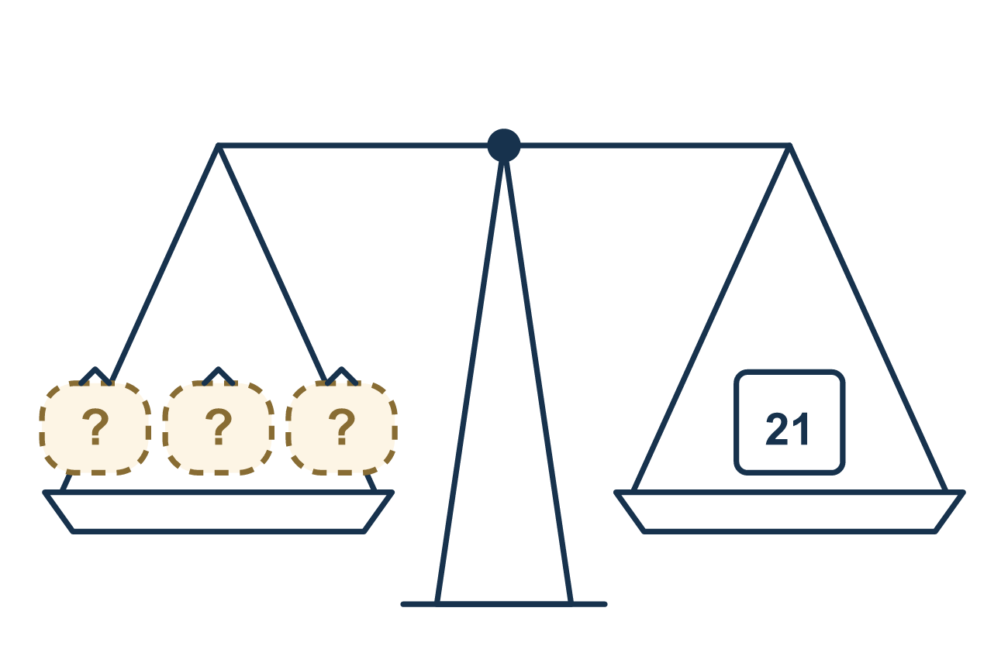
Our class model: undo it on both sides

Try it
Work it out on paper. Write one answer on each line.
- What undoes multiplying by 4?
A. Multiplying by 4 B. Dividing by 4 C. Adding 4 D. Subtracting 4
My answer
- Solve: 3x = 12
A. 36 B. 9 C. 4 D. 15
My answer
- Solve: 5n = 35
A. 7 B. 30 C. 175
My answer
- In 8g = 56, what do you do to both sides?
A. Subtract 8 B. Multiply by 8 C. Divide by 56 D. Divide by 8
My answer
- A pack holds 4 pencils, so 4p = 24 shows how many packs hold 24 pencils. What is p?
A. 20 B. 6 C. 28 D. 96
My answer
- Which value is the solution of 7z = 42?
A. 35 B. 294 C. 6 D. 49
My answer

Talk about it
What operation undoes multiplying by 3? What did you do to both sides?

Home mission
Count out 21 beans. Deal them one at a time into 3 cups, like dealing cards. Before counting, ask: how many are in each cup? What equation shows 3 cups with the same amount and 21 in all?

If we get stuck, ask
- Is the letter being multiplied or divided? What is the opposite?
- Did we do the same operation to both sides?
- Let's put the answer back in and check if it is true.

Do it on a screen

Scan or type the link. Same lesson, with hints. eduwonderlab.com/lessons/8-3/homework.html
How did it feel? (optional) ☐ Tricky ☐ Getting there ☐ Got it

Family Math Studio · For grown-ups Lesson 8.3 · 6.AT.8

Answers and talk notes
Write and Solve Equations Using Multiplication or Division

What your student is learning
Tonight we solve equations that multiply or divide. We use the opposite operation to get the letter by itself.

Answers
Ask your student to explain before you look.
- B. Dividing by 4. Dividing by 4 undoes multiplying by 4.
- C. 4. x = 4, because 12 ÷ 3 = 4.
- A. 7. n = 7, because 35 ÷ 5 = 7.
- D. Divide by 8. Divide by 8 on both sides to leave g alone.
- B. 6. p = 6 packs, because 24 ÷ 4 = 6.
- C. 6. z = 6, because 42 ÷ 7 = 6.

Talk about it
What operation undoes multiplying by 3? What did you do to both sides?

When they are stuck, ask
- Is the letter being multiplied or divided? What is the opposite?
- Did we do the same operation to both sides?
- Let's put the answer back in and check if it is true.

Try not to say
- To undo multiplying by 3, multiply by 3 again.
- To undo dividing by 4, divide by 4 again.
- You only need to change one side.

Home mission
Count out 21 beans. Deal them one at a time into 3 cups, like dealing cards. Before counting, ask: how many are in each cup? What equation shows 3 cups with the same amount and 21 in all?

