Family Math Studio Lesson 8.4 · Session 2 · 6.AT.9

Write and Represent Inequalities
Show an inequality on a number line with an open or closed circle.
Name Date

Tonight's spark
An elevator sign says: "No more than 12 people." You draw the allowed counts on a number line. Is the circle at 12 filled in, or left empty? Guess first: can exactly 12 people ride, yes or no?
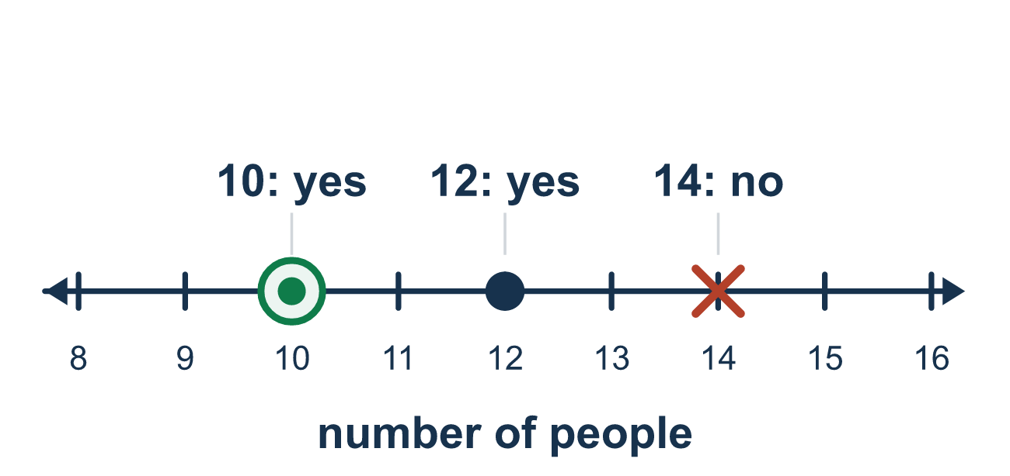
Our class model: the closed-or-open circle test

Try it
Work it out on paper. Write one answer on each line.
- On a number line, what does a closed (filled) circle at 4 tell you?
A. 4 is not a solution B. 4 is a solution C. Only 4 is a solution D. 4 is the smallest number
My answer
- Which inequality needs an open circle at 6?
A. x ≥ 6 B. x ≤ 6 C. x > 6 D. x = 6
My answer
- Which inequality needs a closed circle at 9?
A. x ≤ 9 B. x < 9 C. x > 9
My answer
- The graph of x > 2 has an open circle at 2. Which way is it shaded?
A. Left, toward smaller numbers B. Both directions C. Nowhere, it is only a dot D. Right, toward larger numbers
My answer
- A graph has a closed circle at 5 and shading to the left. Which inequality does it show?
A. x < 5 B. x ≤ 5 C. x > 5 D. x ≥ 5
My answer

Talk about it
Does the number at the circle count? How does the circle show that?

Home mission
Use a ruler as a number line. Say: "No more than 12 inches." Put a coin on 12. Should the coin count as a closed or open circle? Which way do you slide your finger?

If we get stuck, ask
- Does the boundary number itself count as a solution?
- Which words tell you that — "at most", "more than"?
- Which direction do the allowed values go?

Do it on a screen
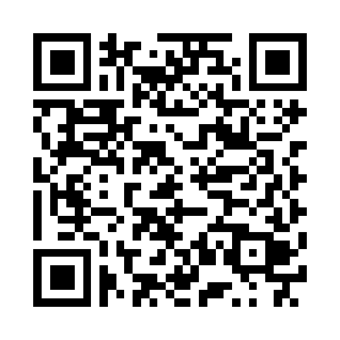
Scan or type the link. Same lesson, with hints. eduwonderlab.com/lessons/8-4-part2/homework.html
How did it feel? (optional) ☐ Tricky ☐ Getting there ☐ Got it

Family Math Studio · For grown-ups Lesson 8.4 · Session 2 · 6.AT.9

Answers and talk notes
Write and Represent Inequalities

What your student is learning
Tonight we show an inequality on a number line — and the open or closed circle tells whether the boundary number counts.

Answers
Ask your student to explain before you look.
- B. 4 is a solution. 4 is a solution, because a closed circle means the number is included.
- C. x > 6. x > 6 needs an open circle, because 6 is not a solution.
- A. x ≤ 9. x ≤ 9 needs a closed circle, because 9 is included.
- D. Right, toward larger numbers. Right, toward larger numbers, because x is greater than 2.
- B. x ≤ 5. x ≤ 5, because 5 is included and the shading goes toward smaller numbers.

Talk about it
Does the number at the circle count? How does the circle show that?

When they are stuck, ask
- Does the boundary number itself count as a solution?
- Which words tell you that — "at most", "more than"?
- Which direction do the allowed values go?

Try not to say
- "At least" means greater than, so use >.
- Use an open circle, it looks cleaner.
- An inequality has one answer like an equation.

Home mission
Use a ruler as a number line. Say: "No more than 12 inches." Put a coin on 12. Should the coin count as a closed or open circle? Which way do you slide your finger?

