Family Math Studio Lesson 8.4 · 6.AT.9

Write and Represent Inequalities
Write an inequality to show a real situation that has many possible answers.
Name Date

Tonight's spark
A sign at the volunteer desk says: "Must be at least 18 years old." Can a 17-year-old sign up? Can an 18-year-old? What about a 30-year-old? Guess first: does "at least 18" include exactly 18, yes or no?
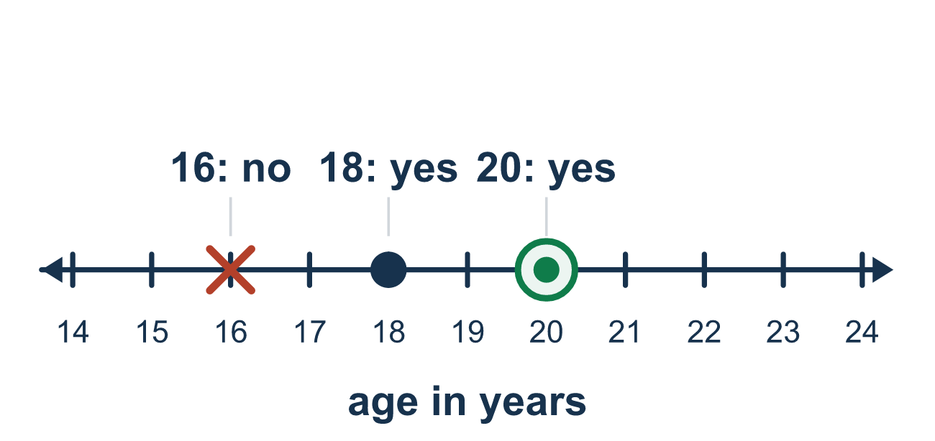
Our class model: the word-to-symbol match

Try it
Work it out on paper. Write one answer on each line.
- Which symbol means 'at least'?
A. < B. ≤ C. ≥ D. >
My answer
- Which inequality means 'x is less than 7'?
A. x < 7 B. x > 7 C. x ≥ 7 D. x = 7
My answer
- A sign says 'No more than 5 people.' Which inequality shows p?
A. p < 5 B. p ≤ 5 C. p ≥ 5 D. p > 5
My answer
- 'You must be at least 48 inches tall to ride.' Which inequality shows height h?
A. h ≤ 48 B. h > 48 C. h < 48 D. h ≥ 48
My answer
- Which words match n > 10?
A. n is at most 10 B. n is more than 10 C. n is fewer than 10 D. n is at least 10
My answer
- Which number makes x ≥ 6 true?
A. 5 B. 4 C. 6 D. 3
My answer

Talk about it
Which words in the sign tell you the symbol? Does the limit number itself fit?

Home mission
Gather some cups. Say: "I need at least 6 cups on the table." Would 6 cups work? 5? 9? Then write c ≥ 6 together.

If we get stuck, ask
- What is the key phrase — 'at least,' 'at most,' 'more than,' or 'fewer than'?
- Is the exact number allowed? That tells us if we use the line under the symbol.
- Can you name two numbers that would fit this rule?

Do it on a screen
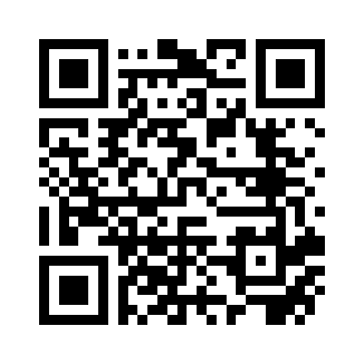
Scan or type the link. Same lesson, with hints. eduwonderlab.com/lessons/8-4/homework.html
How did it feel? (optional) ☐ Tricky ☐ Getting there ☐ Got it

Family Math Studio · For grown-ups Lesson 8.4 · 6.AT.9

Answers and talk notes
Write and Represent Inequalities

What your student is learning
Tonight we write inequalities. An inequality compares two amounts with the signs <, >, ≤, or ≥, when many values are allowed instead of just one.

Answers
Ask your student to explain before you look.
- C. ≥. ≥ means at least, which is greater than or equal to.
- A. x < 7. x < 7 means x is less than 7.
- B. p ≤ 5. p ≤ 5, because exactly 5 people are allowed and fewer is fine too.
- D. h ≥ 48. h ≥ 48, because 48 inches and taller are allowed.
- B. n is more than 10. n is more than 10 matches n > 10.
- C. 6. 6 makes x ≥ 6 true, because 6 is equal to 6.

Talk about it
Which words in the sign tell you the symbol? Does the limit number itself fit?

When they are stuck, ask
- What is the key phrase — 'at least,' 'at most,' 'more than,' or 'fewer than'?
- Is the exact number allowed? That tells us if we use the line under the symbol.
- Can you name two numbers that would fit this rule?

Try not to say
- 'At least 18' means more than 18, so use >.
- An inequality has just one answer, like an equation.
- The symbols < and > mean the same as ≤ and ≥.

Home mission
Gather some cups. Say: "I need at least 6 cups on the table." Would 6 cups work? 5? 9? Then write c ≥ 6 together.

