Family Math Studio Lesson 8.5 · Session 2 · 6.AT.9

Understand Inequalities and Their Solutions
Test numbers in an inequality to see which ones are solutions.
Name Date

Tonight's spark
A pizza coupon says: "Order total over $20 gets a free drink." Does an order of exactly $20 get the free drink? What about $21? Guess first: does exactly $20 get a free drink, yes or no?
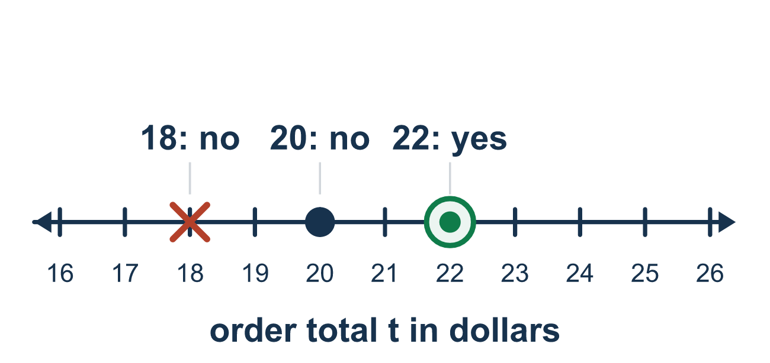
Our class model: test one value, then decide

Try it
Work it out on paper. Write one answer on each line.
- Is 5 a solution of x > 3?
A. Yes, because 5 > 3 is true B. No, because 5 > 3 is false C. No, because 5 does not equal 3 D. Only 3 is a solution
My answer
- Is 4 a solution of x ≥ 4?
A. No, because 4 is not more than 4 B. Yes, because 4 ≥ 4 is true C. Yes, because 4 > 4 D. No, because inequalities never allow equal
My answer
- Is 4 a solution of x < 4?
A. Yes, because 4 = 4 B. Yes, because 4 < 4 C. No, because 4 < 4 is false D. No, because 4 is negative
My answer
- Which value is a solution of x ≤ 9?
A. 10 B. 11 C. 12 D. 9
My answer
- How many solutions does x > 2 have?
A. Exactly one B. Exactly two C. Many D. None
My answer

Talk about it
Was the boundary number a solution? How does that tell you which circle to draw?

Home mission
Find a real coupon or receipt. Say: "Over $20 gets a free drink." Is 20 > 20 true? Test $21 and $25 the same way. What does that tell you about the circle at 20?

If we get stuck, ask
- Put that number in. Is the statement true or false?
- What happens when you test the boundary number itself?
- Does the symbol point toward bigger numbers or smaller ones?

Do it on a screen
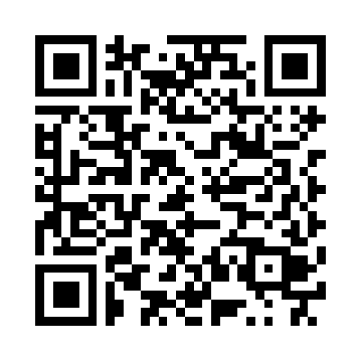
Scan or type the link. Same lesson, with hints. eduwonderlab.com/lessons/8-5-part2/homework.html
How did it feel? (optional) ☐ Tricky ☐ Getting there ☐ Got it

Family Math Studio · For grown-ups Lesson 8.5 · Session 2 · 6.AT.9

Answers and talk notes
Understand Inequalities and Their Solutions

What your student is learning
Tonight we TEST values in an inequality — including the boundary number — and then graph what we found.

Answers
Ask your student to explain before you look.
- A. Yes, because 5 > 3 is true. Yes, because 5 > 3 is true.
- B. Yes, because 4 ≥ 4 is true. Yes, because 4 ≥ 4 is true when the two numbers are equal.
- C. No, because 4 < 4 is false. No, because 4 < 4 is false.
- D. 9. 9 is a solution of x ≤ 9, because 9 ≤ 9 is true.
- C. Many. Many, because every number greater than 2 makes it true.

Talk about it
Was the boundary number a solution? How does that tell you which circle to draw?

When they are stuck, ask
- Put that number in. Is the statement true or false?
- What happens when you test the boundary number itself?
- Does the symbol point toward bigger numbers or smaller ones?

Try not to say
- An inequality has one answer, find it.
- x ≥ 6 gets an open circle, same as x > 6.
- Shade the way the original problem read, before solving.

Home mission
Find a real coupon or receipt. Say: "Over $20 gets a free drink." Is 20 > 20 true? Test $21 and $25 the same way. What does that tell you about the circle at 20?

