Family Math Studio Lesson 8.5 · 6.AT.9

Understand Inequalities and Their Solutions
Graph all the solutions of an inequality on a number line.
Name Date

Tonight's spark
An express bus stops at every stop number t where t ≥ 2. The stops on the route are 0, 1, 2, 3, and on. Does the bus stop at Stop 2? At Stop 1? Guess first: does the bus stop at Stop 2, yes or no?
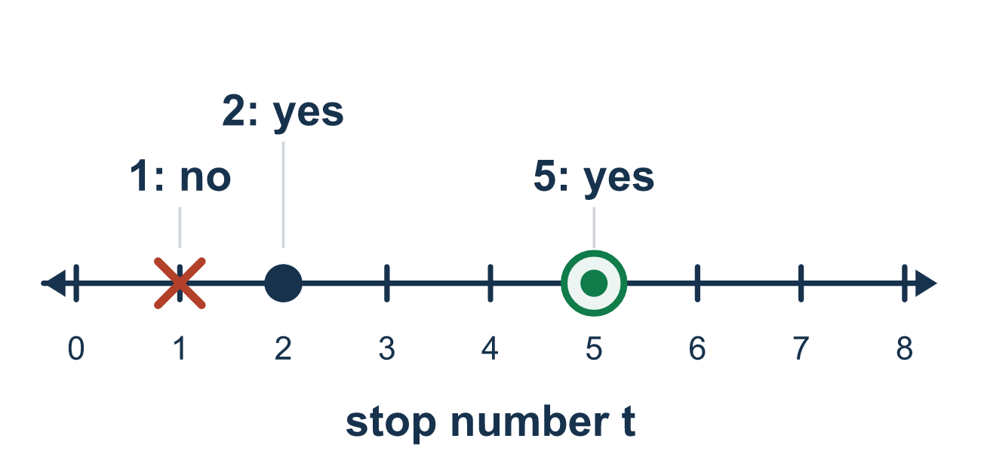
Our class model: the circle and the shading

Try it
Work it out on paper. Write one answer on each line.
- Which circle do you use to graph x ≤ 7?
A. An open circle B. A closed circle C. No circle D. Two circles
My answer
- Which circle do you use to graph x > 2?
A. A closed circle B. An arrow only C. An open circle
My answer
- To graph x > 4, which way do you shade?
A. Right of 4 B. Left of 4 C. Only at 4 D. Both sides
My answer
- A graph has an open circle at 3 and shading to the left. Which inequality is it?
A. x > 3 B. x ≥ 3 C. x < 3 D. x ≤ 3
My answer
- Which number is a solution of x < 6?
A. 7 B. 6 C. 8 D. 5
My answer
- A graph has a closed circle at 8 and shading to the right. Which inequality is it?
A. x > 8 B. x ≥ 8 C. x ≤ 8 D. x < 8
My answer

Talk about it
Why is the circle at 7 closed in one graph and open in the other? Which side did you shade?

Home mission
Line up 8 cups in a row. Number them 0 to 7 with sticky notes. Say "t ≥ 2." Flip the cups that work. Is cup 2 one of them? Which side is flipped?

If we get stuck, ask
- What number is the boundary, where the shading starts?
- Does the symbol have a line under it? That tells us open or closed circle.
- Which way are the answers — bigger numbers or smaller numbers?

Do it on a screen

Scan or type the link. Same lesson, with hints. eduwonderlab.com/lessons/8-5/homework.html
How did it feel? (optional) ☐ Tricky ☐ Getting there ☐ Got it

Family Math Studio · For grown-ups Lesson 8.5 · 6.AT.9

Answers and talk notes
Understand Inequalities and Their Solutions

What your student is learning
Tonight we graph an inequality on a number line. We draw a circle at the boundary number and shade the side that works.

Answers
Ask your student to explain before you look.
- B. A closed circle. A closed circle, because 7 is included in x ≤ 7.
- C. An open circle. An open circle, because 2 is not included in x > 2.
- A. Right of 4. Right of 4, because x is greater than 4.
- C. x < 3. x < 3, because 3 is not included and the shading goes toward smaller numbers.
- D. 5. 5 is a solution of x < 6, because 5 is less than 6.
- B. x ≥ 8. x ≥ 8, because 8 is included and the shading goes toward larger numbers.

Talk about it
Why is the circle at 7 closed in one graph and open in the other? Which side did you shade?

When they are stuck, ask
- What number is the boundary, where the shading starts?
- Does the symbol have a line under it? That tells us open or closed circle.
- Which way are the answers — bigger numbers or smaller numbers?

Try not to say
- Always use a closed circle, it doesn't matter which symbol.
- Always shade to the right.
- x < 5 and x ≤ 5 graph exactly the same way.

Home mission
Line up 8 cups in a row. Number them 0 to 7 with sticky notes. Say "t ≥ 2." Flip the cups that work. Is cup 2 one of them? Which side is flipped?

