Family Math Studio Lesson 8.6 · Session 2 · 6.AT.8

Solve and Graph Inequalities
Solve an inequality first, then shade the graph from the solved symbol.
Name Date

Tonight's spark
A family phone plan allows at most 20 GB of data each month. The bill shows 12 GB already used. Can the family use 10 more GB? Guess first: can they use 10 more GB, yes or no?
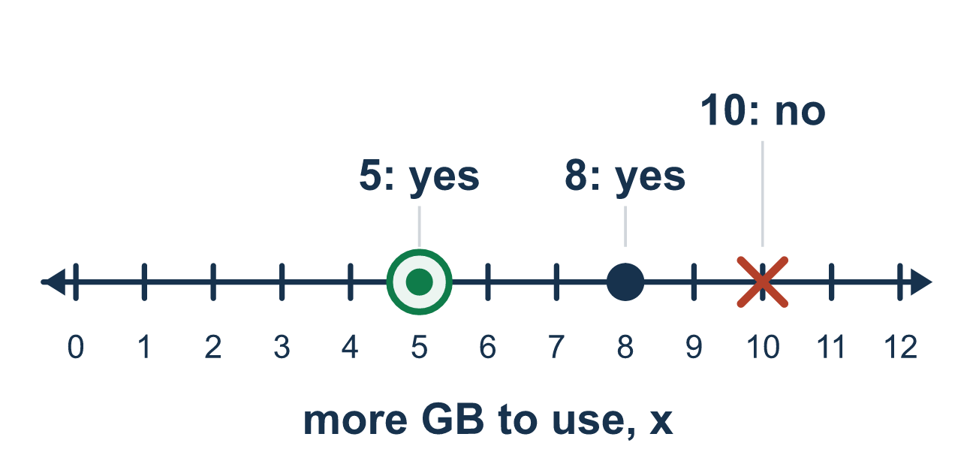
Our class model: shade from the solved symbol

Try it
Work it out on paper. Write one answer on each line.
- Solve: x − 4 > 2
A. x > 2 B. x > −2 C. x > 6
My answer
- Solve: 5x ≤ 30
A. x ≤ 6 B. x ≤ 25 C. x ≤ 150 D. x ≥ 6
My answer
- After solving you get n ≥ 3. Which graph shows it?
A. Closed circle at 3, shade left B. Open circle at 3, shade right C. Open circle at 3, shade left D. Closed circle at 3, shade right
My answer
- Solve: k ÷ 2 > 5
A. k > 7 B. k > 10 C. k > 2.5
My answer

Talk about it
Which number goes at the circle, the one you started with or the solved one? Why?

Home mission
Look at a phone bill or gift card. Pretend a plan allows at most 20 GB and 12 are used. Write x + 12 ≤ 20 and solve it. Test one number that works and one that does not.

If we get stuck, ask
- Solve it first. What does the symbol say NOW?
- Does that symbol point toward bigger or smaller numbers?
- Test a shaded value in the original. Is it true?

Do it on a screen

Scan or type the link. Same lesson, with hints. eduwonderlab.com/lessons/8-6-part2/homework.html
How did it feel? (optional) ☐ Tricky ☐ Getting there ☐ Got it

Family Math Studio · For grown-ups Lesson 8.6 · Session 2 · 6.AT.8

Answers and talk notes
Solve and Graph Inequalities

What your student is learning
Tonight we SOLVE an inequality first, then graph its solution set — and the shading follows the SOLVED symbol, not the original.

Answers
Ask your student to explain before you look.
- C. x > 6. x > 6, because 2 + 4 = 6.
- A. x ≤ 6. x ≤ 6, because 30 ÷ 5 = 6.
- D. Closed circle at 3, shade right. Closed circle at 3, shade right, because n ≥ 3 includes 3 and goes up.
- B. k > 10. k > 10, because 5 × 2 = 10.

Talk about it
Which number goes at the circle, the one you started with or the solved one? Why?

When they are stuck, ask
- Solve it first. What does the symbol say NOW?
- Does that symbol point toward bigger or smaller numbers?
- Test a shaded value in the original. Is it true?

Try not to say
- Shade the direction the original problem pointed.
- Inequalities are solved differently from equations.
- Once it is solved, the graph does not need checking.

Home mission
Look at a phone bill or gift card. Pretend a plan allows at most 20 GB and 12 are used. Write x + 12 ≤ 20 and solve it. Test one number that works and one that does not.

