Family Math Studio Lesson 8.6 · 6.AT.8

Solve and Graph Inequalities
Solve an inequality, then graph its solutions on a number line.
Name Date

Tonight's spark
A fundraiser concert needs more than 53 tickets sold. Your class has sold 3 so far. If x more are sold, is 50 more tickets enough? Guess first: is 50 more tickets enough, yes or no?
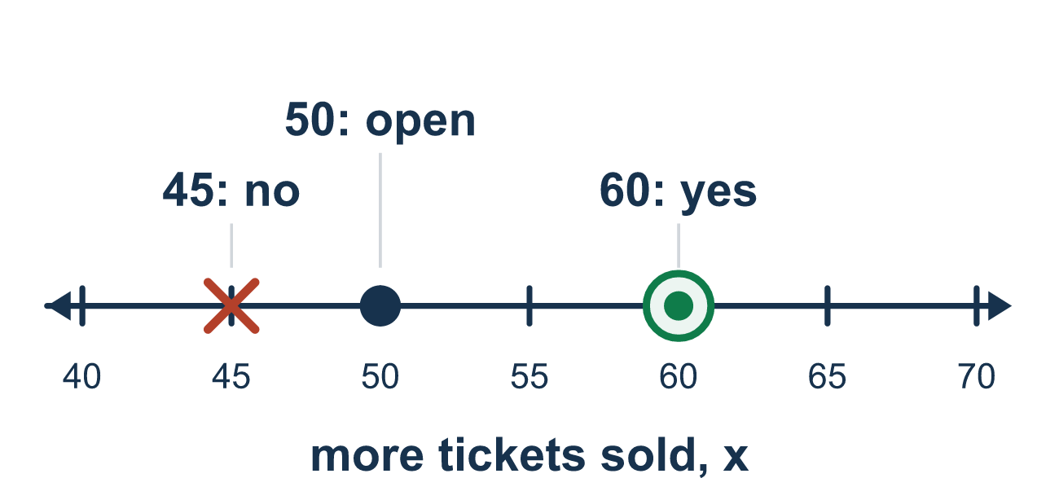
Our class model: solve first, then graph

Try it
Work it out on paper. Write one answer on each line.
- Solve: x + 3 > 7
A. x > 10 B. x > 4 C. x > 3 D. x < 4
My answer
- Solve: y − 2 ≤ 5
A. y ≤ 3 B. y ≤ 10 C. y ≤ 7 D. y ≥ 7
My answer
- Solve: 4n ≥ 20
A. n ≥ 5 B. n ≥ 80 C. n ≥ 16 D. n ≤ 5
My answer
- Solve: m ÷ 3 < 4
A. m < 1 B. m < 7 C. m > 12 D. m < 12
My answer
- After solving x + 5 ≥ 9, which graph is correct?
A. Open circle at 4, shade right B. Closed circle at 4, shade right C. Closed circle at 14, shade right D. Closed circle at 4, shade left
My answer
- A rope must be at least 10 feet long. Anna has 6 feet and needs r more feet, so 6 + r ≥ 10. Solve it.
A. r ≥ 16 B. r ≤ 4 C. r ≥ 4 D. r ≥ 6
My answer

Talk about it
What did you do to both sides? Why does the answer show many numbers, not just one?

Home mission
Stick 3 notes on the fridge as sold tickets. Say: "We need more than 53 tickets in all." How many more must we sell? Write x + 3 > 53, solve it, and test one number that works.

If we get stuck, ask
- What is being added or subtracted? Use the opposite to get x alone.
- Look at the symbol now: does it include the boundary number — open or closed circle?
- Let's substitute a number from the shaded side to check it is true.

Do it on a screen

Scan or type the link. Same lesson, with hints. eduwonderlab.com/lessons/8-6/homework.html
How did it feel? (optional) ☐ Tricky ☐ Getting there ☐ Got it

Family Math Studio · For grown-ups Lesson 8.6 · 6.AT.8

Answers and talk notes
Solve and Graph Inequalities

What your student is learning
Tonight we solve an inequality and then graph it. We get the letter alone the same way as an equation, but the answer is a range of values.

Answers
Ask your student to explain before you look.
- B. x > 4. x > 4, because 7 − 3 = 4.
- C. y ≤ 7. y ≤ 7, because 5 + 2 = 7.
- A. n ≥ 5. n ≥ 5, because 20 ÷ 4 = 5.
- D. m < 12. m < 12, because 4 × 3 = 12.
- B. Closed circle at 4, shade right. Closed circle at 4, shade right, because x ≥ 4.
- C. r ≥ 4. r ≥ 4, because 10 − 6 = 4, so she needs 4 feet or more.

Talk about it
What did you do to both sides? Why does the answer show many numbers, not just one?

When they are stuck, ask
- What is being added or subtracted? Use the opposite to get x alone.
- Look at the symbol now: does it include the boundary number — open or closed circle?
- Let's substitute a number from the shaded side to check it is true.

Try not to say
- The answer to an inequality is one number, like an equation.
- Use a closed circle for every inequality.
- You don't need to check by substituting a value.

Home mission
Stick 3 notes on the fridge as sold tickets. Say: "We need more than 53 tickets in all." How many more must we sell? Write x + 3 > 53, solve it, and test one number that works.

