Family Math Studio Lesson 8.7 · Session 2 · 6.AT.8

Equations and Inequalities Problem Solving
Decide if a situation gives one exact value or a limit, then pick an equation or an inequality.
Name Date

Tonight's spark
Two notes are on the community-center board. A: a reward split equally among 5 people gave each $40. B: the van held no more than 6 bags. Which note gives ONE exact number? Guess first: is it note A or note B?
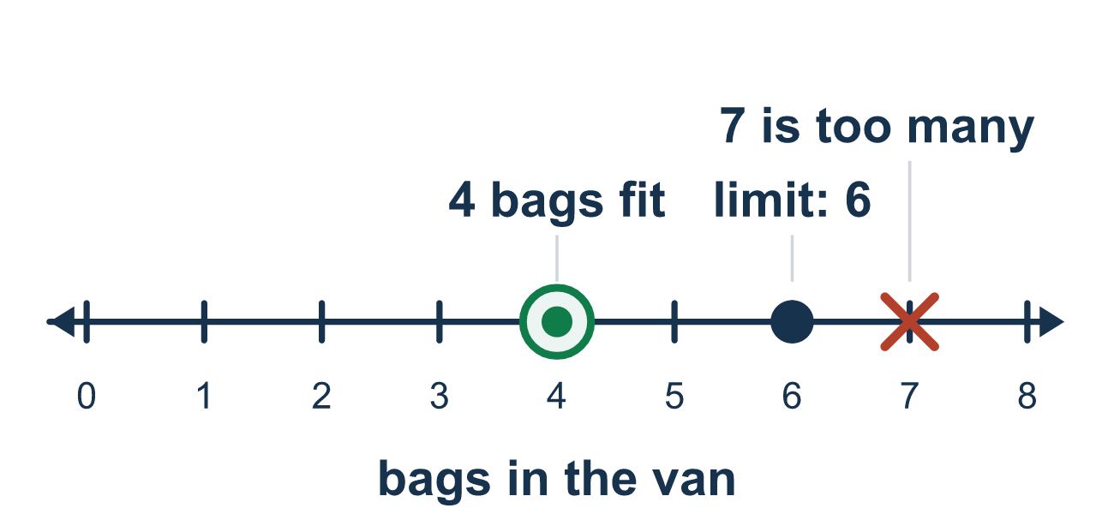
Our class model: exact value or limit

Try it
Work it out on paper. Write one answer on each line.
- Which clue words usually point to an equation?
A. split equally, each, is B. at most, at least C. no more than D. fewer than
My answer
- Which situation needs an inequality?
A. A rope is exactly 9 feet. B. A box can hold at most 12 books. C. Four friends share $20 equally. D. A book costs $7.
My answer
- Which situation needs an equation?
A. A bag holds no more than 10 pounds. B. You need at least 15 points. C. Six friends share 24 stickers equally. D. A ride allows at most 4 people.
My answer
- 'Tickets cost $4 each and the total is $28.' Which model fits, with t tickets?
A. 4t < 28 B. 4t = 28 C. 4t ≥ 28 D. t − 4 = 28
My answer
- 'You can spend at most $30 on 3 gifts that cost g dollars each.' Which model fits?
A. 3g ≥ 30 B. 3g = 30 C. 3g ≤ 30 D. g ÷ 3 ≤ 30
My answer

Talk about it
Which pile has a limit, and which has one exact value? How do you know?

Home mission
Find two notes at home: one with an exact amount ("the total is $28") and one with a limit ("at most 3 snacks"). Ask your student which is an equation and which is an inequality, and which words decided it.

If we get stuck, ask
- Does this give one exact answer, or a limit?
- Which words in the problem told you that?
- Could more than one number work here?

Do it on a screen

Scan or type the link. Same lesson, with hints. eduwonderlab.com/lessons/8-7-part2/homework.html
How did it feel? (optional) ☐ Tricky ☐ Getting there ☐ Got it

Family Math Studio · For grown-ups Lesson 8.7 · Session 2 · 6.AT.8

Answers and talk notes
Equations and Inequalities Problem Solving

What your student is learning
Tonight the decision comes first: does this situation give ONE exact value, or a LIMIT? That picks equation or inequality.

Answers
Ask your student to explain before you look.
- A. split equally, each, is. split equally, each, is usually point to an equation.
- B. A box can hold at most 12 books.. A box can hold at most 12 books, because at most gives a limit.
- C. Six friends share 24 stickers equally.. Six friends share 24 stickers equally, because sharing equally gives one exact amount.
- B. 4t = 28. 4t = 28, because the total is one exact amount.
- C. 3g ≤ 30. 3g ≤ 30, because the spending must be $30 or less.

Talk about it
Which pile has a limit, and which has one exact value? How do you know?

When they are stuck, ask
- Does this give one exact answer, or a limit?
- Which words in the problem told you that?
- Could more than one number work here?

Try not to say
- One number in the problem means use an equation.
- Equations and inequalities are interchangeable.
- Write the equation and add the limit later.

Home mission
Find two notes at home: one with an exact amount ("the total is $28") and one with a limit ("at most 3 snacks"). Ask your student which is an equation and which is an inequality, and which words decided it.

