Family Math Studio Lesson 8.7 · 6.AT.8

Equations and Inequalities Problem Solving
Model real-world problems with equations and inequalities, then solve and check them.
Name Date

Tonight's spark
At a rec-center raffle, a prize was divided equally among 4 friends. Each friend got $85. How much was the whole prize? Guess first: is the whole prize more than $85, or less?
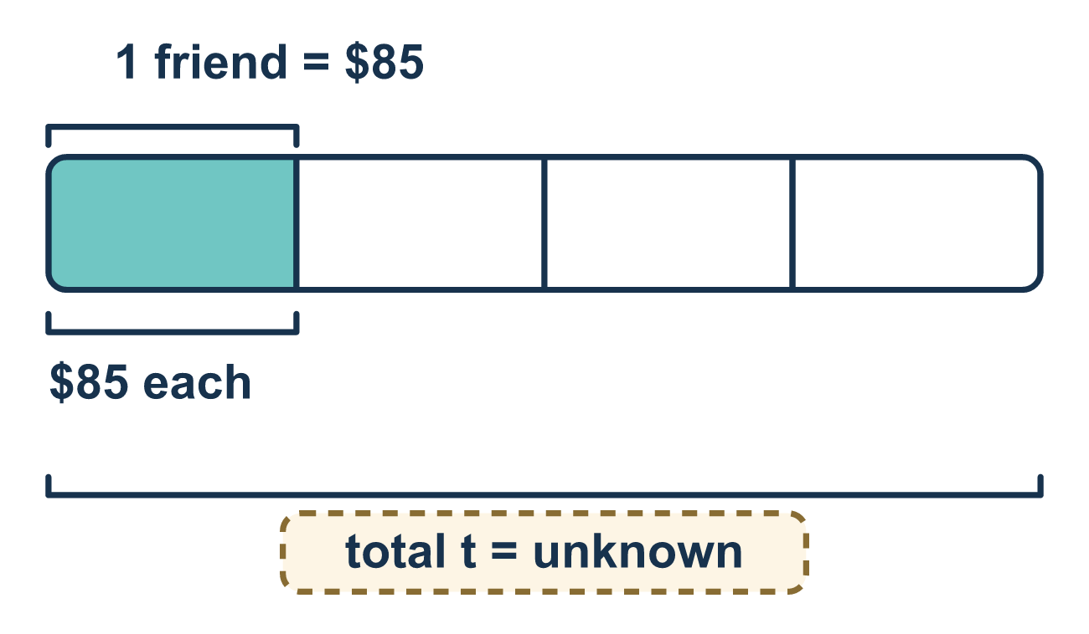
Our class model: the equation-or-inequality check

Try it
Work it out on paper. Write one answer on each line.
- Which clue points to an inequality?
A. exactly B. at most C. equals D. is the same as
My answer
- 'Jo has exactly $12 to spend.' What kind of model fits?
A. Neither one B. An inequality, because there is a limit C. An equation, because exactly means equal D. Both at once
My answer
- 'A bus holds at most 40 riders.' Which model shows the riders r?
A. r ≤ 40 B. r = 40 C. r ≥ 40 D. r > 40
My answer
- A pizza costs $9 and you pay with $20. Your change is c, so 9 + c = 20. What is c?
A. $29 B. $9 C. $180 D. $11
My answer
- Maria saves $5 a week and wants at least $40. Which inequality shows the weeks w?
A. 5w ≤ 40 B. 5w = 40 C. 5w ≥ 40 D. w + 5 ≥ 40
My answer

Talk about it
Which clue word told you to use = and which told you to use an inequality symbol?

Home mission
Look at a store receipt. Say, "A total of $24 was split equally among 4 people." Can your student say if that is an equation or an inequality? Then try "at most $24."

If we get stuck, ask
- What words give the clue — 'equals/exactly' or 'at least/at most/more than/fewer than'?
- Let's write the model first, then solve it step by step.
- Does the answer make sense for real life? Could it be negative or a half person?

Do it on a screen

Scan or type the link. Same lesson, with hints. eduwonderlab.com/lessons/8-7/homework.html
How did it feel? (optional) ☐ Tricky ☐ Getting there ☐ Got it

Family Math Studio · For grown-ups Lesson 8.7 · 6.AT.8

Answers and talk notes
Equations and Inequalities Problem Solving

What your student is learning
Tonight we read a word problem and decide whether to model it with an equation or an inequality, then solve it and check that the answer makes sense.

Answers
Ask your student to explain before you look.
- B. at most. at most points to an inequality, because it gives a limit.
- C. An equation, because exactly means equal. An equation, because exactly means equal.
- A. r ≤ 40. r ≤ 40, because 40 riders or fewer fit.
- D. $11. c = $11, because 20 − 9 = 11.
- C. 5w ≥ 40. 5w ≥ 40, because her savings must be $40 or more.

Talk about it
Which clue word told you to use = and which told you to use an inequality symbol?

When they are stuck, ask
- What words give the clue — 'equals/exactly' or 'at least/at most/more than/fewer than'?
- Let's write the model first, then solve it step by step.
- Does the answer make sense for real life? Could it be negative or a half person?

Try not to say
- Every word problem is an equation, so always use the equal sign.
- 'At most 200' means exactly 200, so use =.
- Once you get a number, you're done — no need to check if it makes sense.

Home mission
Look at a store receipt. Say, "A total of $24 was split equally among 4 people." Can your student say if that is an equation or an inequality? Then try "at most $24."

