Family Math Studio Lesson 9.1 · Session 2 · 6.AT.11

Explore Relationships Between Two Variables
Build a table of values and find the rule that connects the input to the output.
Name Date

Tonight's spark
A faucet at the rec center fills a tub with 11 gallons each minute. You make a table for 1, 2 and 4 minutes. How many gallons are in the tub after 4 minutes? Guess first: is it more than 40 gallons, or less?
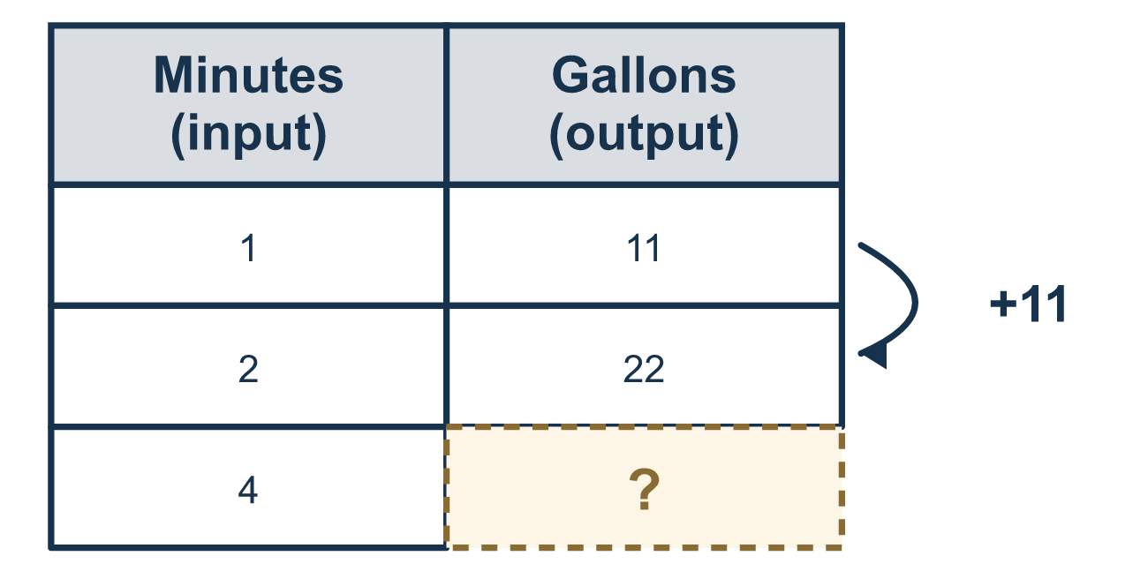
Our class model: the input-output table rule

Try it
Work it out on paper. Write one answer on each line.
- In a table of values, where does the input go?
A. Column 2 B. Column 1 C. The title D. The bottom row
My answer
- A table shows x = 1, 2, 3, 4 and y = 5, 10, 15, 20. What is y when x = 3?
A. 15 B. 10 C. 20 D. 3
My answer
- A table shows x = 1, 2, 3 and y = 3, 6, 9. How much does y change each time x goes up by 1?
A. 1 B. 2 C. 3 D. 9
My answer
- A table shows x = 1, 2, 3 and y = 7, 9, 11. What is y when x = 4?
A. 11 B. 12 C. 14 D. 13
My answer
- A table shows x = 1, 2, 3 and y = 2, 4, 6. Which rule connects y to x?
A. y = x + 2 B. y = 2x C. y = x − 2 D. y = 3x
My answer
- For the rule y = x + 4, what is y when x = 5?
A. 20 B. 1 C. 9 D. 45
My answer

Talk about it
Which column is the input and which is the output? What is the rule that connects them?

Home mission
Take a small cup and a bowl. Pour 2 cups at a time. Make a table for 1, 2 and 3 pours. Can your student say which column is the input and tell you the rule?

If we get stuck, ask
- Which quantity could you choose, and which one follows from it?
- Say the sentence: "the ___ depends on the ___."
- How much does y change each time x goes up by one?

Do it on a screen

Scan or type the link. Same lesson, with hints. eduwonderlab.com/lessons/9-1-part2/homework.html
How did it feel? (optional) ☐ Tricky ☐ Getting there ☐ Got it

Family Math Studio · For grown-ups Lesson 9.1 · Session 2 · 6.AT.11

Answers and talk notes
Explore Relationships Between Two Variables

What your student is learning
Tonight we build a table of values — input in the first column, output in the second — and find the rule connecting them.

Answers
Ask your student to explain before you look.
- B. Column 1. Column 1, because the input is listed first.
- A. 15. y = 15 when x = 3, because 15 is in the same row as 3.
- C. 3. y goes up by 3, because 6 − 3 = 3 and 9 − 6 = 3.
- D. 13. y = 13, because y goes up by 2 each time and 11 + 2 = 13.
- B. y = 2x. y = 2x, because each y is 2 times x.
- C. 9. y = 9, because 5 + 4 = 9.

Talk about it
Which column is the input and which is the output? What is the rule that connects them?

When they are stuck, ask
- Which quantity could you choose, and which one follows from it?
- Say the sentence: "the ___ depends on the ___."
- How much does y change each time x goes up by one?

Try not to say
- The variable the question asks about is the independent one.
- It does not matter which column each one goes in.
- Just fill in the numbers, you do not need a rule.

Home mission
Take a small cup and a bowl. Pour 2 cups at a time. Make a table for 1, 2 and 3 pours. Can your student say which column is the input and tell you the rule?

