Family Math Studio Lesson 9.1 · 6.AT.11

Explore Relationships Between Two Variables
Tell which quantity you choose and which quantity changes because of it.
Name Date

Tonight's spark
A neighbor pays you for helping at her stand. Her table shows 1 hour, $4; 2 hours, $8; 3 hours, $12. You decide how many hours to work. Which number do you choose, and which one changes? Guess first: if you work 4 hours, will the pay be more than $12, or less?
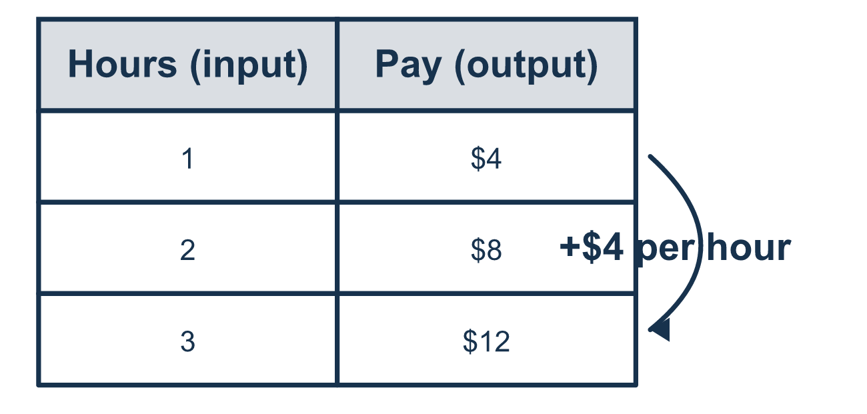
Our class model: the choose-and-respond sort

Try it
Work it out on paper. Write one answer on each line.
- The more hours you work, the more money you earn. Which is the independent variable?
A. money earned B. hours worked C. the job D. the hourly pay
My answer
- Plants get different amounts of water, and then their heights are measured. Which is the dependent variable?
A. height of the plant B. amount of water C. number of plants D. color of the pot
My answer
- In a table of values, which column holds the independent variable?
A. The last row B. The second column (output) C. The first column (input) D. The title row
My answer
- The cost of apples depends on how many pounds you buy. Which quantity depends on the other?
A. the store B. number of pounds C. the apple color D. total cost
My answer
- Which sentence describes a dependent variable?
A. You pick its value B. It changes because of the other variable C. It never changes D. It is always the larger number
My answer

Talk about it
Which one did you pick first, and which one followed from your pick?

Home mission
Use coins. Lay out $4 for 1 hour and $8 for 2 hours of stand work. Ask, "Which number do we choose? Which one depends on it?" Can your student say, "The pay depends on the hours"?

If we get stuck, ask
- Which one did someone get to decide?
- Which one changed because of the other?
- Can you say it with the words "depends on"?

Do it on a screen

Scan or type the link. Same lesson, with hints. eduwonderlab.com/lessons/9-1/homework.html
How did it feel? (optional) ☐ Tricky ☐ Getting there ☐ Got it

Family Math Studio · For grown-ups Lesson 9.1 · 6.AT.11

Answers and talk notes
Explore Relationships Between Two Variables

What your student is learning
Tonight we look at two quantities that change together and decide which one is the independent variable and which is the dependent variable.

Answers
Ask your student to explain before you look.
- B. hours worked. hours worked is the independent variable, because you choose how many hours to work.
- A. height of the plant. height of the plant is the dependent variable, because it changes in response to the water.
- C. The first column (input). The first column (input) holds the independent variable.
- D. total cost. total cost depends on the number of pounds, so it is the dependent variable.
- B. It changes because of the other variable. It changes because of the other variable, so it depends on it.

Talk about it
Which one did you pick first, and which one followed from your pick?

When they are stuck, ask
- Which one did someone get to decide?
- Which one changed because of the other?
- Can you say it with the words "depends on"?

Try not to say
- The first one mentioned is always independent.
- It does not matter which is which.
- The bigger number is the dependent variable.

Home mission
Use coins. Lay out $4 for 1 hour and $8 for 2 hours of stand work. Ask, "Which number do we choose? Which one depends on it?" Can your student say, "The pay depends on the hours"?

