Family Math Studio Lesson 9.2 · Session 2 · 6.AT.11

Analyze Graphs of Relationships Between Two Variables
Read the rate of change from a graph and use it to predict a value you cannot see.
Name Date

Tonight's spark
A school printer graph has the points (1, 13), (2, 26) and (3, 39). The x-values are minutes and the y-values are pages. The graph stops at 3 minutes. How many pages print in 10 minutes? Guess first: is it more than 100 pages, or less?
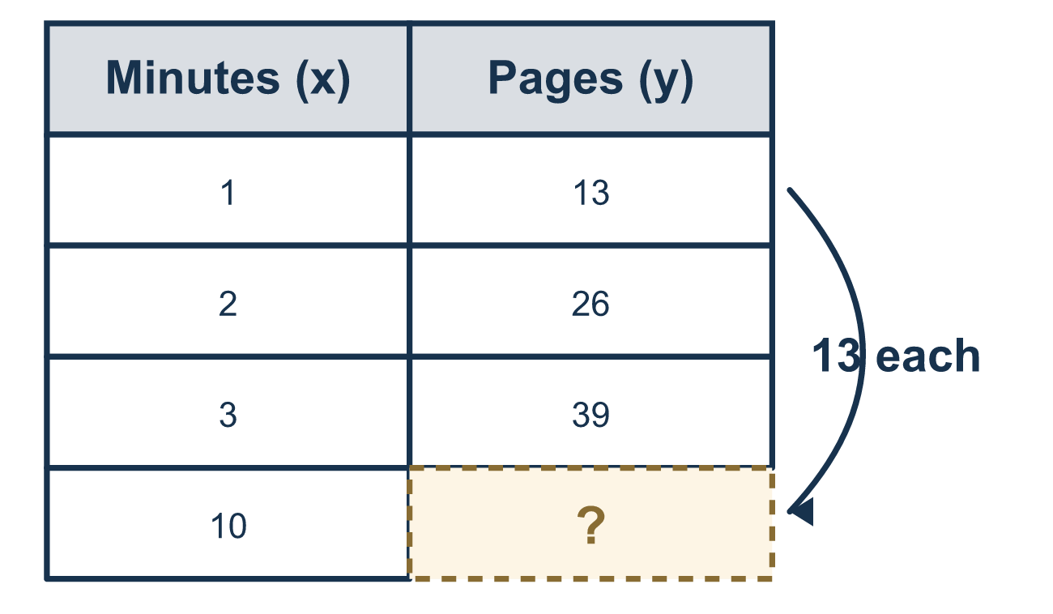
Our class model: read the rate, then predict

Try it
Work it out on paper. Write one answer on each line.
- A graph has the points (1, 4), (2, 8), (3, 12). What is the rate of change?
A. 1 B. 4 C. 8 D. 12
My answer
- The same graph has the points (1, 4), (2, 8), (3, 12). What is y when x = 4?
A. 16 B. 13 C. 20 D. 12
My answer
- A graph has the points (1, 3), (2, 6), (3, 9). What is y when x = 10?
A. 13 B. 39 C. 10 D. 30
My answer
- The point (5, 15) is on a graph. What does the 5 stand for?
A. the output B. the origin C. the independent value (input) D. the rate of change
My answer
- A graph passes through (0, 0) and (2, 10). What is the unit rate, or y for each 1 of x?
A. 2 B. 10 C. 12 D. 5
My answer

Talk about it
What is the rate of change on your graph? How did it help you find a point that is not drawn?

Home mission
Pretend a printer makes 13 pages each minute. Ask your student to say the point for 5 minutes, with minutes first. Then ask how they found it.

If we get stuck, ask
- What does this point mean in real words?
- How much does y climb each time x goes up by one?
- Which number in the pair did you write first?

Do it on a screen

Scan or type the link. Same lesson, with hints. eduwonderlab.com/lessons/9-2-part2/homework.html
How did it feel? (optional) ☐ Tricky ☐ Getting there ☐ Got it

Family Math Studio · For grown-ups Lesson 9.2 · Session 2 · 6.AT.11

Answers and talk notes
Analyze Graphs of Relationships Between Two Variables

What your student is learning
Tonight we read a relationship off a graph — its rate of change, its unit rate — and use it to predict a value we cannot see.

Answers
Ask your student to explain before you look.
- B. 4. The rate of change is 4, because y goes up by 4 each time x goes up by 1.
- A. 16. y = 16, because 12 + 4 = 16.
- D. 30. y = 30, because the rate is 3 and 3 × 10 = 30.
- C. the independent value (input). the independent value (input), because the first number in a point is x.
- D. 5. The unit rate is 5, because 10 ÷ 2 = 5.

Talk about it
What is the rate of change on your graph? How did it help you find a point that is not drawn?

When they are stuck, ask
- What does this point mean in real words?
- How much does y climb each time x goes up by one?
- Which number in the pair did you write first?

Try not to say
- The order of the coordinates does not matter.
- You can only read values that are drawn on the graph.
- A steeper line always means bigger numbers.

Home mission
Pretend a printer makes 13 pages each minute. Ask your student to say the point for 5 minutes, with minutes first. Then ask how they found it.

