Family Math Studio Lesson 9.2 · 6.AT.11

Analyze Graphs of Relationships Between Two Variables
Turn each row of a table into an ordered pair and plot it as a point.
Name Date

Tonight's spark
A show ticket costs $45. The table says 1 ticket, $45; 2 tickets, $90; 3 tickets, $135. You plot each row as a point. In each point, which number goes first? Guess first: does the number of tickets go first, or the total cost?
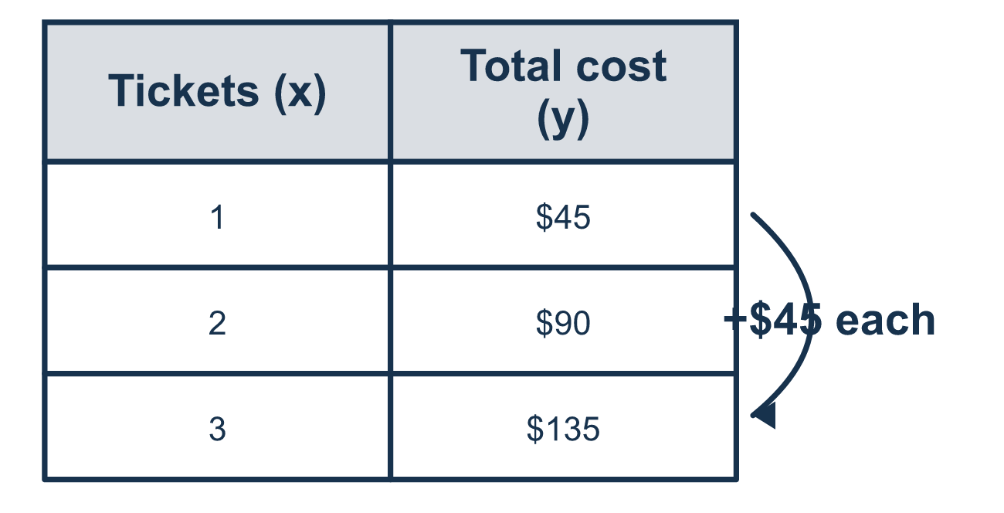
Our class model: row to point

Try it
Work it out on paper. Write one answer on each line.
- Which ordered pair matches x = 3 and y = 6?
A. (6, 3) B. (3, 6) C. (3 + 6) D. 36
My answer
- In the ordered pair (2, 5), which number is the independent value?
A. 2 B. 5 C. 7 D. 10
My answer
- How do you plot the point (4, 1) from the origin?
A. Up 4, right 1 B. Right 1, up 4 C. Right 4, up 1 D. Left 4, up 1
My answer
- A table shows x = 1, 2, 3 and y = 3, 6, 9. Which ordered pair comes from x = 2?
A. (2, 3) B. (6, 2) C. (2, 9) D. (2, 6)
My answer
- Which point is on the vertical axis (the y-axis)?
A. (0, 4) B. (4, 0) C. (4, 4) D. (1, 1)
My answer

Talk about it
Which quantity do you choose first, the tickets or the cost?

Home mission
On the back of an envelope, write a ticket table: 1 ticket $45, 2 tickets $90, 3 tickets $135. Ask your student for the three points, tickets first. Then ask what to write on each axis.

If we get stuck, ask
- Which quantity goes first in the pair?
- What does one row of the table become on the graph?
- Are both axes labeled?

Do it on a screen

Scan or type the link. Same lesson, with hints. eduwonderlab.com/lessons/9-2/homework.html
How did it feel? (optional) ☐ Tricky ☐ Getting there ☐ Got it

Family Math Studio · For grown-ups Lesson 9.2 · 6.AT.11

Answers and talk notes
Analyze Graphs of Relationships Between Two Variables

What your student is learning
Tonight we turn a table into a graph. Each row of the table becomes one point on the coordinate plane.

Answers
Ask your student to explain before you look.
- B. (3, 6). (3, 6) is correct, because an ordered pair is written (x, y).
- A. 2. 2 is the independent value, because it is the first number in the pair.
- C. Right 4, up 1. Right 4, up 1, because x tells how far to go right and y tells how far to go up.
- D. (2, 6). (2, 6) comes from x = 2, because y is 6 in that row.
- A. (0, 4). (0, 4) is on the vertical axis, because its x-value is 0.

Talk about it
Which quantity do you choose first, the tickets or the cost?

When they are stuck, ask
- Which quantity goes first in the pair?
- What does one row of the table become on the graph?
- Are both axes labeled?

Try not to say
- Plot the bigger number first.
- You do not need to label the axes.
- Connect the dots any way you like.

Home mission
On the back of an envelope, write a ticket table: 1 ticket $45, 2 tickets $90, 3 tickets $135. Ask your student for the three points, tickets first. Then ask what to write on each axis.

