Family Math Studio Lesson 9.3 · Session 2 · 6.AT.11

Write Equations to Represent Relationships Between Two Variables
Write an equation for a situation with a rate that multiplies and a start amount that adds.
Name Date

Tonight's spark
A parking garage charges $5 to drive in, plus $2 for each hour. A driver parks for 3 hours. How much does the driver pay? Guess first: is it more than $10, or less?
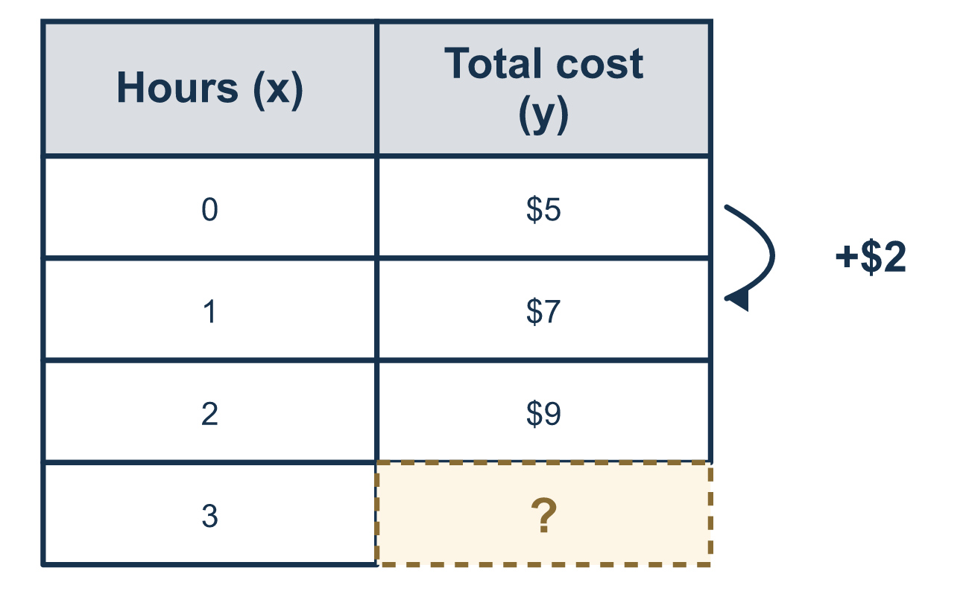
Our class model: rate multiplies, start adds

Try it
Work it out on paper. Write one answer on each line.
- A taxi charges $2 for each mile. Which equation gives the cost c for m miles?
A. c = m + 2 B. m = 2c C. c = 2 − m D. c = 2m
My answer
- Which equation matches '$5 to start plus $2 per hour' with total y for x hours?
A. y = 7x B. y = 2x + 5 C. y = 5x + 2 D. y = x + 7
My answer
- In y = 2x + 5, what is y when x = 3?
A. 30 B. 10 C. 11 D. 16
My answer
- In y = 2x + 5, which part is the starting amount?
A. 5 B. 2 C. x D. y
My answer
- A club costs $16 per hour, so c = 16h. How much does it cost for 3 hours?
A. $19 B. $48 C. $13 D. $163
My answer

Talk about it
Which part of your equation multiplies and which part is added once? How do you know?

Home mission
Pretend a parking spot costs $5 to enter plus $2 for each hour. Ask your student for the cost of 4 hours. Which number is paid once, and which number repeats?

If we get stuck, ask
- Which amount happens every time, and which happens once?
- Does the rate multiply the variable, or get added to it?
- Test your equation on one row you already know.

Do it on a screen

Scan or type the link. Same lesson, with hints. eduwonderlab.com/lessons/9-3-part2/homework.html
How did it feel? (optional) ☐ Tricky ☐ Getting there ☐ Got it

Family Math Studio · For grown-ups Lesson 9.3 · Session 2 · 6.AT.11

Answers and talk notes
Write Equations to Represent Relationships Between Two Variables

What your student is learning
Tonight we turn a real situation into an equation — spotting the rate that MULTIPLIES and any starting amount that ADDS.

Answers
Ask your student to explain before you look.
- D. c = 2m. c = 2m shows $2 for each of m miles.
- B. y = 2x + 5. y = 2x + 5 matches, because $2 is multiplied by the hours and $5 is added once.
- C. 11. y = 11, because 2 × 3 = 6 and 6 + 5 = 11.
- A. 5. 5 is the starting amount, because it is added once.
- B. $48. $48, because 16 × 3 = 48.

Talk about it
Which part of your equation multiplies and which part is added once? How do you know?

When they are stuck, ask
- Which amount happens every time, and which happens once?
- Does the rate multiply the variable, or get added to it?
- Test your equation on one row you already know.

Try not to say
- Add all the numbers in the problem together.
- A monthly fee gets added once, whatever the months.
- You do not need to test the equation.

Home mission
Pretend a parking spot costs $5 to enter plus $2 for each hour. Ask your student for the cost of 4 hours. Which number is paid once, and which number repeats?

