Family Math Studio Lesson 9.3 · 6.AT.11

Write Equations to Represent Relationships Between Two Variables
Write an equation from a table to show how two variables are related.
Name Date

Tonight's spark
Miguel joined a gym. The table shows 1 month, $24.95; 2 months, $49.90; 3 months, $74.85. How much will 10 months of membership cost? Guess first: is 10 months more than $200, or less?
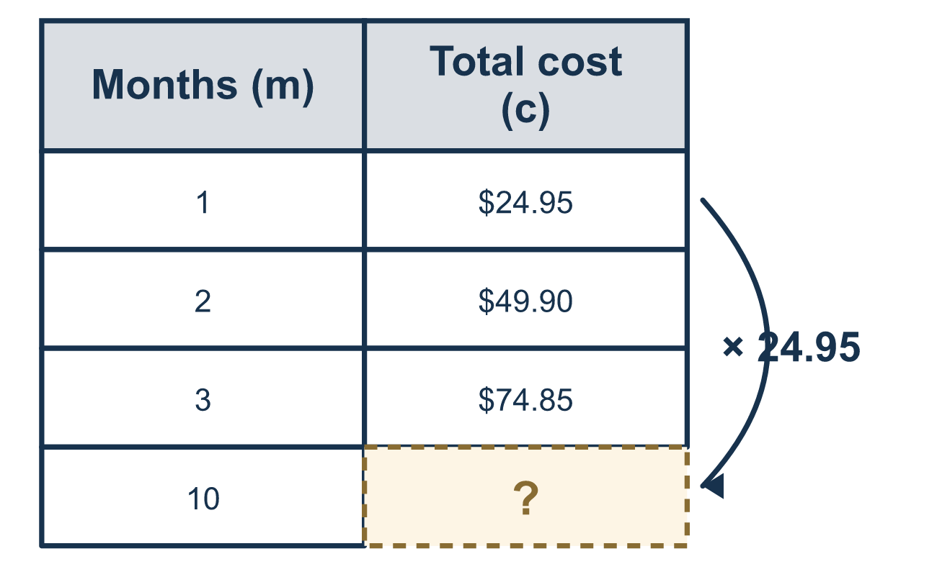
Our class model: rate × amount

Try it
Work it out on paper. Write one answer on each line.
- A table shows x = 1, 2, 3 and y = 4, 8, 12. Which equation fits?
A. y = x + 3 B. y = 4x C. y = x + 4 D. y = 12x
My answer
- A snack costs $3 each. Which equation shows the cost c for n snacks?
A. c = n + 3 B. c = 3 ÷ n C. c = 3n D. n = 3c
My answer
- In y = 5x, what is y when x = 4?
A. 20 B. 9 C. 1 D. 45
My answer
- In d = 60t, which letter is the independent variable?
A. d B. 60 C. t D. =
My answer
- In y = 7x, what is x when y = 28?
A. 21 B. 35 C. 196 D. 4
My answer
- A table shows x = 2, 4, 6 and y = 6, 12, 18. Which equation fits?
A. y = x + 4 B. y = 3x C. y = 2x D. y = 6x
My answer

Talk about it
If m is 2, does 24.95 + m match the table's cost for 2 months?

Home mission
Find a monthly bill, like a phone or streaming plan. Ask your student, "What is the price each month?" Can they write c = (that price) × m and test it with 2 months?

If we get stuck, ask
- How much does the total change from one row to the next?
- What should each letter stand for?
- Does your equation work on every row?

Do it on a screen

Scan or type the link. Same lesson, with hints. eduwonderlab.com/lessons/9-3/homework.html
How did it feel? (optional) ☐ Tricky ☐ Getting there ☐ Got it

Family Math Studio · For grown-ups Lesson 9.3 · 6.AT.11

Answers and talk notes
Write Equations to Represent Relationships Between Two Variables

What your student is learning
Tonight we write an equation from a table or a graph, so two letters can describe the whole relationship.

Answers
Ask your student to explain before you look.
- B. y = 4x. y = 4x fits, because each y is 4 times x.
- C. c = 3n. c = 3n shows $3 for each of n snacks.
- A. 20. y = 20, because 5 × 4 = 20.
- C. t. t is the independent variable, because d is found from t.
- D. 4. x = 4, because 28 ÷ 7 = 4.
- B. y = 3x. y = 3x fits, because each y is 3 times x.

Talk about it
If m is 2, does 24.95 + m match the table's cost for 2 months?

When they are stuck, ask
- How much does the total change from one row to the next?
- What should each letter stand for?
- Does your equation work on every row?

Try not to say
- Just add the numbers you see.
- You do not need to say what the letters mean.
- Any letter works, so it does not matter.

Home mission
Find a monthly bill, like a phone or streaming plan. Ask your student, "What is the price each month?" Can they write c = (that price) × m and test it with 2 months?

